Level 3 Earth & Marine Science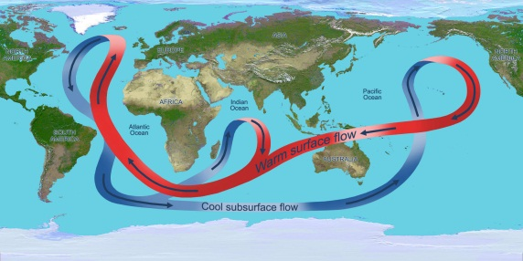 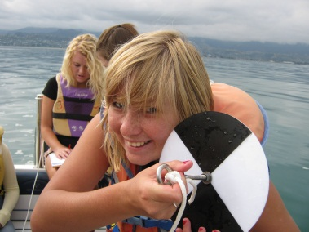 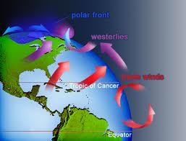
You will be assessed using a range of internal and external Level 3 standards from:
Earth & Space Science & Education for Sustainability & Biology
Topics & Assessment 2016 (subject to change if we feel so inclined… and we probably will)
Standard | Credits | Topic
ESS 91410 | 4 Int | Practical Investigation: Tasman Bay oceanography / or?
ESS 91411 | 4 Int | A socio-scientific issue: Cobb quarry / Abel Tasman NP / Waimea plains Dairy farming / or?
ESS 91413 | 4 Ext | Understand processes in the Ocean system
ESS 91414 | 4 Ext | Understand processes in the Atmosphere system
In addition we will also set aside 4-5 weeks for work on a topic of individual choice, selected from the following:
E4S 90829 | 4 Int | Investigate Interrelationship between Humans and the Environment (ATNP restoration)
ESS 91415 | 4 Int | Investigation of an aspect of Astronomy…. wide open, you choose
E4S 90828 | 6 Int | Evaluate a Personal Action, eg drain fish / Tahuna beach cleanup / Oyster Island
Bio 91601 | 4 Int | Practical Biology Investigation: any ideas?
Bio 91602 | 4 Int | Investigate a biological issue, eg fisheries management / land use impacts / or?
Total 20 - 22

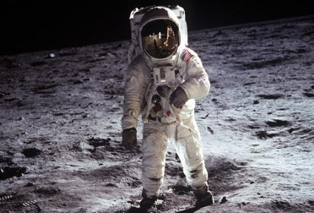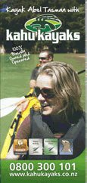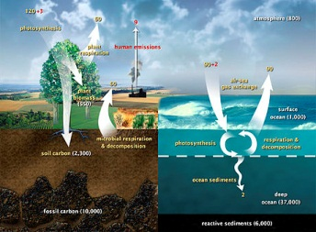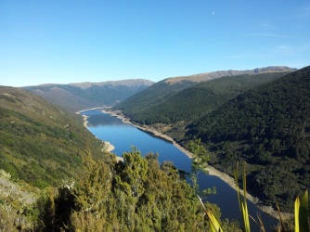
Some idea of what, when and how long
Term 1
Topic 1 [91410] (5 wk)
Tasman Bay oceanography: literature research/ secchi investigation / plankton & sediment
Topic 2 [91411] (5 wk)
Humans and sustainability: Cobb Quarry
&/or
Abel Tasman NP: history / impacts / restrictions
&/or
Waimea plains dairying: impacts / measuring? / or snapper over the years
Term 2
Topic 1 [91413] (5 wk)
Ocean structure (the external stuff)
Topic 2 [lots to choose from] (5 wk)
topic of their choice
examples:
comparing some conservation initiatives / a personal action / astronomy / geology
Term 3
Topic 1 [91414] (5 wk)
Atmosphere structure (the external stuff)
or
Topic 2 [90829] (5wk)
Human-environment interaction (something from above not done earlier?)
School Exams (1 wk)
Term 4
Topic 2 cont.[90829] (2 wk)
Complete Human-environment interaction
Revision for exams

