Level 3 Earth, Marine & space Science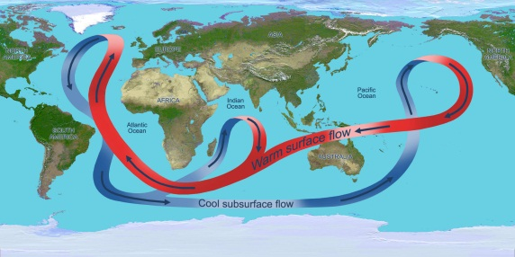 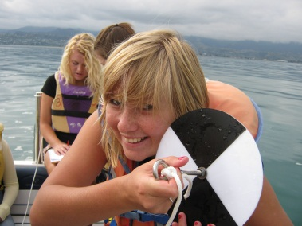 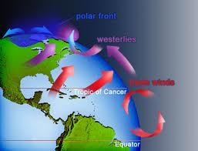
You will be assessed using a range of internal and external Level 3 standards from:
Earth & Space Science & Education for Sustainability
Topics & Assessment (subject to change if we feel so inclined… and we probably will)
Standard | Credits | Topic
ESS 91410 | 4 Int | Practical Investigation: Tasman Bay oceanography / or?
ESS 91412 | 4 Int | Investigation evidence for geological dating / alpine fault
ESS 91413 | 4 Ext | Understand processes in the Ocean system
ESS 91414 | 4 Ext | Understand processes in the Atmosphere system
In addition we will also set aside 4-5 weeks for work on a topic of individual choice, selected from the following:

E4S 91735  ESS 91411  BIO 91602 | 4 Int | Evaluate measure for sustainability ……… Salmon farm sites  A socio-scientific issue - ESS  A socio-scientific issue - Bio
ESS 91415 | 4 Int | Investigation of an aspect of Astronomy …. wide open, you choose
E4S 90828 | 6 Int | Evaluate a Personal Action, eg drain fish / Tahuna beach cleanup / Oyster Island
ESS 91411 | 4 Int | A socio-scientific issue: Cobb quarry / Abel Tasman NP / Waimea plains Dairy farming / or?
Total 20 - 22

