**[Antarctic voyage: the Mertz Polynya](http://sciblogs.co.nz/fieldwork/2013/01/31/antarctic-voyage-the-mertz-polynya/" \o "Permanent Link to Antarctic voyage: the Mertz Polynya) Guest Work Jan 31**

**Ever wondered what it is really like to be working on a ship off Antarctica?**

[*Dr Helen Bostock*](http://www.niwa.co.nz/people/helen-bostock)*, marine geologist at NIWA, writes:*

On the 2nd February I will be part of a team of 22 Australian, French and New Zealand, scientists departing Wellington on board NIWA’s R.V. Tangaroa.

The science team is made up of oceanographers and geologists, and we will be heading out on a 42-day voyage to the Mertz Polynya region of Antarctica.

[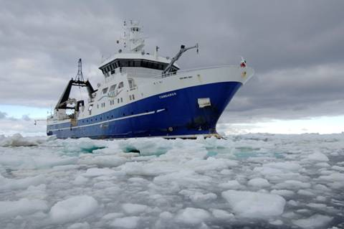](http://sciblogs.co.nz/fieldwork/files/2013/01/NIWA-vessel.jpg)

*Credit: Peter Marriot, NIWA from 2008 voyage to the Ross Sea as part of the International Polar Year*

**Why study the Mertz Polynya?**

Back in February 2010 the tongue of the Mertz Glacier broke off after being rammed by a huge iceberg. The Mertz Polynya is one of three areas around Antarctica where the deep waters of the ocean are formed. The so-called “Antarctic bottom waters” are created during the formation of sea ice, which leaves behind very salty, dense water. This salty water sinks to the bottom and flows over the edge of the continental shelf, like an overflowing dam, to the bottom of the Southern Ocean.

So one of the main aims of this voyage is to understand how changes in the Mertz Polynya, caused by the break off of the glacier tongue, will affect the formation of Antarctic bottom water and the flow in to the deep ocean, and the potential global implications of these changes.

1. What is the global importance of this Antarctic bottom water? Consider in your answer the:
   * Thermohaline current
   * Distribution of heat around the globe
   * Effect on climate

The voyage will also be sampling seafloor sediments and taking underwater video to see what lived under the Mertz Glacier Tongue before it broke away. Sediment cores may also provide clues as to how often the glacier tongue has broken off in the past.

[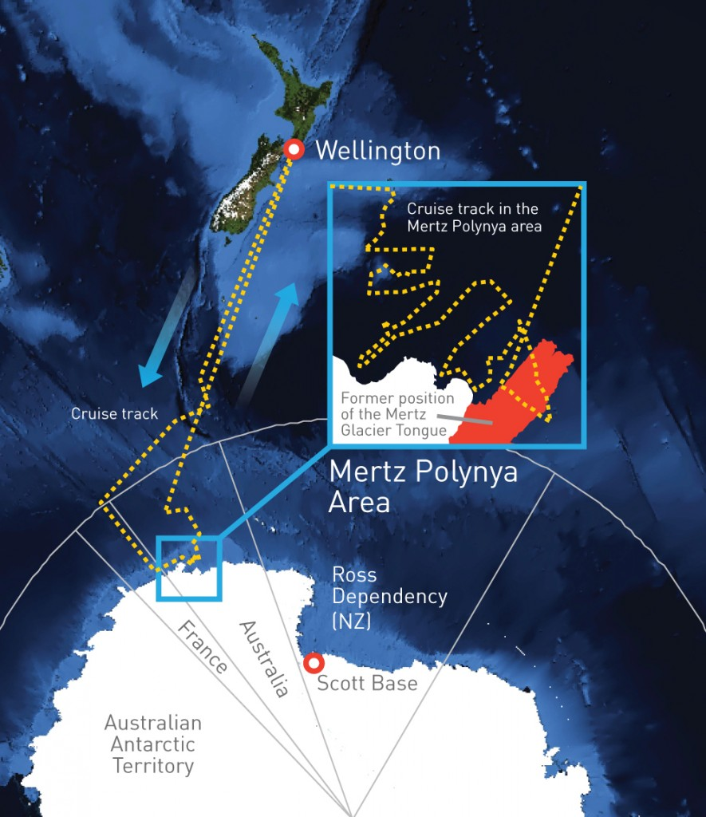](http://sciblogs.co.nz/fieldwork/files/2013/01/ANT_overview_v6.jpg)

Map of NIWA’s R. V Tangaroa path to the Mertz Polynya area, Antarctica. Credit: NIWA

We will be continuously sampling the surface waters and the air for the CO2 content. We will be towing a “continuous plankton recorder” behind the ship, which collects and preserves plankton. And we will also be collecting a couple of sediment cores and deploying some Argo floats, which measure the temperature and salinity of the ocean.

1. List the research objectives for the voyage

These observations and samples will add to the on-going Sub-Antarctic and Southern Ocean research programmes in New Zealand, Australia and New Zealand.

Planning for this voyage started many years ago. It is latest in a series of Australian and French voyages to visit this region and monitor the environmental changes.

About a year ago, funding was secured and the voyage confirmed.

We started by putting together a detailed science plan with our overseas collaborators.

First, we estimated the time it would take for the initial “wish list” of stations (places that measurements or samples are taken) – including the time to steam between stations and deploy the gear. The ship works 24 hours a day, 7 days a week, but this first draft is always too ambitious. So we cut back the number of stations and the area we want to cover to produce a more realistic **Plan A**. In reality, this **Plan A** is still too ambitious as we assume that we will have perfect sea conditions, a highly unlikely scenario in the famously stormy Southern Ocean.

We also have to worry about sea ice as we approach the coast of Antarctica. The [RV*Tangaroa*](http://www.niwa.co.nz/our-science/vessels/tangaroa) is not an ice breaker – it only has an ice-strengthened hull. So over the last few weeks we have been obsessively looking at the latest sea ice reports produced from the cloud free satellite images. The sea ice is still present over the Mertz area, so we are currently coming up with **Plan B**and**Plan C** just in case.

[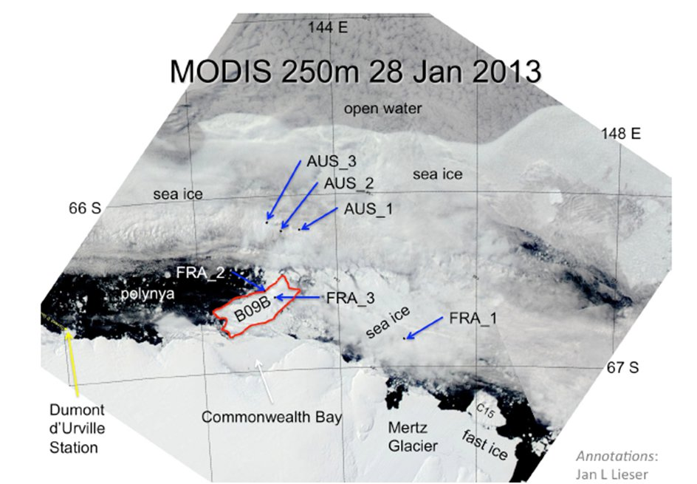](http://sciblogs.co.nz/fieldwork/files/2013/02/Mapo.jpg)

*NASA MODIS Satellite photo of the sea ice around the Mertz Glacier, courtesy of Jan Lieser, ACE CRC. Aus 1 – 3 and Fra 1-3 are the Australian and French moorings we were hoping to retrieve during the voyage. Iceberg B09B is the old Mertz Tongue that broke off in 2010. Dumont D’urville is the French Antarctic Base. Still a lot of sea ice!*

As we are going to be sailing through New Zealand, Australian and international waters we have had to apply for 3 times the normal number of permits – approximately 10 different permits for sampling water, mud and plankton.

Next, we have to work out who we need to run all the scientific gear and undertake the sampling and analyses. This requires technical specialists, meaning that the majority of the science party is made up of experienced technicians. We also take a few lucky students to give them some hands on experience and train up the next generation of scientists and technicians.

There are scientists from three different disciplines on board: oceanographers, chemists and geologists (the latter are also doing a little biology).

Although we are from institutions in 3 different countries, there are actually 8 different nationalities on board. Interestingly, there are 14 female scientists and 8 male scientists!

The oceanography team is responsible for running the CTD (conductivity, temperature, depth profiler – pronounced seeteedee), which measures the salinity, temperature, pressure, and oxygen at different depths in the water as we lower it the sea floor. The team also collect water samples at different depths on the way back up to the surface, to calibrate the sensors on the CTD, and for the chemists to analyse. Similar sensors on the ship’s ‘underway’ system also collect continuous surface water data along the ship’s track.

1. Sensors detect salinity, temperature, pressure and oxygen, depending on the sensor.
   * What is meant by “calibrating the sensors”?
   * Why is it so important to calibrate scientific instruments that are measuring variables such as salinity etc?

[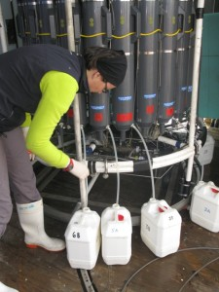](http://sciblogs.co.nz/fieldwork/files/2013/02/Sampling-CTD_sm.jpg)

*Aitana Forcen sampling the CTD during TAN1106 voyage (credit: Bruce Hayward, Geomarine Research)*

Attached to the CTD frame is an ADCP (Acoustic Doppler Current Profiler) which measures flow speeds at different depths in order to get an idea of how fast the currents are flowing. There is another ADCP attached to the bottom of the ship that constantly measures the currents in the upper few hundred metres. The ADCP works by sending out pulses of sound that bounce off objects in the water; then they pick up the change in frequency of the reflected sound pulse to determine the speed of the objects in the water, which we take to be is the same as the water speed.

1. Watch a Youtube clip on Doppler. Doppler is the change in pitch you hear when a fire engine come towards you and then races away from you. Doppler has many applications and is used by animals such as dolphins and bats to catch locate food. It’s also used in ultrasound and is used to determine blood or urine flow for example.

The oceanography team is also responsible for the moorings. These are a series of instruments measuring temperature, salinity, and currents, attached to a long cable. The cable is held down by a weight which sits on the seafloor, and then held upright in the water with a series of floats. While a CTD takes a snapshot of what is going on in the water column, moorings are usually deployed for a few months or a couple of years to monitor seasonal or yearly changes.

[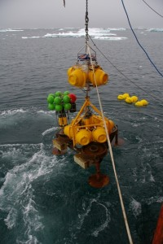](http://sciblogs.co.nz/fieldwork/files/2013/02/mertzmooring_sm.jpg)

*Mooring hanging above the water (credit: Mark Rosenberg, ACE CRC)*

One of the main objectives of this voyage is to retrieve some moorings that the Australians and French teams put out into the ocean over a year ago to measure changes in the water column on the shelf near the Mertz Glacier. As the moorings sit below the surface of the ocean, the instruments should have measured the water column even in the middle of winter when the sea ice freezes over this region and there is no way a ship can get in.

Together the physical and chemical properties of the water can be used to trace different water masses in the ocean. When the data is compared to previous voyages to this region, it also tells us how the water mass properties are changing over time.

1. Why do moorings need to be put down for years? What are the advantages of long-term experiments?

[Antarctic Voyage: Multibeam mapping of the seafloor](http://sciblogs.co.nz/fieldwork/2013/02/07/antarctic-voyage-multibeam-mapping-of-the-seafloor/)

We are collecting some seafloor data on the voyage to and from Antarctica. We also hope to map the continental shelf around the Mertz Glacier to add to the data that was collected on previous voyages. These detailed maps will be used to understand the oceanographic flow, evidence of past Antarctic ice extent (using the iceberg gouges on the sea floor), as well as the distribution of biology and sediments.

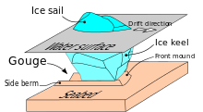

<http://en.wikipedia.org/wiki/Seabed_gouging_by_ice>

**How do we map the seafloor with the multibeam?**

Let’s start with a bit of history. Back in the good old days, the positions of features on the seabed were plotted using soundings taken by lead-line.

The position of the sounding was fixed using a quadrant, compass bearings off land features, and later on a sextant. Charting was extremely labour-intensive and not very accurate. More commonly, directions and hazards were handed down through the generations by word of mouth or learned by experience – not always good ones!

After World War II, single beam echo sounders became widely available. Echo sounding is a technique for measuring water depths by transmitting an acoustic (sound) pulse (or ping) from a transducer mounted on the hull of a vessel and listening for the reflection (or echo) from the sea floor. The time taken for that ping to travel to the seabed and back again is converted into a depth by halving the time taken between transmission and reception, and multiplying that time by the speed of sound in water (somewhere near 1500 metres per second).

Most of the charts that currently map the world’s coasts and oceans were made using these soundings. These single beam echo sounders are commonly found on even small boats to determine the depth of coastal areas when fishing or cruising.

However, single beam sounders don’t provide 100% coverage of the seafloor. In between the soundings there may be areas which potentially contain large rocks or holes. So, in 1964, a technique for multiple narrow-beam depth sounding was patented by SeaBeam. This system allowed survey vessels to produce high-resolution coverage of wide swaths of the ocean bottom.

The multibeam system fitted to the Tangaroa is a Simrad EM302. It has 432 beams. These are sent out from the ship in a fan shape (see [this video](http://vimeo.com/44906412) explaining how it works; or go to this link <http://vimeo.com/44906412>), and can cover an area of seafloor up to 5 km or more in width with each pass of the ship, although the coverage is much smaller for shallower depths.

1. Look at the above video clip before going on.

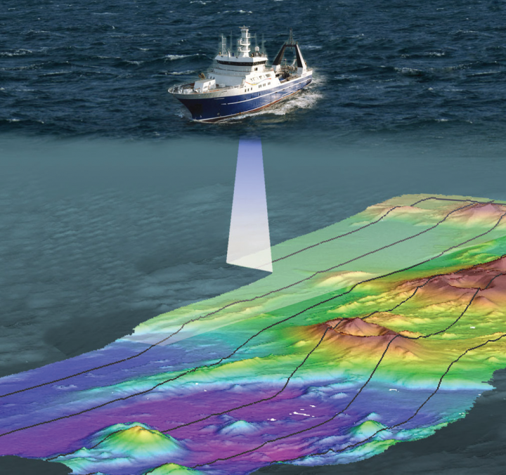Various factors must be considered:

* The speed of sound through the water is not constant and changes with density. Data from the CTD is used to calculate the density, using temperature and salinity measurements.
* The ship is constantly in motion. The ship’s position must be precisely known at all times and this is achieved using GPS (Global Positioning System; the same as in your phones or satnav), which can tell us where we are within a metre or less.
* We also have to correct the swath data for the ship’s [roll, pitch and yaw](http://en.wikipedia.org/wiki/Ship_motions#Rotation_motions). (click on this link if you want to know what those 3 things are: <http://en.wikipedia.org/wiki/Ship_motions#Rotation_motions>

The end result of all this is that we can create very accurate maps of the seabed, which can be used for a whole range of science.

[**Antarctic Voyage: The Continuous Plankton Recorder**](http://sciblogs.co.nz/fieldwork/2013/02/07/antarctic-voyage-the-continuous-plankton-recorder/)

Several of the crew deployed the Continuous Plankton Recorder (CPR), just south of Stewart Island.

[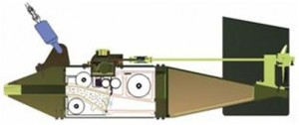](http://sciblogs.co.nz/fieldwork/files/2013/02/cpg.jpg)*The CPR (Diagram: Australian Antarctic Division)*

The CPR is a metal box in the shape of a fish – designed to be towed behind any ship at a water depth of about 10 m. Water passes into the CPR at the front, and plankton are filtered onto a slow-moving band of silk (270 micrometre mesh size) and covered by a second band of silk.

The silks and plankton are then spooled into a storage tank containing formalin (or formaldehyde) to preserve the plankton so they don’t rot. On return to the laboratory, the silk is removed and divided into samples representing 10 nautical miles (19 km) of tow. The plankton preserved in the silk are then identified and counted by specialist plankton taxonomists.

[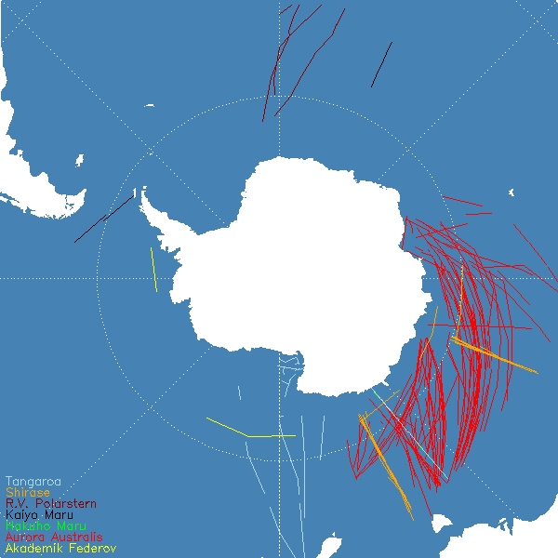](http://sciblogs.co.nz/fieldwork/files/2013/02/Map-of-known-CPR-tows.jpg)

*Map of known CPR tows. Credit:*[*Southern Ocean Continuous Plankton Recorder Survey*](https://data.aad.gov.au/aadc/cpr/)*(SO-CPR)*

The overall aim of the CPR surveys in this region is to map the biodiversity of the plankton. Any changes to their quantity and distribution will affect the organisms that live off them, such as fish and the whales.

Plankton also reproduce rapidly, are very abundant, and are sensitive to changes in environmental conditions. This means that they act as early warning indicators of the health of the Southern Ocean.

## [Antarctic voyage: The geology team and coring](http://sciblogs.co.nz/fieldwork/2013/02/08/antarctic-voyage-the-geology-team-and-coring/)

The team is made up of 2 scientists, 2 students and an IT person.

Our main geological roles are going to be mapping the sea floor using the multibeam and undertaking some sediment coring and sampling.

The sediments on the bottom of the ocean are made up of sand and mud, which are transported into the ocean from the land via rivers, or blown in as dust.

[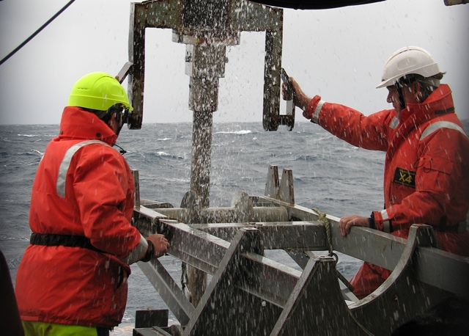](http://sciblogs.co.nz/fieldwork/files/2013/02/Gravity-coring_sm.jpg)

*Gravity core being recovered during the TAN0803 voyage. Credit: NIWA.*

The sediments also contain thousands to *millions* of the skeletal remains of plankton – tiny microfossils ranging in size from 2μm-0.5mm – which fall to the bottom of the ocean when they die, if they are eaten first.

Sediments cores provide an archive of past changes in the ocean. The sediments slowly build up over time, so as we look down the core we go back in time. It’s like an oceanographic time machine.

Today we reached our first official station on the voyage, where we attempted a gravity core in the Emerald Basin east of the Macquarie Ridge at a water depth of 3600 m. The core is lowered to the sea floor by a winch on a very long wire, and then driven into the sediment by a large lead weight (approximately 2 tonnes).

[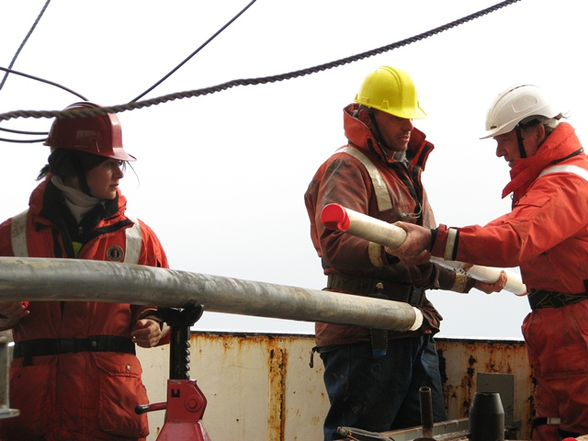](http://sciblogs.co.nz/fieldwork/files/2013/02/coring_sm.jpg)

*Sediment in the core liner being extracted from the core barrel during the TAN0803 voyage. Credit: NIWA*

We recovered about a 4 m core, made up of pale cream, muddy sediment. Unfortunately, the core was also bent – probably due to the stiffness of the sediment – which wasn’t ideal as this made it hard to bring on deck without sloshing it around. We will try a slightly different strategy for our next core tomorrow. Sediment coring is as much an art as a science!

Mud doesn’t sound very exciting, but it is made up of billions of microfossils. Changes in the type of microfossils, or the chemistry of the skeletons, along with the size of the grains, are proxies for changes in the environmental conditions in the past.

We (my collaborators and I) hope that the sediment cores will provide information on what has happened to the water masses in the Southern Ocean over the last 30,000 years (or longer), covering changes from the last glacial to the modern interglacial. The Southern Ocean is thought to have played an important role in causing these large natural climate transitions, but we still know very little about this region.

In order to calibrate these proxies we are also collecting some modern plankton during the voyage. The chemistry of the modern skeletons will be compared with the oceanographic data (temperature, salinity, nutrients, pH) from the voyage, to produce a calibration which can be used on the sediment cores back through time.

1. Write a paragraph showing how the scientists’ work is inter-connected. Consider what can be found out using:
   * Readings from the CTD
   * Data from moorings
   * Multi-beam mapping
   * Continuous plankton recorders
   * Sediment cores
   * Calibration

Link the findings from two or more of these instruments and consider how the data from one instrument can be used to cross correlate (check or back-up), calibrate or enhance the data from another instrument.