Assessment Schedule 2013

Evidence Statement
Q | Evidence |  |  | Achievement |  | Achievement with Merit |  | Achievement with Excellence
ONE | The Sun heats air at the Earth’s surface near the equator. The warm air rises, creating a band of low pressure at the equator. Once the rising air reaches the top of the troposphere at approximately 10-15 kilometres above the Earth’s surface, the air flows toward the North and South poles. Air returns to the Earth’s surface at 30⁰ N or S, creating a high pressure area, and flows back towards the equator. This is the Hadley cell.  Air near the surface flows toward the equator into the low pressure area, replacing the rising air. These are the trade winds which blow from the north and south but are deflected towards the east by the Coriolis effect. They are NE trades in the Northern Hemisphere and SE trades in the Southern Hemisphere.  The area of low pressure and no winds is called the Intertropical Convergence Zone (ITCZ) or doldrums. This moves with the seasons because is it affected by where the Sun is directly overhead and that varies seasonally.  The Hadley cell is important in that it distributes heat north and south away from the equator. The Trade winds bring cool air towards the equator. |  |  | Explanation of the structure of the Hadley cell, mention of heating effect of the Sun |  | Explanation of the structure of the Hadley cell, linked to the direction the trade winds blow and the Coriolis effect and/or distribution of heat |  | Integrated answer using most of the key points, showing good understanding
 | NØ  No response, no relevant evidence. | N1  Only 1 -2 facts briefly mentioned | N2  Partial explanation of structure of Hadley cell | A3  Partial explanation of the structure of the Hadley cell, mention of trade wind direction and Coriolis effect | A4  Explanation of the structure of the Hadley cell, mention of trade wind direction and Coriolis effect | M5  Explanation of the structure of the Hadley cell, linked to the direction the trade winds blow or the Coriolis effect | M6  Explanation of the structure of the Hadley cell, linked to the direction the trade winds blow and the Coriolis effect | E7  Good answer with many links, especially Hadley cell structure to heat distribution | E8  Good answer with multiple links, especially Hadley cell structure to heat distribution  .

Q2 | Expected coverage |  |  |  |  |  | Achieved |  | Merit |  | Excellence
 | 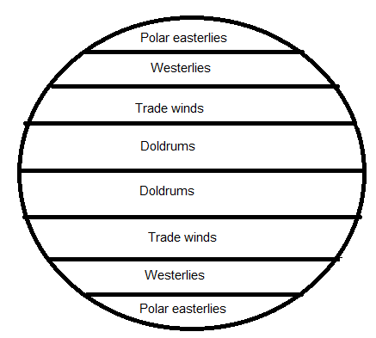  Polar easterlies- located at the poles  - Blow irregularly from the east and north with cold dry winds  Westerlies- just above/ below the polar easterlies, latitude of Western Europe and America in the north, approx. New Zealand in the south  - Blow from the west and tend north  Trade winds- north and south of the equator, 30° latitude  - The northeastlies blow (southwest) towards the equator in the northern hemisphere and southeastlies blow (northwest) in the southern hemisphere  Doldrums- about the equator (5° north and south) where the trade winds meet  - light, irregular wind  Polar easterlies- formed as cold air moves towards the equator. As they move toward the westerlies a polar front occurs and creates an area of low pressure. This often brings storms.  Westerlies- contain jetstreams, these are super high speed winds. Also high pressure areas are produced with dry and hot surface air. Can result in clear skies.  Trade winds- a sailor’s favourite wind. As the trade winds meet the boundary between the troposphere and stratosphere the air splits, the cooled air descends and is then compressed and warmed and creates an area of high pressure.  Doldrums- hot and humid and can have occasional thunderstorms and squalls. The winds can be stagnant (little or no wind for weeks). Air pressure generally low. The doldrums area shifts with the sun. |  |  |  |  |  | - At least three areas correctly labelled  - TWO area’s locations described OR the direction of the wind described for 2 areas |  | - TWO area’s locations described  AND the direction of the wind explained |  | - TWO areas fully discussed with at least one special characteristic about the area
N0 |  | N1 | N2 | A3 | A4 | M5 |  | M6 |  | E7 |  | E8
No relevant information |  | Some relevant information but not totally correct | 1 part achieved answer | 1 achieved answer | 2 achieved answers | 1 merit answer  (Two areas described and the direction of the wind explained for one area) |  | 1 merit answer  Two areas described and the direction of the wind explained for two areas) |  | 1 excellence answer may have an omission |  | 1 excellence answer

Q3
Achieved:
Brief explainations of the weather conditions associated with high and low pressure. (wind speed, direction, temperature, clouds and mention of westerly winds) Basic diagrams of low and high pressure with correct air flow.

Merit:
Detailed explanations of Achieved, plus rainshadow effect and synoptic charts.

Excellence:
Merit + linking in New Zealands weather with the overall Atmospheric circulation model.

