Bryozoan colonies

- A bryozoan coral is a sedentary aquatic invertebrate of the phylum Bryozoa, which comprises the moss animals.
- Individuals in bryozoan colonies are called zooids since they are not fully independent animals.
- In the tasman bay bryozoan corals form significant populations and coralline growths, especially off abel tasman national park (separation point) and outer parts of marlborough sounds.
- The bryozoan colonies were identified as important juvenile fish habitats because the physical structure of the colonies increased the microhabitat diversity and localised biodiversity
- There has been a significant drop in numbers of bryozoan around separation point due to net fishing which ripped up the vast amount of coral due to it being very weak and brittle
- with the reduction in number of snapper and tarakihi reported after fishing at separation point, 156 square km of separation point was closed off to all power-fishing methods in 1980 to protect the bryozoan habitat
- a study was followed up on the bryozoan colonies at separation point later on in 2003. this study showed that the ban of power fishing worked because the bryozoan coral colonies had regrown and there was no signs of trawl or dredge marks from the large fishing nets, it also showed that the colonie had not been completely destroyed but just just almost destroyed, if they had put the ban of power fishing in much later they wouldn’t have been able to grow back.
- when the bryozoan corals were studied in 2003 they were covered with a slight film of silt showing that over the years the amount of sedimentation in the water has increased
- a study of the percentage occurrence of invertebrate happened in 2000 and another in 2005 for comparison. some examples of invertebrate were starfish (Asteroidea), sea urchins (Echinoidea) and sea cucumbers (Holothuroidea).
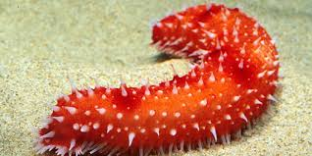
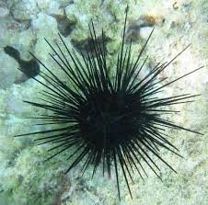
a surprising outcome with the study was that the Pecten Novaezelandiae (scallop) was at 70% in the first catch in 2000 but in the second test 5 years later it was at 0%

