Images:
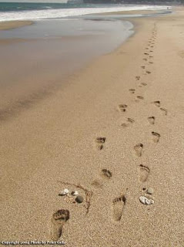

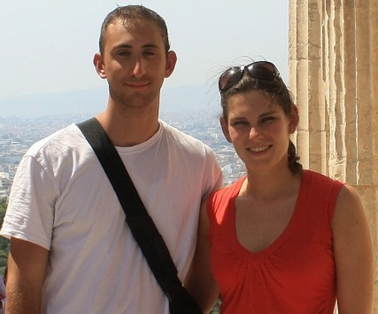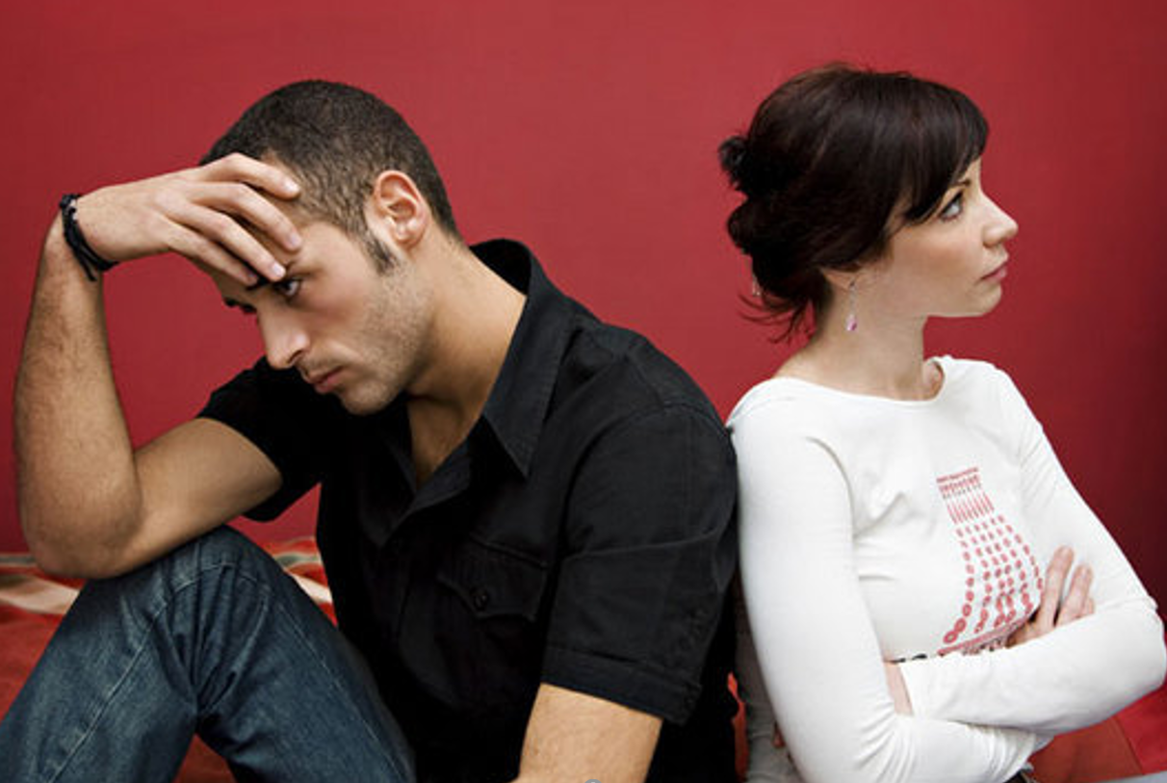

Names:________________________________________________
Picture 1:
What do you see?

What can you figure out about this (infer)?

How certain are you? Any other possibilities ?

Picture 2:
What do you see?

What can you figure out about this (infer)?

How certain are you? Any other possibilities ?

Picture 3:
What do you see?

What can you figure out about this (infer)?

How certain are you? Any other possibilities ?

What are the 5 things or Capabilities that we should be getting better at
1 _________________________________ 2 ______________________ 3 _______________
4 _____________________________ 5 ____________________________

