Chromosomes, Genes, DNA
Part 1: YouTube: Genes, DNA and Chromosomes explained
Label the cell

What is in the nucleus of a human cell…
How do males and females differ …
What are chromosomes made of…
Describe a double helix…
What are the 4 bases…
A length of DNA is called a gene, what does a gene code for…
What do proteins do…

Part 2:
Name these dudes
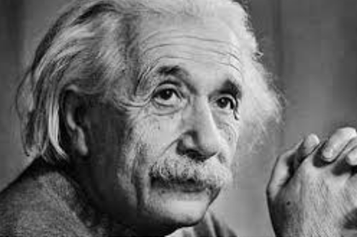 … 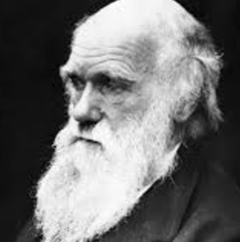 … 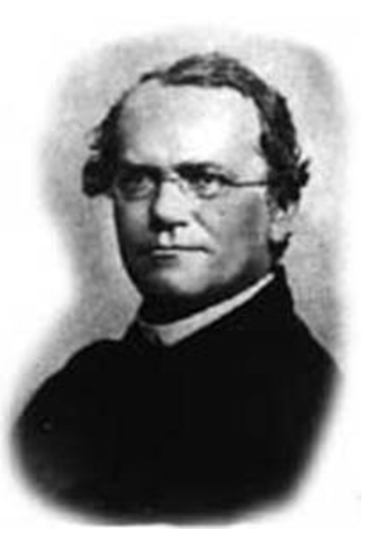…
Name a famous woman scientist…
Why is the list of famous scientists a bit lacking in women…
Mendel was an…
He was also a…
The plant he studied was..
His work involved…
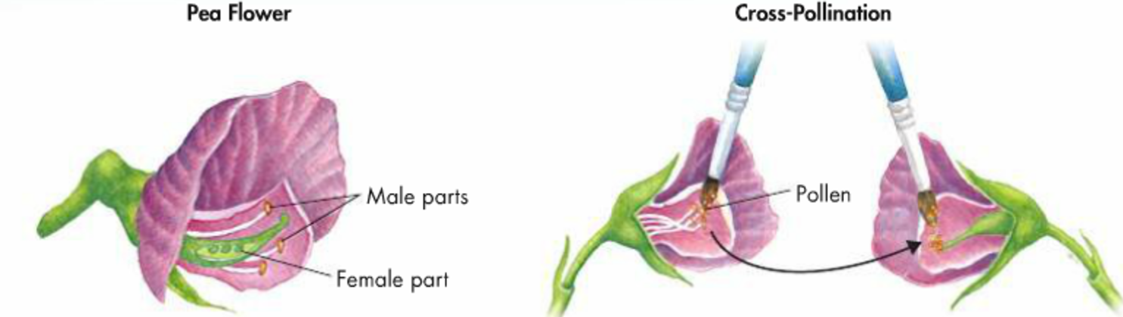 explain what he did

Use this diagram to explain the first part of his work
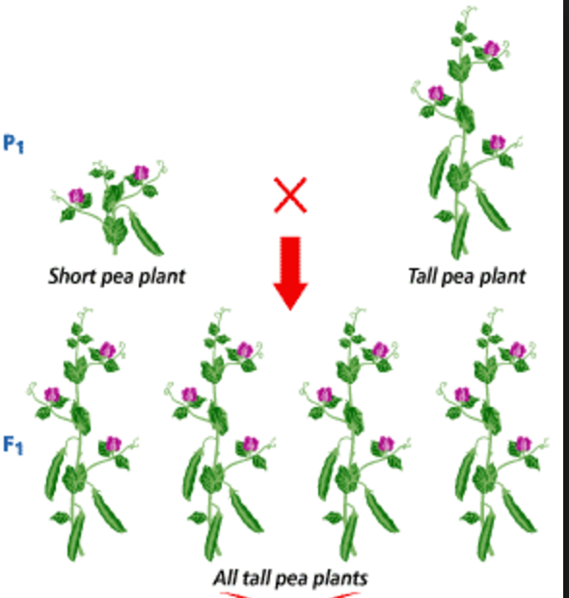describe this result…

What does F1 and F2 mean…
When he crosses two F1 plants this happened
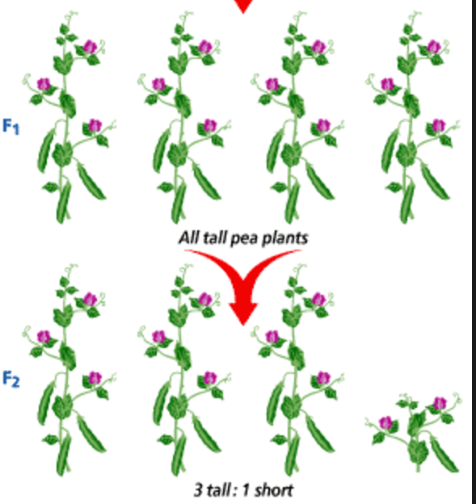describe this result…

Explain these results
Original tall parent…..
Original short parent…

