Coromandel and the Top of the South Heavy Rain and Flooding
Compare and contrast the extremely heavy rainfall and flooding experienced in both of those two regions around Tues 19 (July 2022)
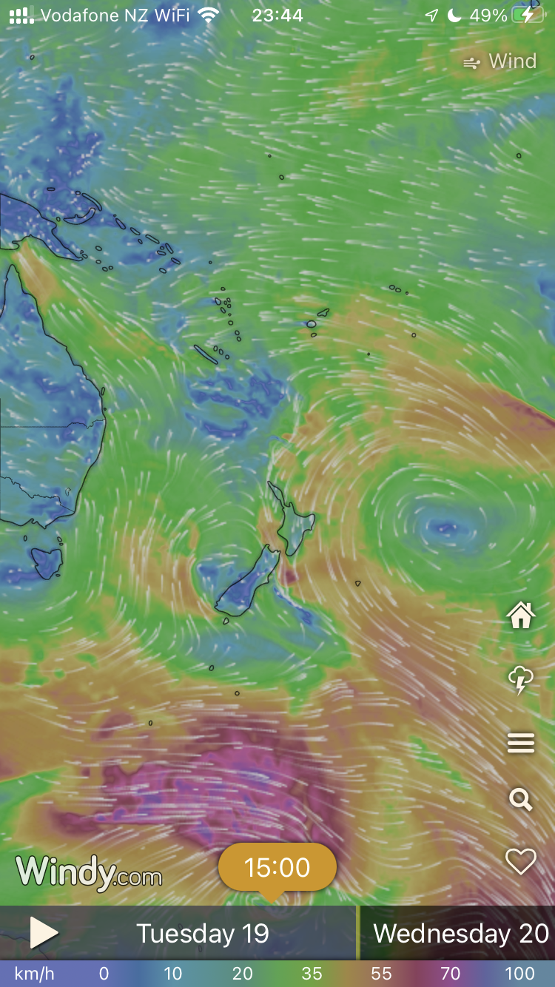
Think about:
- What is needed to make heavy rain come out of the atmosphere
- Wind directions and air temperatures
- The impact of any hills/mountains
- Areas where masses of air are meeting

