Rainfall in Maui vs South Island
By Gerry, Joseph and Mink
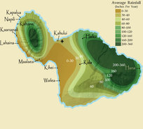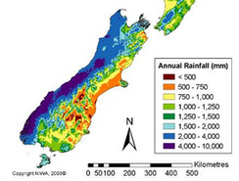
Figure 1: Maui rainfall Figure 2: South Island rainfall

Maui lies in the Northern Hadley cell at a latitude of about 20 degrees. The South Island of New Zealand lies in the Southern Ferrel cell at a latitude of about 40-45 degrees.
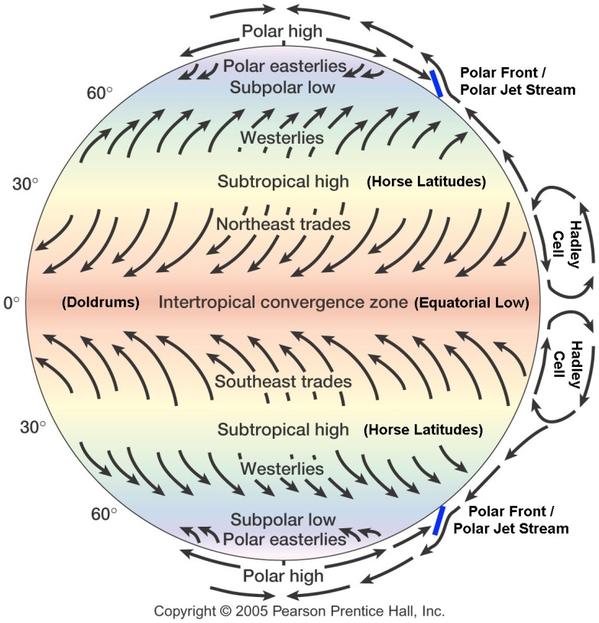
At the equator, solar radiation hits the Earth at a perpendicular angle. This means that the solar radiation is concentrated on a small area, so heats up the Earth and the air above it. There is a lot of ocean at the equator, so this warming evaporates water. This results in warm, moist air at the equator. The warm air particles move faster, so are less dense. This results in warm air at the equator rising, and an area of low pressure. As the air rises, it cools and the water particles condense into droplets and form clouds. The air pushes away from the equator Northwards and Southwards. As the air moves away from the equator, it cools, because the solar radiation strikes the Earth at a more oblique angle, so it is spread over a larger area, and so less concentrated. As it cools it gets more dense, and sinks, resulting in an area of high pressure. This occurs at about 30 degrees latitude North and South. The air at about 30 degrees moves to replace the air rising at the equator, resulting in surface winds. Because the Earth is spinning, the air does not move in a straight line relative to the Earth, resulting in a deflection to the right in the Northern Hemisphere, and left in the Southern Hemisphere. This results in the easterly trade winds. The prevailing winds at Maui would therefore be north-easterlies.
Cold air sinks at the poles, and then rises at about 60 degrees latitude, due to the warmer climate. Some of the air sinking at 30 degrees latitude will move to replace the air rising at 60 degrees latitude. This results in a convection cell. As the air moves along the surface away from the equator, it will deflect to the left in the Southern hemisphere, and to the right in the Northern, due to the coriolis effect. This results in westerly winds between 30 and 60 degrees latitude North and South. These are called Ferrel cells. The South Island of New Zealand lies in the Southern Ferrel cell. Therefore the prevailing winds affecting the South Island are westerly.
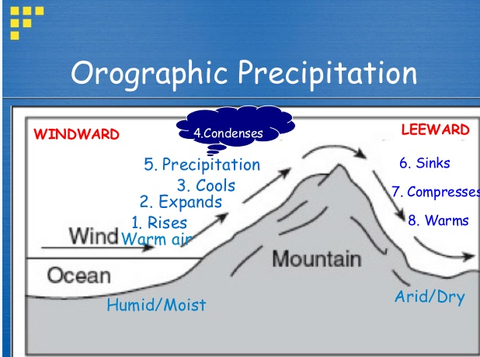
The Southern Alps runs along the West Coast of the South Island of New Zealand. The westerly blow into the Southern Alps. The mountains force the air upwards, because it can’t travel through ground. This is called orographic lifting. The air is moist because it has been travelling over the ocean. As the air rises, the water particles condense into droplets. This results in clouds, and rain. As the air flows down the other side of the mountain, the dry air compresses. As air compresses it heats. This heats the leeward side of the mountain, called adiabatic heating. Therefore, there will be heavier rainfall on the windward side of the Southern Alps, rather than the leeward side.

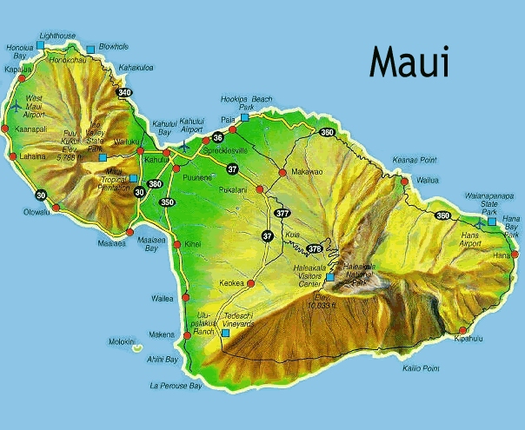
On the right, is an image of the topography of Maui. The north-easterly winds hit the mountains, and are lifted orographically. Like in the South Island, this results in high rainfall windward of the mountains, and low rainfall leeward.
Heavy rainfall occurs to the North-East of the mountains in Maui, while it occurs to the West of the Southern Alps. This is because the prevailing winds come from different directions, because they are in different cells, since they are at different latitudes.

