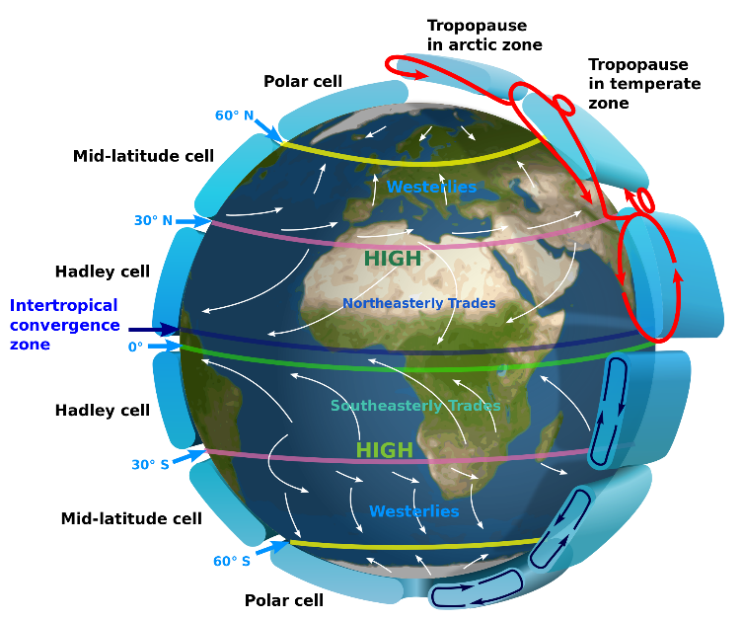
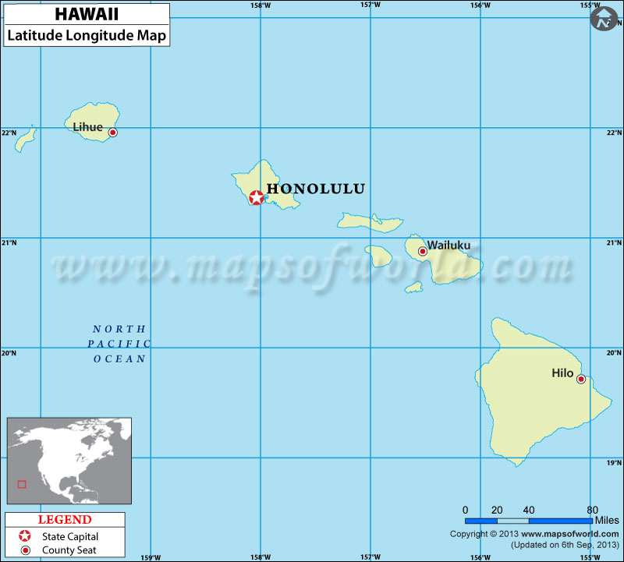
Hawaii is at a latitude of 20 degrees north. Because of this latitude, Hawaii is subject to the Hadley cell!!! At the equator (0degrees) the suns radiation is more directs and therefore heats the air up more. This air rises due to higher energy levels and becoming less dense. This air rises and moves towards 30 degrees where it sinks because it cooled down at higher altitudes and lost its energy. The wind when traveling to replace the rising air is deflected by the corriolis effect to the right. The corriolis effect is the deflections on earth due to the earth’s rotation which is left in the southern hemisphere and to the right in the northern hemisphere. This is the Hadley cell. The Hadley cell in the north and south hemisphere together create the easterly trade winds at the equator. Since the air at 20 degrees is coming from the east, Hawaii is getting hit by easterly winds with water levels pretty high since it travelled over the ocean. Hawaii is causing orographic precipitation. As the easterly approaches MT Haleakala the warm air rises and is lowered in pressure, the air cools since higher altitudes have lower temperatures, and the water condenses into clouds, these clouds rain all over the east coast of the island hence all the green bushes and stuff. When the air goes over the mountain it sinks and it compresses making high pressure warm and dried out air so on the west side of the islands it is all dry and hot. This all happens in the troposphere where all of the earthly weather occurs.

egs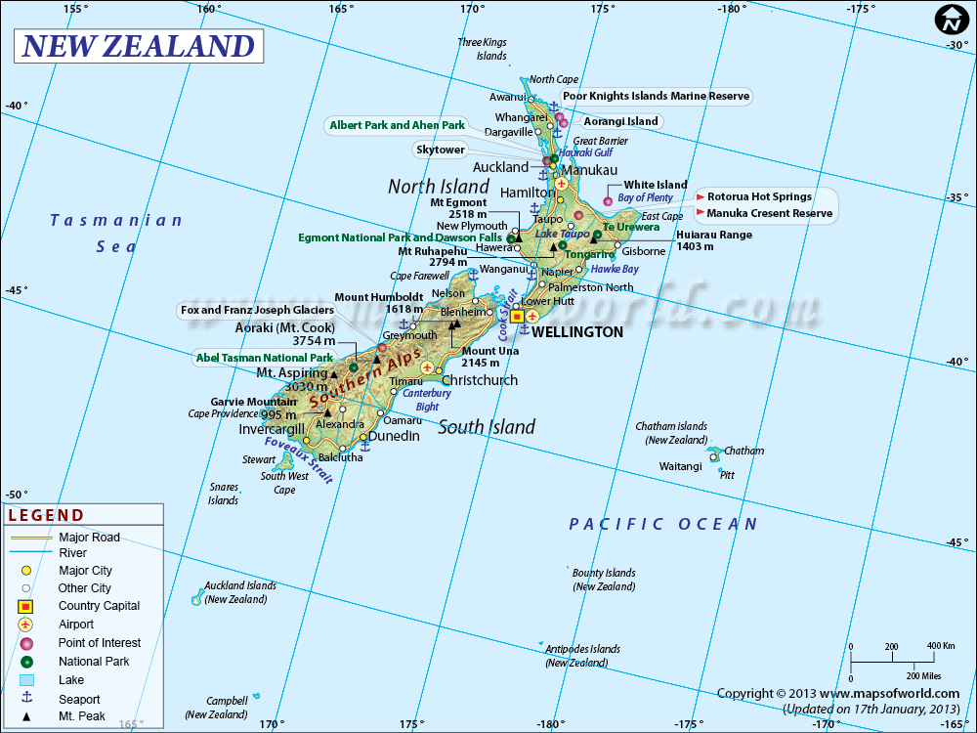
the south island of New Zealand is located in between 40 degrees and 50 degrees south.

Similar to the above explanation, the equator is heated more directly from the sun so hot air rises, it moves away from the equator as it cools in higher altitudes and as it does so it is deflected to the left. It sinks at around 30 degrees north and south and creates the Hadley cell. Some of the sinking Hadley cell air and the rising polar cell air causes an air cell in the latitudes 30 degrees to 60 degrees (where the south island is) that is called the feral cell. Because this cell is made not directly by the sun or lack of sunlight, it is more inconsistent. The wind is deflected to the left in the southern hemisphere so the air currents are westerly’s in NZ. The effect of this wind is similar to Hawaii, the water rich air hits the Southern Alps and it is forced to rise. As the air gets cooler through adiabatic cooling the water condenses into clouds and the Alps and west coast gets a lot of rain, then the air travels off the mountain to the east coast where it is now dry and it has higher pressure so on the east coast it is less wet., SO they are similar in that they both experience orographic lifting that causes the raining, however it is from the east in Hawaii and from the west in south NZ. They are both in difference climate cells, Hawaii in the Hadley and South NZ in the Ferrell cell.
Also, they are both islands surrounded by lots of ocean so the wind that hits the islands is very wet from traveling across the ocean which is why they both experience orographic precipitation.

