Hawaii vs South Island

The island of Maui is located only a few degrees south of the Tropic of Cancer at approximately 20.8 degrees North and 156.3 degrees West. This means that being close to the equator, Maui experiences more solar radiation in which hits the surfaces directly causing warmer temperatures. This places Maui in the center of not only the Hadley cell but also the prevailing Easterly trade winds route. Almost three quarters of the island is made up of the large shield volcano, Haleakala, which rises 3,055m above sea level. Along with the direction and the nature of the Easterly Trade Winds, these two features are what bring over 9m of rain per year to the Northeast coast of Maui.
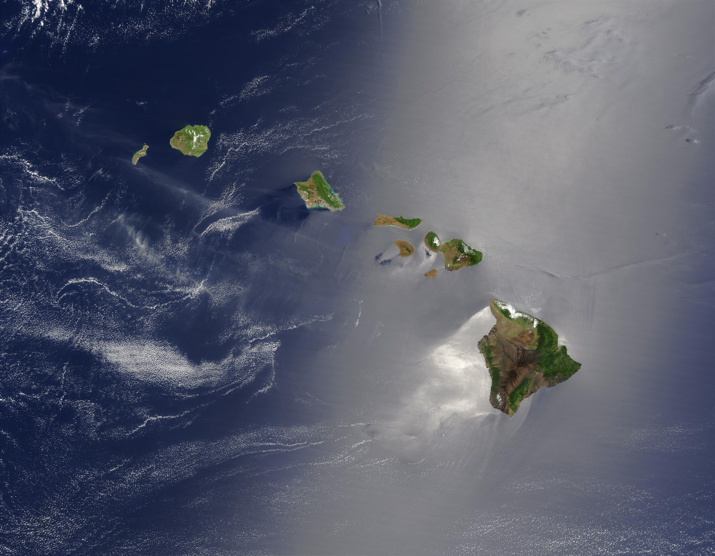
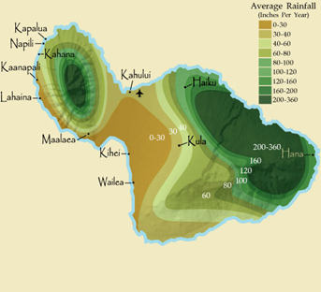
Due to the location within the upper part of the Hadley Cell circulation, warm moist air is consistently travelling over the island of Maui, brought on year round by the prevailing Easterly Trade winds which are powered by the high pressure systems from the downdraft of air cycling downwards from the Hadley circulation and is deflected to the right by the spin of the Earth or the Coriolis Effect. These winds travel across the warm Pacific ocean gathering moisture all the way from the coast of mainland US where the warm moist air reaches Maui and more specifically, Haleakala, and is forced up the mountain side due to orographic lifting in order for the winds to keep travelling westward. The moist air blows up the face of the mountain where due to rapid temperature change the moist air condenses and forms clouds and rain. This means rain often falls in order for the clouds to rise up and over Haleakala and due to the prevailing Easterlies, this Northeast face of the island receives more rain than any other direction meaning it is very green from thriving vegetation due to the warm moist air and consistent rain. This prevailing Easterly wind means that rain mainly comes from the east meaning all other sides of the island receive little rain in comparison, leaving them less abundant, except for occasional times of the year when the trade winds stop and reverse with hot and sticky weathers systems blowing from the Southwest called ‘Kona’ or Leeward bringing hot air and rain from the equator. The trade winds can experience a funnelling effect between the islands of Hawaii, coming from the Northeast, and can increase in speed from 5 upto 20 knots faster than the speeds over the open ocean.

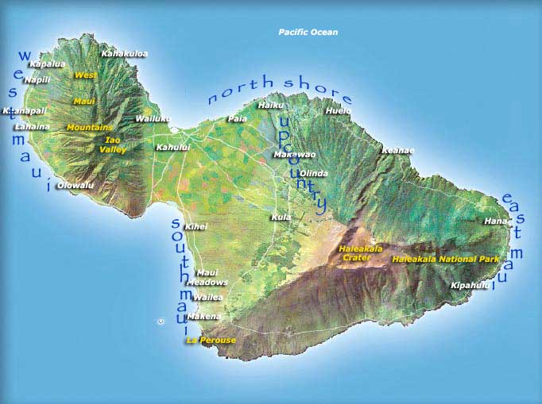
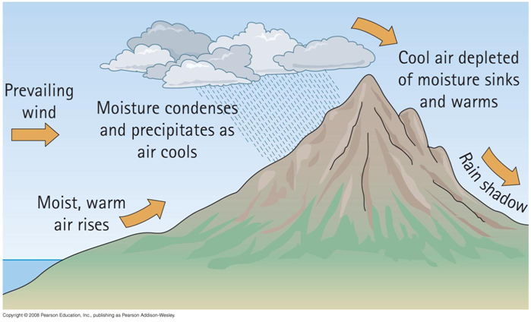

Comparatively, the South Island of New Zealand sees just as much rain, yet is located in an entirely different cell and is located in a different climate zone. The South Island is centered in the middle of the Ferrel cell at approximately 43.9 degrees South and 170 degrees East. The South Island sees up to 10m of rainfall a year which is brought on by the Southwesterly winds bringing cold air up from the subantarctic. The Southern Alps that run along the west coast of the South Island reach upto and over
3000m (Mount Cook among others) all along the coast causing a land barrier for clouds. The weather for the SOuth Island predominately comes from the Southwest bringing cool subantarctic air up picking up moisture as it travels across the South Pacific towards New Zealand. This cool moisture laden air is met by the shelf of the Southern Alps and forced upwards causing rain clouds to form, much the same as Maui, due to rapid temperature decreases condensing the moisture and creating rain. However due to the South Island being located further south at a lower latitude, and having the predominate winds being a Southwesterly, the Southern Alps see snow and cold blast compared to the tropical winds experienced by Maui created by the tropical winds of the Hadley Cell. Solar radiation also hits the South Island and the origin of the weather systems at a more oblique angle meaning that there is less warmth being transferred to the surface and atmosphere.
