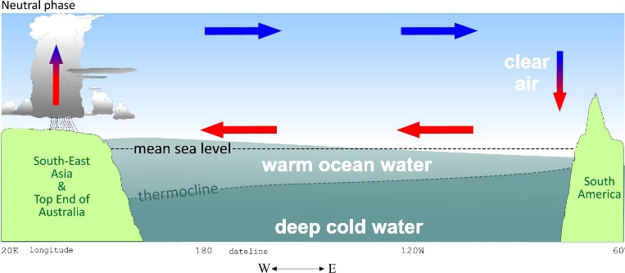 | 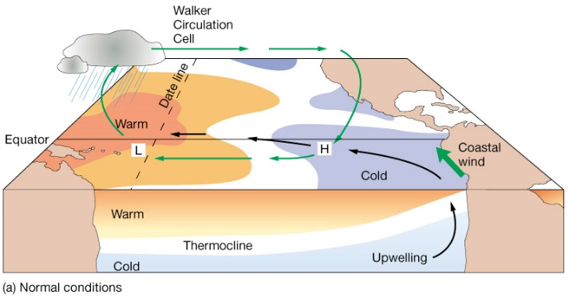
What country is to the West?

What Countries are on the East?

What direction are the hot and cold air moving?

Where is raining?

Describe the areas of low and high pressure

Describe the layers of ocean

Why do you think there is there good fishing in South America in these conditions?

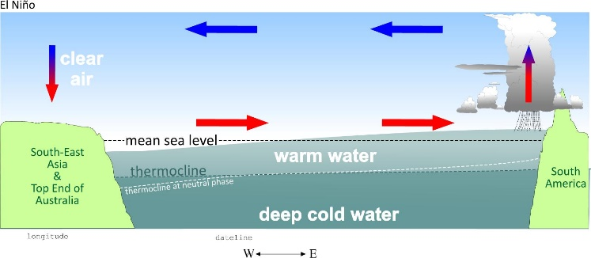 | 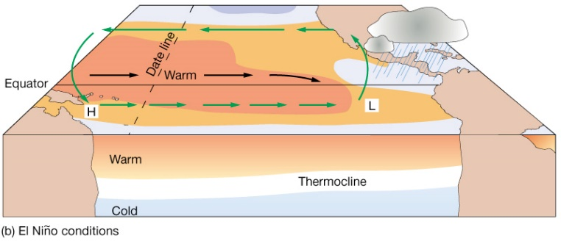
What country is to the West?
What countries are on the East?
What direction is the hot and cold air moving?

Where is raining?

Describe the areas of low and high pressure

Describe the layers of ocean

Why do you think there are high numbers of bush fires in Australia in these conditions?

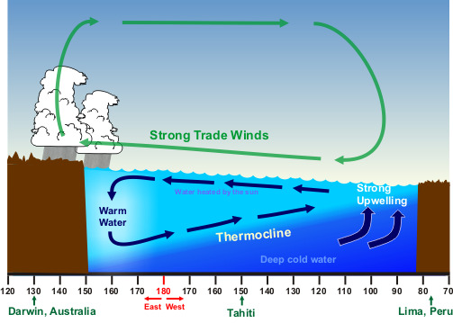 | 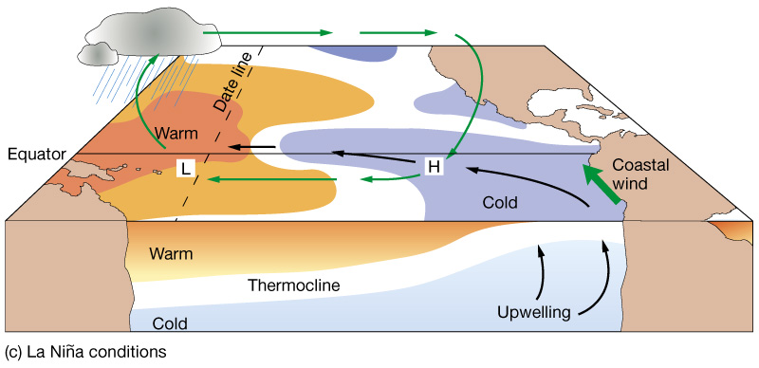
What country is to the West?
What countries are on the East?
What direction is the hot and cold air moving?
Where is raining?

Describe the areas of low and high pressure

Describe the layers of ocean

Why do you think there is an increase in fishing in South America these conditions?

What are the key features of El Nino?  What are the key features of La Nina  What are the key features of normal Southern Oscillation conditions? | Find out about the effects of El Nino  Find out about the effects of La Nina  Find out about the effects of normal Southern Oscillation conditions?
Compare and contrast the Normal, El Nino and La Nina conditions of the Southern Oscillation

