Evolution: Two ideas from the 1800’s
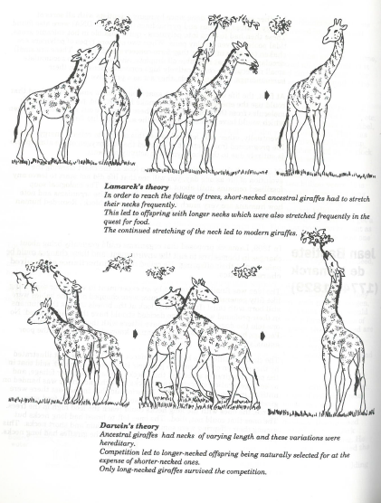

Lamarck’s theory is sometimes called evolution of acquired characteristics. Explain why?
____________________________________________________________________________________________________________________________________________________________________
Lamarck tested his theory by chopping the tails off newborn mice, he did this for many generations. What did he expect to find? ________________________________________________________
Does this happen? _________ Is his idea correct? _____________
Explain how Darwin’s idea was quite different
________________________________________________________________________________________________________________________________________________________________________________________________________________________________________________________________________________________________________________________________________

