Feedbacks
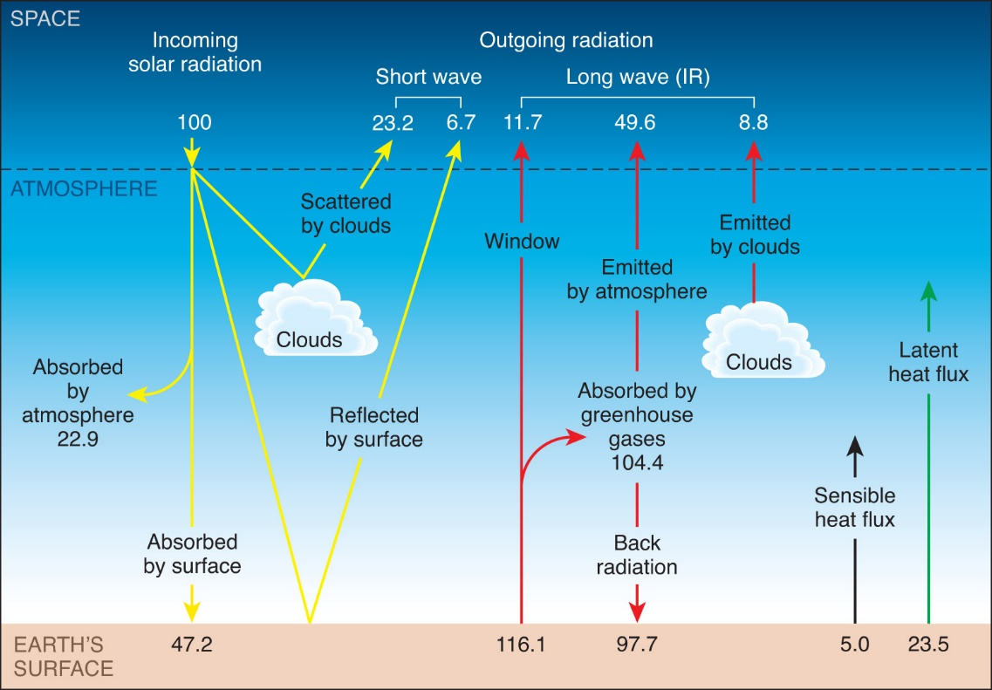

Annoying little ****er
A feedback: Stimulus response impact on the stimulus

Response 1 = slap the noisy little blighter
Stimulus (crying) - response (slap) - stimulus - response (slap more) - stimulus
This is a positive feedback (positive does not mean good )

Response 2 = give the noisy little blighter a pineapple lump
Stimulus response (lolly) stimulus
A negative feedback
Now lets think about climate / temperature feedbacks ?

