**Formative assessment**

[**http://www.youtube.com/watch?v=GCjpHWpTYGA&safe=active**](http://www.youtube.com/watch?v=GCjpHWpTYGA&safe=active)

Task 3 – Write a report

Name:

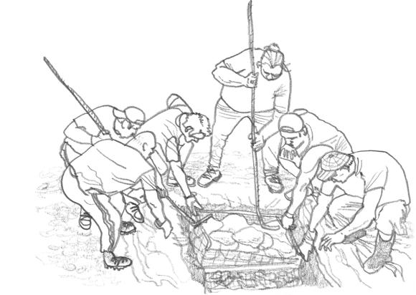When preparing a hāngi people use a variety of methods to ensure a hot temperature so the kai can be cook thoroughly and relatively quickly (4 hours).

**Discuss how the construction of hāngi is designed to generate a high temperature.**

*Primary information (experiment)*

You carried out an experiment relating to the **colour of metals**. Use the information you gathered to explain why silver coloured corrugated iron plates were used around the fire and why the food baskets were lined with tin foil.

*Secondary information (research)*

As you did for the car example in your research, refer to **all 3 heat transfer methods** toexplain how various features of the hāngi can ensure a hot temperature.

*some ideas of things you may refer to:* ***tin foil, type of rock or use of metal bars, type of wood, placement of hot stones or metal bars and kai, blankets, wind breaker, wet sacks or blankets, corrugated iron boards, whole in the ground, silver, black, light colour, emit, absorb, reflect, rise, sink, less or more dense, kinetic (movement) energy, radiation, convection, conduction, solid, liquid, gas, convection current, vibrate…***

more space available if required

<http://www.youtube.com/watch?v=x51IGHxqb1s&safe=active>

Task 3 – Write a report

Name:

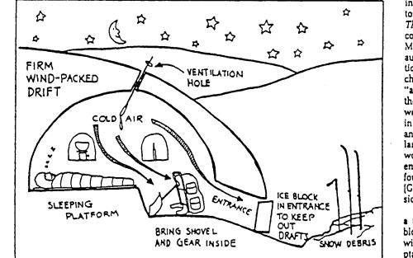When the indigenous people of Greenland and Canada (Inuit) make igloos they use a variety of methods to ensure an inside temperature above freezing. The outside temperature can easily be as low as -20 0C

**Discuss how the construction of the igloo is designed to generate a temperature above freezing.**

*Primary information (experiment)*

You carried out an experiment relating to the **colour of metals**. Use the information you gathered to explain what impact the white colour of the snow has on the temperature inside the igloo. With your knowledge about radiation and colour what would you change about the way the Inuit build their igloos if you had access different coloured snow.

*Secondary information (research)*

As you did for the car example in your research, refer to **all 3 heat transfer methods** toexplain how various features of the igloo can ensure an inside temperature above freezing

*some ideas of things you may refer to:* ***heat source, trapped air, silver, black, light colour, emit, absorb, reflect, rise, sink, less or more dense, kinetic (movement) energy, radiation, convection, conduction, solid, liquid, gas, vibrate, ventilation, convection current, placement of sleeping area, use of fur blankets, sleeping bags…***

more space available if required