Geology: the story of the Earth and its history
Name:
Japan 2011……
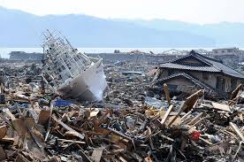
What caused this? ___________________
What caused that? ______________________
What made that happen? ______________________

Christchurch 2011
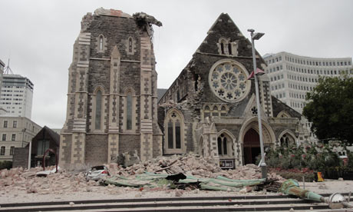
What caused this? ___________________
What made that happen? ______________________

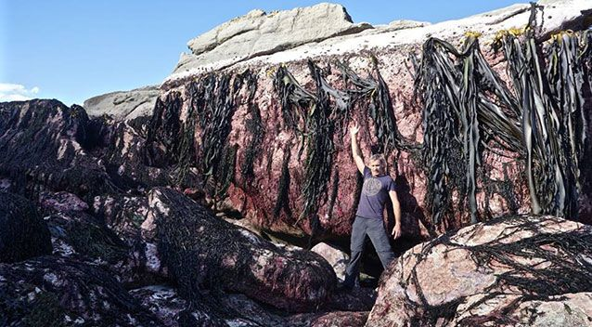
Kaikoura 2016
What caused this? ___________________
What made that happen? ____________________

https://www.youtube.com/watch?v=fRHnoZoIBc8 Sri Lanka 2011

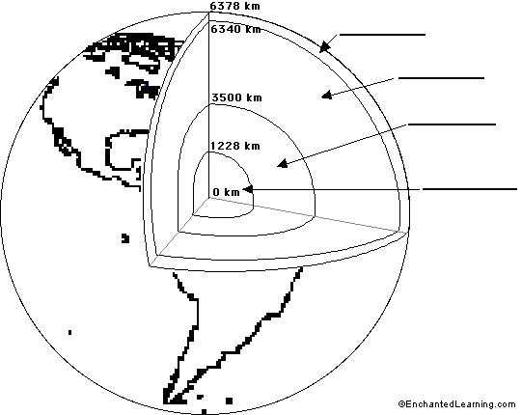

https://www.youtube.com/watch?v=DL3Ez9bxMTo lava lamp
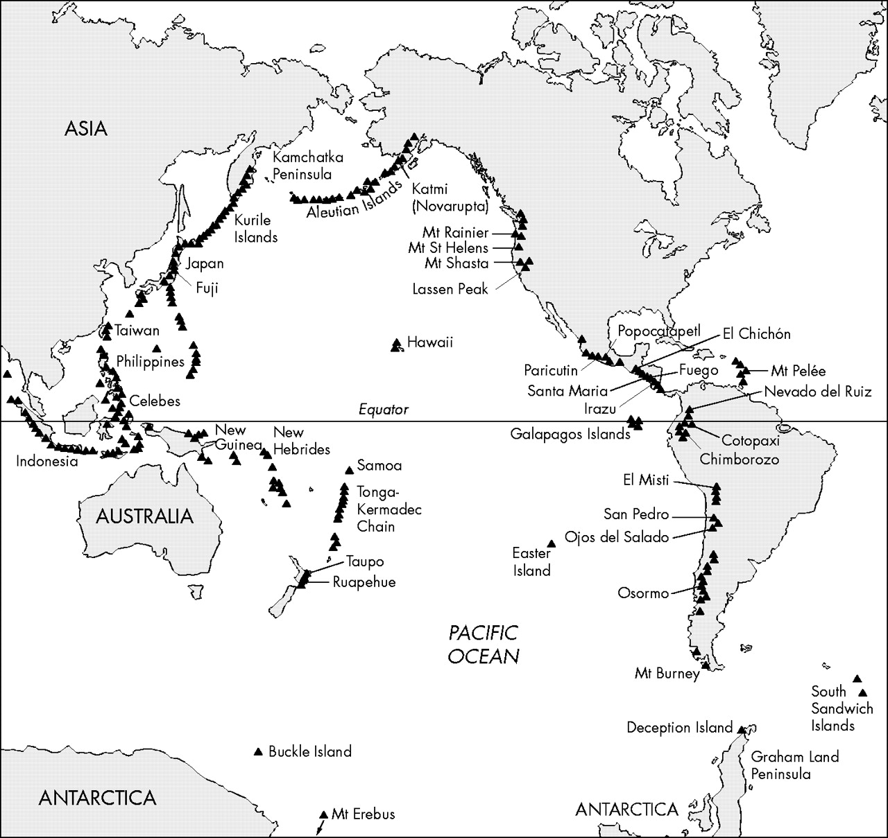
This pattern of volcanoes is called the _________ ___ _________
How can it be explained?

