Biology of Tasman bay
The soft bottom fauna that populate the sediments of Tasman bay in depths of 1-50m are largely bivalves (hinged shell e.g. cockles, mussels and scallops etc) and echinoderms (starfish, sea urchins and sea cucumbers etc).
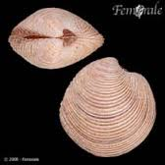
Bivalves are filter feeders that bury themselves in the seafloor and extract food from the bottom layer of water. Suspended (floating) sediment kills bivalves. Bivalve species present within this area include:
- Dosinia lambata
- Nucula nitidula
- Neilo australis
- Maoricolpus roseus
- Gari lineolata
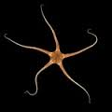
Echinoderms have exoskeletons and tend to be bottom feeders. Echinoderm species present within this area include:
- Amphivra rosea
- Echinocordium cordatum
Pectinaria Australis, a type of sea worm is also found in Tasman bay
Amphipods, small crustaceans are also found in Tasman bay as they are in most aquatic environments
Both Golden and Tasman bays have supported commercial shell fishing in the past but today Flat oysters, green lipped mussels and scallops are in decline in Tasman bay.
Suspended sediment being washed in from the rivers blocks sunlight which kills phytoplankton, the bottom of the food chain in the ocean, thus creating food shortages for scallops, mussels and oysters.

