International Marine Science
At the end of the course students will have:
- Learned about the various seashores in the Nelson area
- Developed an awareness of the impact of people on the marine environment
- Developed data gathering, data processing and research skills
Things we will study may include:
topic | how
Shorebirds of the area | Boat trip, research and report
Mudsnails, periwinkles or similar | Field trip, lab work, data processing and report
Oyster island | Boat trip, field work, research and report
Cable Bay | Field trip, data processing, research and report
Plankton | Field trip and microscope work
Tahuna sand dunes | Field trip, data processing and report
Boulder bank | Field trip, research and report
Salinity | Field trip, lab analysis, data processing and report
Human impacts (Undaria, sediment) | Field trip, research and report
Natives (Godwit, pukeko, whitebait) | Field trip, research and report
Oceanography (waves, currents etc) | Class lessons
Fish and shellfish biology | Class and lab work

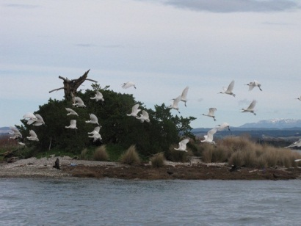 | 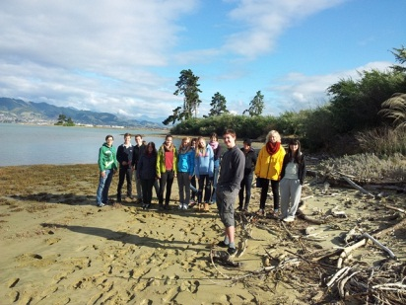 | 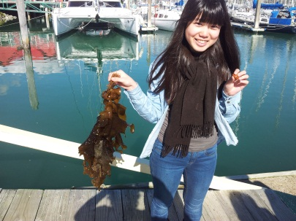
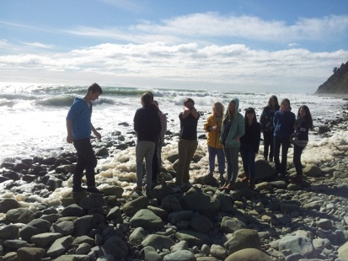 | 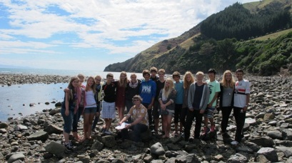 | 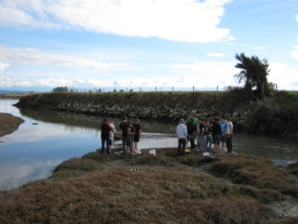
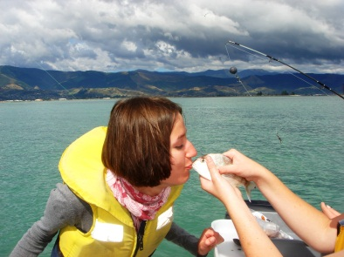 | 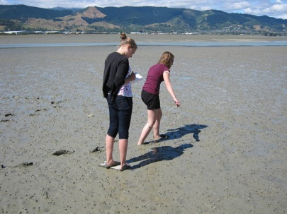 | 