Introduction
The History of fishing and dumping (Trawl, Finfish, dredge spoil and aquaculture)

Tasman Bay has changed a lot , since Humans arrived in New Zealand, but the change has become much faster in recent years due to fishing activity and the dumping of many tons of material every year due to human actions ( like forestry and other projects which make the areas of mountains and rivers more exposed to erosion )
A really big change to the Oceanography of Tasman Bay came through Trawl fishing which always has a lot of by catch every time.
Together with all the other things we do to the environment these factors have a massive negative impact on our environment.

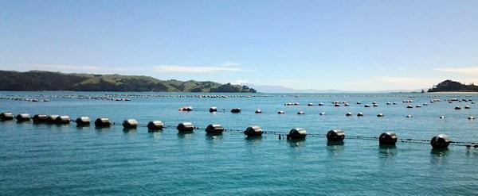
(above: mussel farm)
Aquaculture
Tasman Bay and Golden Bay
Mussel farms have been in place around Golden Bay since 1980, and marine farms have been issued in Tasman Bay in 2004 for spat catching for scallops and mussel spat.
Mussel farms produce debris that falls to the seabed, namely faeces, pseudo-faeces and as well as intact mussels and fouling algae and marine invertebrates. The amount that reaches the seabed and the extent of the ‘footprint’ is dependent on the water depth, current speed and direction, the weight of debris, and farming practises.
What is pseudo-faeces?
Particles rejected by a mollusc (invertebrate animals, eg chitons, gastropods) as unsuitable for food and expelled without passing through the digestive tract.
Dredge Spoil

Dredging is required annually at Port Nelson to maintain depths at berths, basins, channels and entrances in the port area. Dredging occurs at six locations across the port:

• The outer channel (extends from harbour entrance to 1.8 kilometres into Tasman Bay)
• The entrance rocks
• The inner harbour channels
• The Dixon Basin approach channel
• Dixon Basin
• shipping berths

The type of dredge used is predominantly a trailer suction, however, a backhoe dredge is used to excavate rocks and hard material.

Over the past 10 years, Port Nelson Ltd has dredged on average 50,000 cubic metres of material per year. This material is disposed at an approved dump ground in the Tasman Bay, sited approximately 3.5 kilometres west of the harbour entrance.

Although the dredged sediment contains traces of toxins such as metals, pesticides and macrofauna, when dumped into Tasman Bay it disperses rapidly and so the toxicity levels of the bay do not appear to be greatly affected by the spoil.

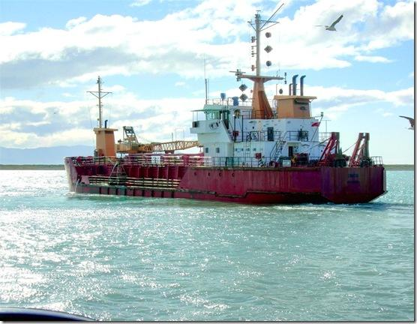

Trawling

Commercial trawling for snapper in Tasman and Golden Bay has occurred since at least 1945, with annual landings recorded in the early 1960’s to be between 500-600 tonnes. Peak catching’s have even exceeded 1,500 tonnes in the mid 1960’s.

Landings of 600 tonnes in 1970 were typical until the Total Allowable Commercial Catch rate or (TACC) increased to 1,000 tonnes with the introduction of bottom trawling in 1972, which led to the decline of the fishery to 500 tonnes by 1975-1976, and kept declining, in 1986 (TACC) was set to 330 tonnes and in 1989 (TACC) was set to 160. The catch rate for the last 5 years has been 175 tonnes and is now currently set at 200 tonnes in 2015.

Bottom Trawling:
Bottom trawling 'strip-mines' the ocean floor – a single pass of huge metal trawl net doors, ropes, and rollers leaves deep gouges in the seabed and scoops up or crushes any creatures in its path, including centuries-old corals that give life, food and shelter to vast numbers of species.
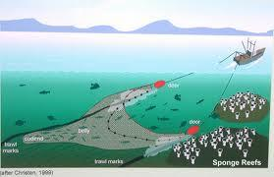
Bottom trawling has its pros also for example it opens the range of species available and can increase
the amount of fish caught.

Mid-water trawling:
Mid-water trawling is towing the trawl through free water above the bottom of the ocean. Mid-water trawling targets fishing such as Tuna, Shrimp & Mackerel.
Benefits of Mid water trawling is that the net is above the sea floor & does not destroy it, like bottom trawling does, the disadvantages are that they can catch non target species like dolphins.
To avoid this, mid-water trawling is done only where their target species live.

