Hawaii v New Zealand
Refer to the maps showing annual rainfall on Maui (Hawaii) and Te Wai Pounamu (NZ)
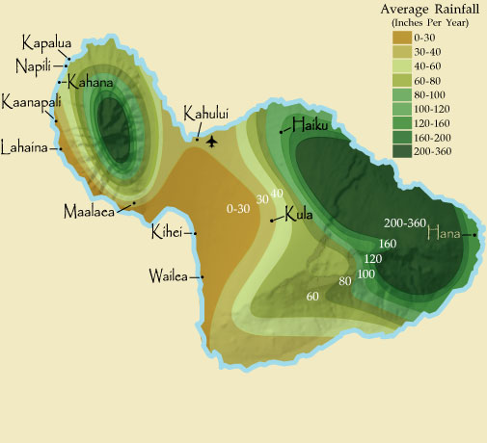
Note: 1 inch = about 25 mm

Mt Haleakala over 3000m high

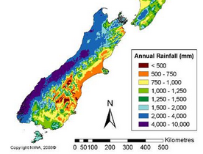
Compare and contrast the rainfall patterns on Maui and Te Wai Pounamu.
You will need to consider:
- The latitude of each island (look it up)
- Any circulation cells of the atmosphere that will affect each island
- Relevant wind belts and the causes of these
- The impact of any mountains (name them)
Include relevant diagrams and the following words:
Ferrel, Hadley, trades, westerlies, orographic, adiabatic, condensing, altitude, latitude, solar radiation, pressure, troposphere, and of course Coriolis

