**Abstract**

Mice are widely distributed introduced rodents and cause great harm to New Zealand native plants and wildlife. Mice compete for resources such as food, shelter and they eat the eggs of some of New Zealand’s smaller endemic birds e.g. piwakawaka. Mice are also a food source for some larger introduced predators e.g. stoats. In 2015 our Year 9 science class went to Oyster island just off Monaco beach to see if it was pest free. After monitoring, using tracking tunnels, we realised mice were a common problem on the island and we thought the population number were high. In 2016 we decided to monitor the mice activity on Oyster Island again to see if the numbers have changed and the possible impacts this may have.

**Background research**

New Zealand is an island filled with unique plants and wildlife, with no previous threats such as rodents. When mice arrived with the first Polynesian settlers, about 1250–1300 AD they very quickly grew in numbers. The effects this had on native wildlife and plants was devastating. Feeding on plants and birds and other wildlife, native species started to die out and rodent numbers continued to grow. Mice eat a wide range of fruit and plants putting them in competition with endemic wildlife for food. Oyster Island is an island that constantly has human contact. People are regularly taking boats to the island, which poses the risk of mice or and rats being on board. At low tide the water gets incredibly low around Oyster Island leaving only a few meters of water between the island and mainland. This becomes a prime time for rodents to swim across to the island. With constant human contact and a population of mice, this has many effects on the island. Mice can be stopped in many ways, poisoning and trapping are easy and effective although there is a lot of controversy about poisoning such as 1080 as there many negative effects such as a carcass of a dead animal is still poisoning until it decomposes which can be deadly for dogs. Many organisations such as Department of Conservation work to stop the growing population of pests in New Zealand. The government has plans to have New Zealand pest free by 2050.

**Research Question**

**Has the mouse population on Oyster Island changed when measured during two different seasons, within a 12 month period?**

Sub questions:

* Has the pest problem of rodents increased or decreased?
* Have specific areas eg 1 and 2 shown an increase in number and activity of rodents?
* Do the seasons affect the mice population?temperature change, rainfall)

**Hypothesis**

We think that the mice numbers will have increased, because of the rate mice breed. It has been nearly a year since we have monitored the numbers of rodents. Mice breed at an incredibly fast rate, in 19 to 20 days they can give birth to 13-14 young. Oyster Island is an island without any trapping or other prevention for mice. Mice populations without control increases rapidly and can be hard to keep down. Oyster Island has a huge food supply for mice with plenty of insects and other food sources. With these prime conditions we think we will see dramatic changes in the activity of mice on Oyster Island.

**Procedure**

**Step 1**- Go to Oyster Island by either kayak or boat. Ensure that you have checked the tides and take all necessary safety precautions.

**Step 2**- Use the map below to identify the areas where you need to place your tracking tunnels.

**Step 3**- Place the tracking tunnels and cards in Area 1&2, you will need to place them 15-20 meters inland. Putting them in a place that is sheltered and surrounded by grass/bush is best

**Step 4**- Open the tracking card and place one teaspoon of peanut butter in the middle of it. Now slide the tracking card into the tunnel and place back in the sheltered place.

**Step 5**- Repeat with area 3&4, 5&6, 7&8.

**Step 6**- leave the cards out for 20-24 hours.

**Step 7**- Go back to Oyster Island remembering to take all necessary safety precautions.

**Step 8**- Start at area 1&2, pull the tracking card out of the tracking tunnel. Remove excess peanut butter, fold the card and put it in a clean plastic bag.

**Step 9**- Repeat this in area 3&4 5&6 7&8

**Step 10**- To analyse the data you will need to the individual tracks and estimate how many mice tracked across the cards.

**Step 11**- Calculate the average of each area and Compare the data from previous seasons and look at how the mice population has changed.

**Conclusion**

After analysing our data we have seen changes in the mice population on Oyster Island. In a total estimate the mice population has gone from 37 sets of prints to 63 sets of prints (mice) Within 8 months. Due to the rate mice breed we think the population will have increased. However mice move a lot so these could the same few mice moving around the island searching for more food and entering our tracking tunnels. We have seen a large change in areas 3,4 and 7,8 this could be due to the dense bush areas they were placed. Mice have territories but usually move in groups, they move depending on seasons, food source, weather and areas changing eg,trees being chopped down. Last year when we tracked mice in early summer, areas 1,2 had large numbers of mice but this year in mid-winter both tracking cards had 0 prints. This could also be due to the surrounding area changing. Numbers have most likely increased due to the lack of trapping on Oyster Island since we don't know the numbers of other pests on the island which could also be prey and with a great food source this could be a prime place for mice to thrive

**Further questions or other things to investigate.**

We found out a lot of interesting and beneficial things during this science experiment. Many things that we think will be helpful to the community. To further investigate this topic we would like to look at other pests on Oyster Island and how they are affecting the island. To monitor other pests on the island we would need to set up tracking tunnels, this time with pieces of meat instead of peanut butter. This would allow us to monitor pests such as stoats. We have already set tracking tunnels and there has been no evidence of rats we also have trapping on the island and have caught one stoat. We would also like to look into the effects pests have on each other and how they aid each other in survival. Another interesting thing we would like to continue is setting up tracking tunnels during different seasons of the year and looking at how seasons affect mice population. Over the summer we plan to contact Nelmac and work closely with them. Nelmac regularly trap rodents on Oyster Island we think it will be effective to send nelmac our data as it will help with. We haven't moved our traps but setting up more tracking tunnels with the intentions of tracking stoats we would be able to move our traps to the most populated areas. As there are no forms of population control for mice on Oyster Island at the moment, we think it is necessary that there is a plan put in place to help control the mice population.

|  |  |  |
| --- | --- | --- |
| Table of raw data showing the mice populations of oyster island at different times of the year | | |
| Location of tracking tunnel | Number of mice footprints within a tracking tunnel | |
| Date: 2 November 2015 | Date: 5 August 2016 |
| 1 | 12 sets of prints | 0 sets of prints |
| 2 | 11 sets of prints | 0 sets of prints |
| 3 | 0 sets of prints | 12 sets of prints |
| 4 | 1 set of prints | 13 sets of prints |
| 5 | 5 sets of prints | 7 sets of prints |
| 6 | 8 sets of prints | 8 sets of prints |
| 7 | 0 sets of prints | 8 sets of prints |
| 8 | 0 sets of prints | 15 sets of prints |
| Total | 37 sets of prints | 15 sets of prints |

|  |  |  |
| --- | --- | --- |
| Table of processed data showing the mice populations of oyster island at different times of the year | | |
| Location of areas where tracking tunnel were placed | Average number of mice footprints within a tracking tunnel | |
| Date: 2 November 2015 | Date: 5 August 2016 |
| 1,2 | 11.5 | 0.0 |
| 3,4 | 0.5 | 12.5 |
| 5,6 | 6.5 | 7.5 |
| 7,8 | 0.0 | 11.5 |

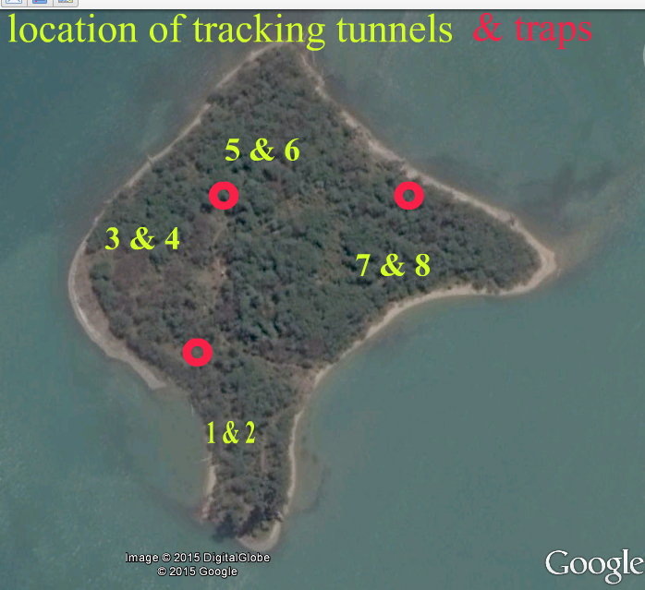 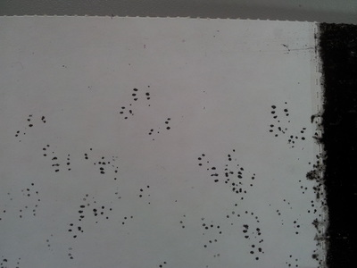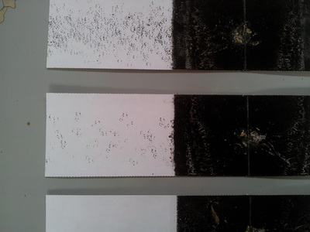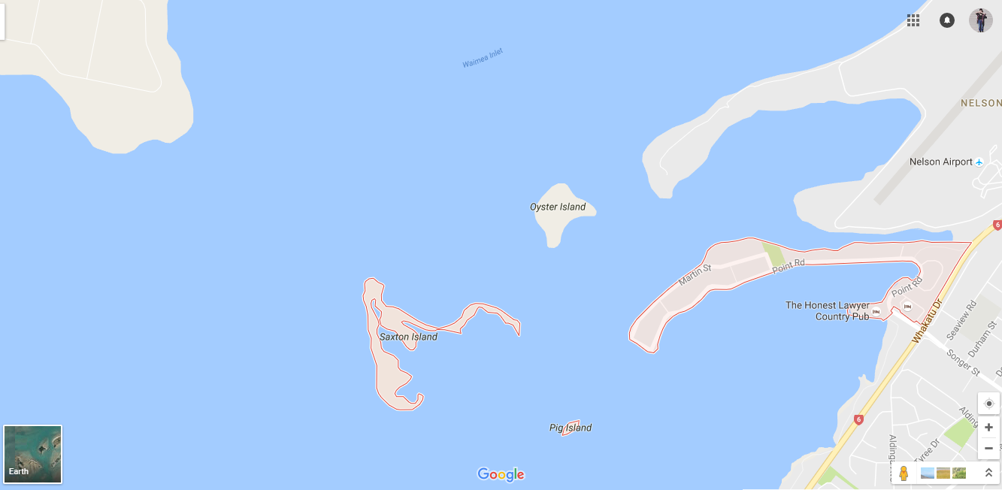 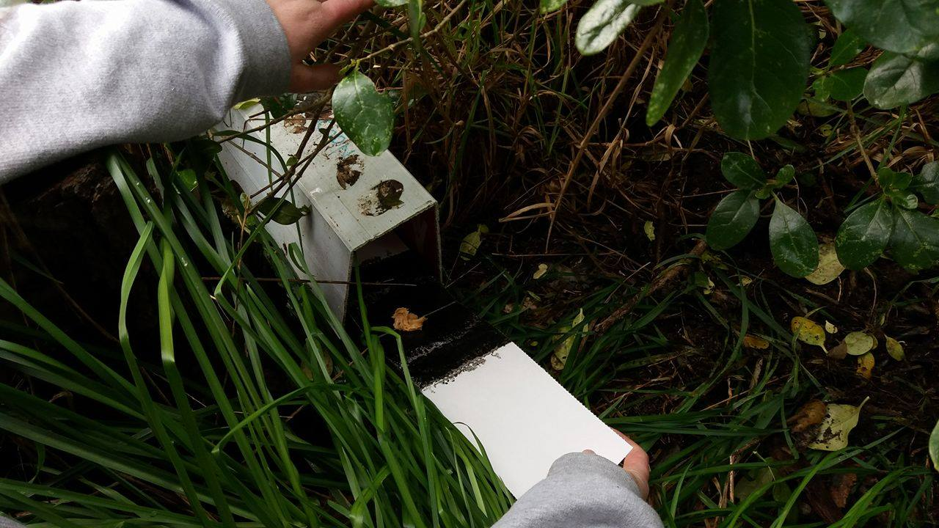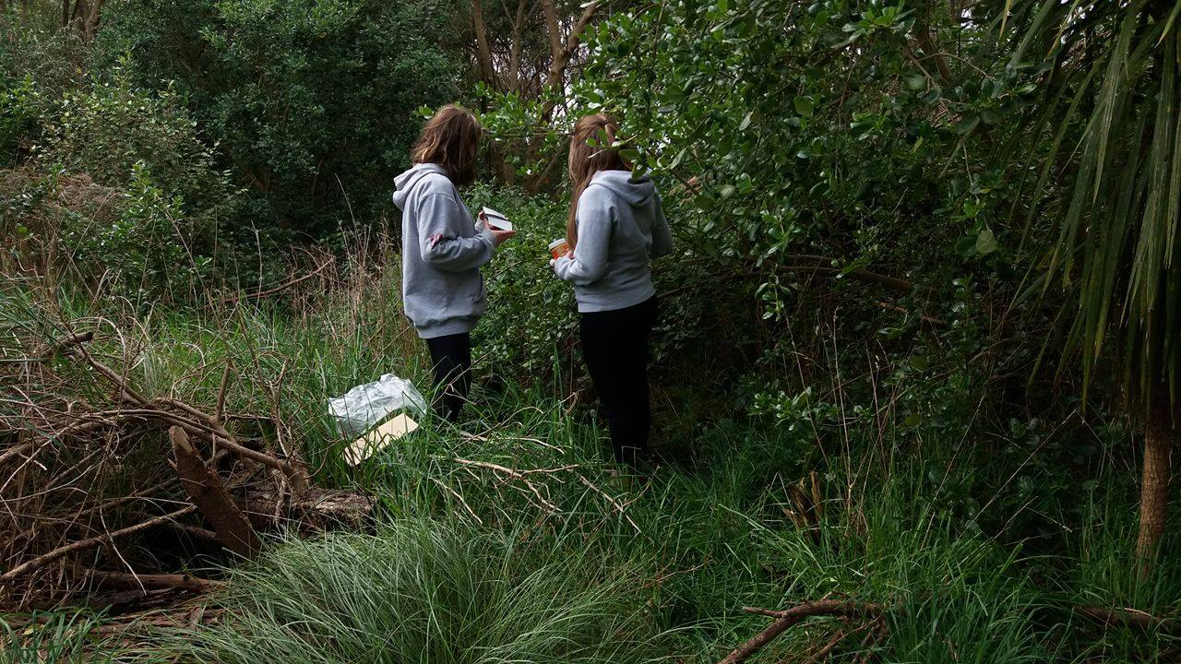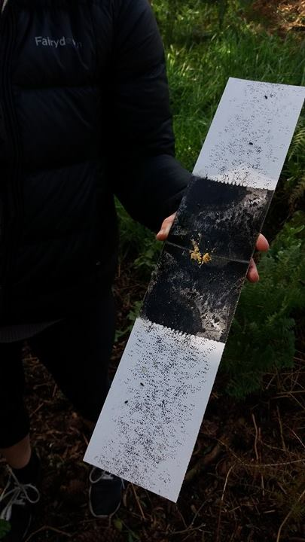

**References**

**Abstract**

**Hypothesis**

-Mice breeding pattern - <https://www.med.umich.edu/tamc/breed.html> (By Analyzing Gene Expression on a C57BL/6 Background,. "Misc." *Misc*. N.p., n.d. Web. 15 Sept. 2016.)

**Background research**

* How Mice got to new zealand - <http://www.teara.govt.nz/en/introduced-animal-pests/page-3> (Brockie, Bob. "Te Ara Encyclopedia of New Zealand." *New Zealand Ministry for Culture and Heritage Te Manatu Taonga*. Ministry for Culture and Heritage Te Manatu Taonga, n.d. Web. 15 Sept. 2016.)
* New zealand pest free - <http://www.stuff.co.nz/environment/82454116/government-sets-target-to-make-new-zealand-predatorfree-by-2050>

- poisoning and trapping are easy and effective although there is a lot of controversy about poisoning such as 1080 as there many negative effects such as a carcass of a dead animal is still poisoning until it decomposes which can be incradiny deadly for dogs, an estimated 20,000 deer are poisoned by 1080 each year - <http://ban1080.co.nz/1080-facts/>

**Equipment**

-All photos by olivia Williams and Mia Faulkner

**Procedure**

Map - google maps

Labeled Map - Bloomscool ("Bloomscool." *Bloomscool*. N.p., n.d. Web. 12 Sept. 2016)

Photos - all photos by Olivia williams and Mia Faulkner

**Answer**

Mice moving - Ian faulkner

**Further**

To monitor other pests on the island we would need to set up tracking tunnels, this time with pieces of meat instead of peanut butter. - Graham bloomfield (bloomscool)

`xx`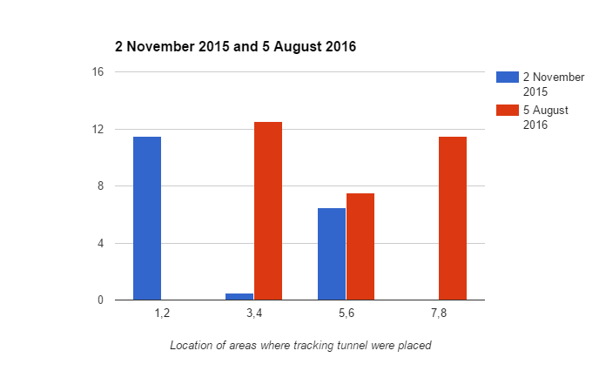

xx