Mt Pinatubo (1991) …… you aerosol
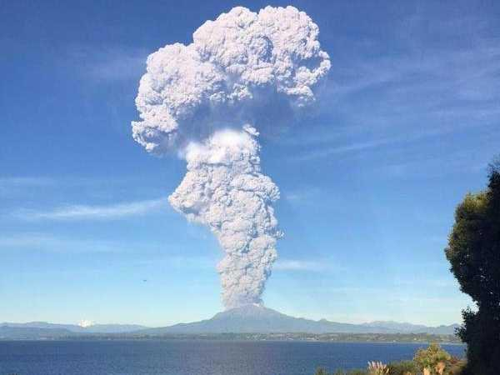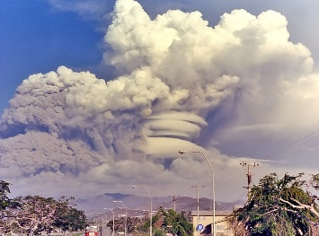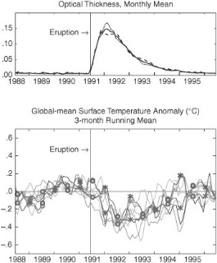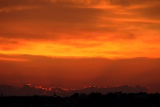

Height, material, dispersal, albedo, spectacular sunsets in NZ , impact on global climate, (also what was “the year without summer”)
[AND coz I put ya crook the other day…. Low clouds have a net cooling effect coz they thick and reflect lots solar radiation, and they absorb (greenhouse effect) and then emit heat up into space as well ]

