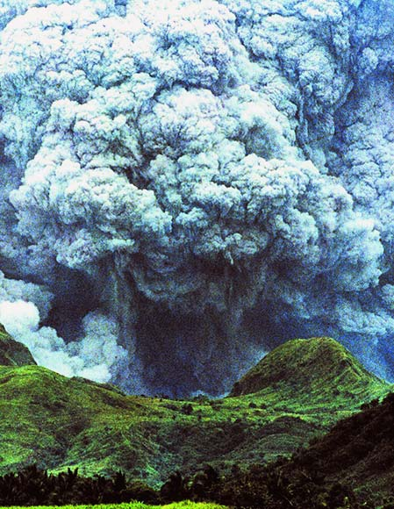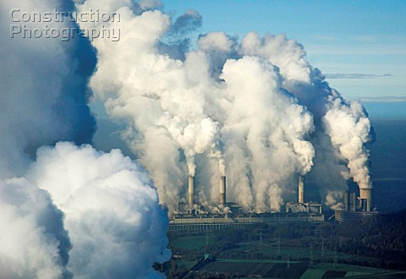
Climate Change
Mt Pinatubo eruption Coal fired power station
Discuss the impact of these two events on global climate.
Consider:
- material / gases produced, where in the atmosphere these end up (short and long term)
- the effect on incoming and outgoing radiation
- the impact on other gases (eg water) in the atmosphere and the impact of this on atmospheric temperature
- the length of time involved.
Support your answer with diagrams, graphs

