NAME TEACHER
NQA
Nayland Qualification Authority

Level Two Biology, 2013

91156 : Demonstrate understanding of life processes at the cellular level
Credits: 4

Suggested Time: 70 minutes

Instructions
- Answer all questions in the spaces provided.
- You must hand this examination paper to the supervisor at the end of the examination.
- Check that this paper has all 10 pages numbered and in the correct order.

Achievement Criteria. (for assessors only)
Achievement |  | Achievement  with Merit |  | Achievement  with Excellence
Demonstrate understanding of life processes at the cellular level |  | Demonstrate in-depth understanding of life processes at the cellular level |  | Demonstrate comprehensive understanding of life processes at the cellular level
Overall Level of performance:

No © Nayland Qualifications Authority, 2013
No rights reserved. Any part of this publication may be reproduced by any means without the prior permission of Graeme or Jeff or our little boss Treena or our big boss Rex, ….after all… it’s all about learning!

Question 1 DNA structure and replication

- DNA is a double-stranded molecule. The diagram below shows ONE strand.
Complete the diagram by drawing the second or complementary strand.
In your diagram you should also indicate and label connections between the two strands.
T
A
G
C

Existing Strand

- An essential property of DNA is its ability to produce exact copies of itself. The diagram below outlines the process of DNA self-replication.
In the spaces provided, describe what is happening at the points labelled i and ii.
i. __________________________________

____________________________________

ii. __________________________________

____________________________________

pre-existing strand

newly synthesised strand

available free nucleotides

- The process of DNA self-replication can be described as ‘semi-conservative’

Describe the meaning of this term AND evaluate its significance.

________________________________________________________________________

________________________________________________________________________

________________________________________________________________________

________________________________________________________________________

________________________________________________________________________

________________________________________________________________________

________________________________________________________________________

________________________________________________________________________

________________________________________________________________________

________________________________________________________________________

________________________________________________________________________

________________________________________________________________________

________________________________________________________________________

________________________________________________________________________

DNA replication produces new copies of DNA. These are produced prior to cell division (mitosis). Cells divide regularly in a series of repeated steps.

- Discuss the reasons cells divide.

________________________________________________________________________

________________________________________________________________________

________________________________________________________________________

________________________________________________________________________

________________________________________________________________________

________________________________________________________________________

________________________________________________________________________

________________________________________________________________________

________________________________________________________________________

________________________________________________________________________

________________________________________________________________________

________________________________________________________________________

________________________________________________________________________

________________________________________________________________________

________________________________________________________________________

________________________________________________________________________

________________________________________________________________________

________________________________________________________________________

________________________________________________________________________

________________________________________________________________________

________________________________________________________________________

________________________________________________________________________

________________________________________________________________________

________________________________________________________________________

________________________________________________________________________

Question 2 Enzymes

Enzymes are vital in many cell processes. However, enzymes can be affected by various environmental factors with detrimental effects on cell activity.

Discuss the effect of two of the environmental factors
In you answer, you should:
- use the graph axes to show how the factors you have chosen affect enzyme action. In the space below each graph, indicate which environmental factor you are describing.
- explain how each of the factors has the effect you have described in your graph
- consider the implications of the effect of the two environmental factors you have chosen.

Enzyme activity (rate of reaction) |  | Enzyme activity (rate of reaction)
 | Environmental factor |  | Environmental factor

________________________________________________________________________

________________________________________________________________________

________________________________________________________________________

________________________________________________________________________

________________________________________________________________________

________________________________________________________________________

________________________________________________________________________

________________________________________________________________________

________________________________________________________________________

________________________________________________________________________

________________________________________________________________________

________________________________________________________________________

________________________________________________________________________

________________________________________________________________________

________________________________________________________________________

________________________________________________________________________

________________________________________________________________________

________________________________________________________________________

________________________________________________________________________

________________________________________________________________________

________________________________________________________________________

________________________________________________________________________

________________________________________________________________________

________________________________________________________________________

________________________________________________________________________

________________________________________________________________________

________________________________________________________________________

________________________________________________________________________

________________________________________________________________________

________________________________________________________________________

Question 3 Osmosis and Plasmolysis

A. | 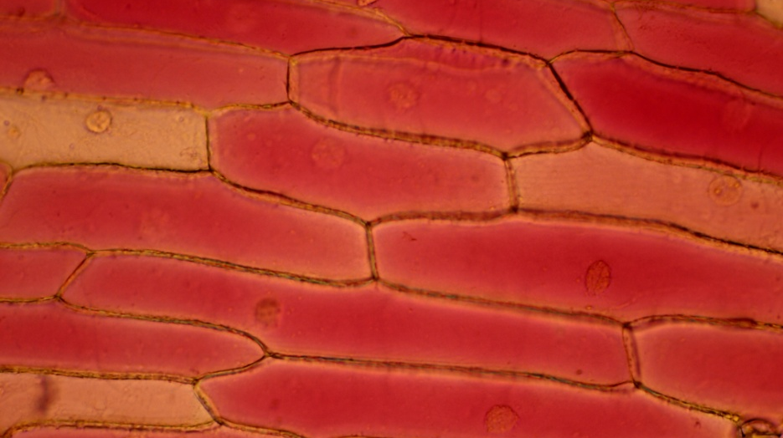 | Both of these photographs are of cells in the epidermal layer of a red onion. The cells contain a red pigment in their cytoplasm.  A shows cells in fresh water  B shows the effects of placing the cells in salt water  Cell parts visible in the photographs include:  - cell wall  - cell membrane  - cytoplasm  - nuclei
B. | 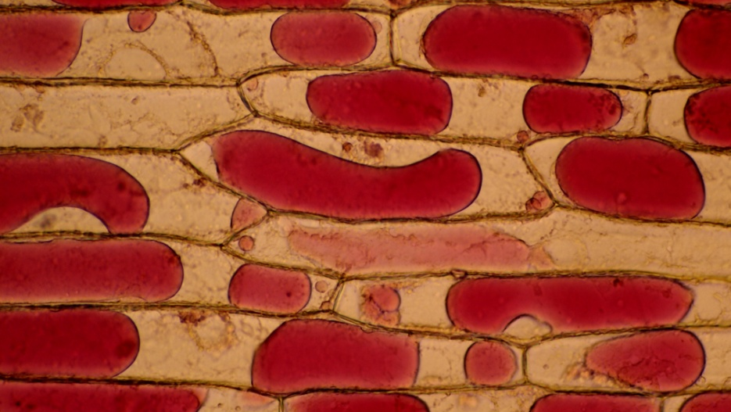

Discuss the role of the cell membrane in the process of osmosis as seen in the photos.
In your answer, you should:
- describe the observed changes in the cell membrane
- explain the mechanism of these changes, consider whether it is active or passive
- elaborate on the role of the cell membrane in this process.

________________________________________________________________________

________________________________________________________________________

________________________________________________________________________

________________________________________________________________________

________________________________________________________________________

________________________________________________________________________

________________________________________________________________________

________________________________________________________________________

________________________________________________________________________

________________________________________________________________________

________________________________________________________________________

________________________________________________________________________

________________________________________________________________________

________________________________________________________________________

________________________________________________________________________

________________________________________________________________________

________________________________________________________________________

________________________________________________________________________

________________________________________________________________________

________________________________________________________________________

________________________________________________________________________

________________________________________________________________________

________________________________________________________________________

________________________________________________________________________

________________________________________________________________________

________________________________________________________________________

________________________________________________________________________

________________________________________________________________________

________________________________________________________________________

________________________________________________________________________

Question 4 Aspects of Photosynthesis

In leafy plants the tissues responsible for photosynthesis are found in two layers within the leaf. Both types of cell contain green chloroplasts.
The photographs below show the two cell types.
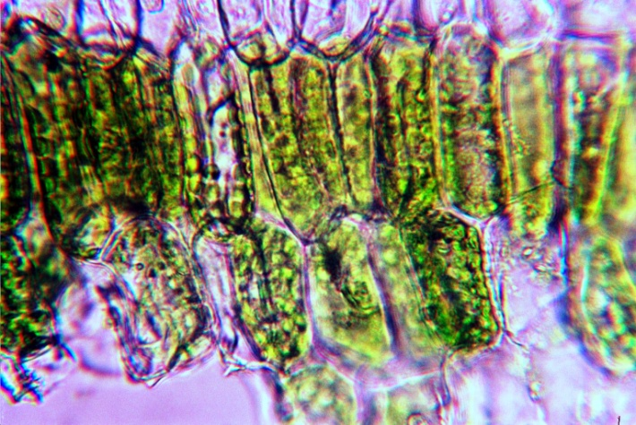 |  | 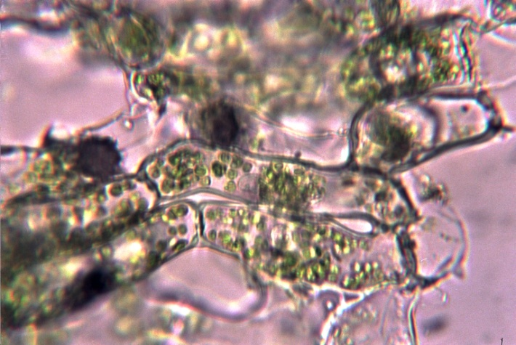
Pallisade mesophyll cells are found in the upper half of the leaf. They are upright and perpendicular to the leaf surface. |  | Spongy mesophyll cells are found in the lower half of the leaf. They have irregular shapes.
- Discuss the TWO life processes (photosynthesis and gas exchange) that these cells perform and relate the structure of these TWO types of cells to these functions.
In your discussion you should:
- analyse the overall shape of the cells
- the organelles they contain with respect to the requirements for photosynthesis.
- how would these cells appear in plants growing in conditions of low light

________________________________________________________________________

________________________________________________________________________

________________________________________________________________________

________________________________________________________________________

________________________________________________________________________

________________________________________________________________________

________________________________________________________________________

________________________________________________________________________

________________________________________________________________________

________________________________________________________________________

________________________________________________________________________

________________________________________________________________________

________________________________________________________________________

________________________________________________________________________

________________________________________________________________________

________________________________________________________________________

________________________________________________________________________

________________________________________________________________________

________________________________________________________________________

________________________________________________________________________

________________________________________________________________________

________________________________________________________________________

________________________________________________________________________

________________________________________________________________________

________________________________________________________________________

________________________________________________________________________

________________________________________________________________________

________________________________________________________________________

________________________________________________________________________

________________________________________________________________________

________________________________________________________________________

________________________________________________________________________

________________________________________________________________________

________________________________________________________________________

________________________________________________________________________

________________________________________________________________________

________________________________________________________________________

________________________________________________________________________

________________________________________________________________________

________________________________________________________________________

