NAME TEACHER

NQA
Nayland Qualification Authority

Level two Biology, 2013

91157: Demonstrate understanding of genetic
variation and change
Credits: 4

Suggested Time: 70 minutes

Instructions
- Answer all questions in the spaces provided.
- You must hand this examination paper to the supervisor at the end of the examination.
- Check that this paper has all 12 pages numbered and in the correct order.

Achievement Criteria. (for assessors only)
Achievement |  | Achievement  with Merit |  | Achievement  with Excellence
Demonstrate understanding of genetic variation and change |  | Demonstrate in-depth understanding of genetic variation and change |  | Demonstrate comprehensive understanding of genetic variation and change.
Overall Level of performance:

No © Nayland Qualifications Authority, 2013
No rights reserved. Any part of this publication may be reproduced by any means without the prior permission of Graeme or Jeff or our little boss Treena or our big boss Rex, ….after all… it’s all about learning!

Question 1 Sea lions and Tuatara  The New Zealand Sea lion is the rarest Sea lion in the world. Once widespread along the coastal shores of New Zealand, they are now found mainly in New Zealand’s sub-Antarctic islands. Sea lion numbers reduced dramatically in the 1900’s and only about 10,000 individuals remain today. Sea lion pup production has declined by 40% over the last decade.  The northern tuatara is a native reptile of New Zealand. Like the New Zealand Sea lion, Tuatara were once common on the mainland, but now are found on only 32 offshore islands.  In 2007, a small number (130) were taken from one offshore island to the predator-free Karori Wildlife Sanctuary in Wellington, to establish a new population.  Both photos: www.doc.govt.nz | 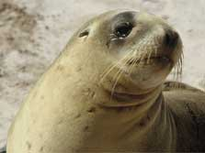  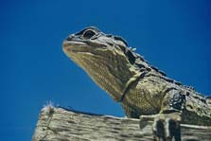

Using the examples above, explain the effect of a population bottleneck and the
founder effect, and relate this to genetic drift.
Using the Tuatara as an example describe how the effect of genetic drift can be
minimised and evaluate the effectiveness of any methods you describe.

________________________________________________________________________

________________________________________________________________________

________________________________________________________________________

________________________________________________________________________

________________________________________________________________________

________________________________________________________________________

________________________________________________________________________

________________________________________________________________________

________________________________________________________________________
More space on next page.

________________________________________________________________________

________________________________________________________________________

________________________________________________________________________

________________________________________________________________________

________________________________________________________________________

________________________________________________________________________

________________________________________________________________________

________________________________________________________________________

________________________________________________________________________

________________________________________________________________________

________________________________________________________________________

________________________________________________________________________

________________________________________________________________________

________________________________________________________________________

________________________________________________________________________

________________________________________________________________________

________________________________________________________________________

________________________________________________________________________

________________________________________________________________________

________________________________________________________________________

________________________________________________________________________

________________________________________________________________________

________________________________________________________________________

________________________________________________________________________

________________________________________________________________________

Question 2 Genetic variation

There are 4 blood groups in humans, shown in the table.  These are determined by 3 alleles I^{A}, I^{B} or i. This is an example of a multiple allele system. | Blood group (phenotypes) | Possible genotypes
 | O | i i
 | A | I^{A} I^{A} or I^{A} i
 | B | I^{B} I^{B} or I^{B} i
 | AB | I^{A} I^{B}

Alleles I^{A} and I^{B} are co-dominant. Both I^{A} and I^{B} alleles are dominant to allele i. Allele i is recessive.

- Explain what is meant by the term co-dominance. Use blood groups in your explanation and distinguish co-dominant alleles from alleles that can be described as having Incomplete dominance

________________________________________________________________________

________________________________________________________________________

________________________________________________________________________

________________________________________________________________________

________________________________________________________________________

________________________________________________________________________

________________________________________________________________________

________________________________________________________________________

________________________________________________________________________

________________________________________________________________________

________________________________________________________________________

________________________________________________________________________

________________________________________________________________________

________________________________________________________________________

- A woman with blood group type B, whose mother was type O, marries a type O man. What are the possible phenotypic ratios of their offspring? Explain how you determined this.

Diagram space:

________________________________________________________________________

________________________________________________________________________

________________________________________________________________________

________________________________________________________________________

________________________________________________________________________

________________________________________________________________________

________________________________________________________________________

________________________________________________________________________

________________________________________________________________________

________________________________________________________________________

________________________________________________________________________

________________________________________________________________________

________________________________________________________________________

________________________________________________________________________

________________________________________________________________________

Meiosis is a type of cell division that results in the production of gametes.
Discuss how the processes that occur during meiosis AND fertilisation lead to genetic variation.
________________________________________________________________________

________________________________________________________________________

________________________________________________________________________

________________________________________________________________________

________________________________________________________________________

________________________________________________________________________

________________________________________________________________________

________________________________________________________________________

________________________________________________________________________

________________________________________________________________________

________________________________________________________________________

________________________________________________________________________

________________________________________________________________________

________________________________________________________________________

________________________________________________________________________

________________________________________________________________________

________________________________________________________________________

________________________________________________________________________

________________________________________________________________________

Question 3 Tail-less felines  Manx cats are born with no tails. This is caused by a mutation in a gene required for normal spinal development,  The tailless Manx condition is produced by the heterozygous genotype (Tt).  Cats with normal tails are genotype tt.  Kittens homozygous for the T allele die before birth as a result of spinal defects and central nervous system abnormalities.  - Define the term ‘mutation’. | 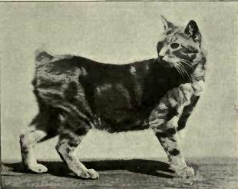  http://commons.wikimedia.org/wiki/File:Manx_by_  Gambier_Bolton.JPG

________________________________________________________________________

________________________________________________________________________

________________________________________________________________________

- Two Manx cats are mated. Give the expected phenotype ratio of the kittens and explain how you got this. You could use a punnet square to support your answer.

Phenotype ratio: _________________________

Diagram space if needed:

Explanation:

________________________________________________________________________

________________________________________________________________________

________________________________________________________________________

________________________________________________________________________

________________________________________________________________________

________________________________________________________________________

Mutations are considered to be the ultimate source of genetic variation.
Discuss this statement. Consider the significance of both somatic and gametic mutations.

________________________________________________________________________

________________________________________________________________________

________________________________________________________________________

________________________________________________________________________

________________________________________________________________________

________________________________________________________________________

________________________________________________________________________

________________________________________________________________________

________________________________________________________________________

________________________________________________________________________

________________________________________________________________________

________________________________________________________________________

________________________________________________________________________

________________________________________________________________________

________________________________________________________________________

________________________________________________________________________

________________________________________________________________________

________________________________________________________________________

________________________________________________________________________

________________________________________________________________________

________________________________________________________________________

________________________________________________________________________

________________________________________________________________________

________________________________________________________________________

________________________________________________________________________

________________________________________________________________________

________________________________________________________________________

________________________________________________________________________

________________________________________________________________________

________________________________________________________________________

________________________________________________________________________

________________________________________________________________________

________________________________________________________________________

________________________________________________________________________

________________________________________________________________________

________________________________________________________________________

________________________________________________________________________

________________________________________________________________________

________________________________________________________________________

________________________________________________________________________

________________________________________________________________________

________________________________________________________________________

________________________________________________________________________

________________________________________________________________________

________________________________________________________________________

________________________________________________________________________

________________________________________________________________________

________________________________________________________________________

Question 4 Poultry problems  When chickens with white feathers are crossed with black-feathered birds, their offspring all have slate blue feathers.  When these blue chickens are crossed among themselves, they produce white, blue, and black offspring in the ratio of 1 : 2 : 1 respectively.  - Explain how these feather traits are inherited. Use appropriate symbols to show the genotypes and phenotypes for these chickens.  Draw a punnet square to support your answer. | 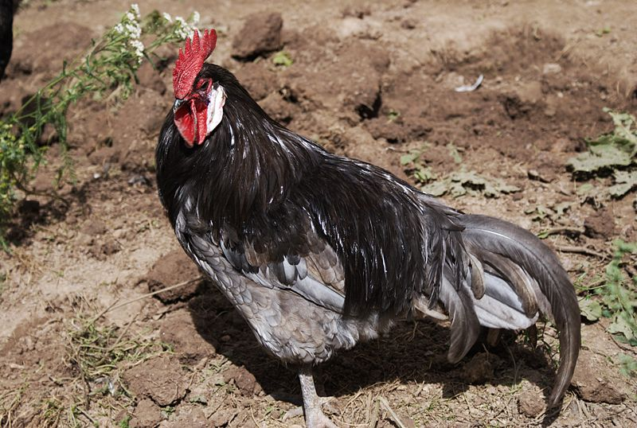  http://commons.wikimedia.org/wiki/File:  Andalusian_Blue_chicken_(male).jpg

________________________________________________________________________

________________________________________________________________________

________________________________________________________________________

________________________________________________________________________

________________________________________________________________________

________________________________________________________________________

Space for punnet square:

In turkeys, bronze colour (R) is dominant over red (r) and normal feathers (H) are dominant over hairy feathers (h).  A turkey farmer bought a bronze coloured turkey with normal feathers and wants to use it to establish a population of pure-breeding bronze, normal feathered turkeys. Back on the farm he has a group of turkeys that display a mixture of the colour and feather phenotypes.  http://commons.wikimedia.org/wiki/File:  Male_north_american_turkey_supersaturated.jpg | 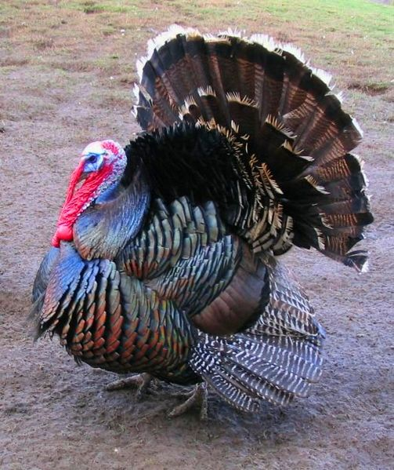
- Consider the options available to the farmer:
- explain how the farmer could determine the genotype of his new turkey
- explain how he would go about establishing a flock of pure-breeding bronze, normal feathered turkeys and analyse the methods he might chose
- evaluate the likely long term success of the farmer’s objective and any reasons he might not be totally successful.
________________________________________________________________________

________________________________________________________________________

________________________________________________________________________

________________________________________________________________________

________________________________________________________________________

________________________________________________________________________

________________________________________________________________________

________________________________________________________________________

________________________________________________________________________

________________________________________________________________________

________________________________________________________________________

________________________________________________________________________

________________________________________________________________________

________________________________________________________________________

________________________________________________________________________

________________________________________________________________________

________________________________________________________________________

________________________________________________________________________
More space next page:

________________________________________________________________________

________________________________________________________________________

________________________________________________________________________

________________________________________________________________________

________________________________________________________________________

________________________________________________________________________

________________________________________________________________________

________________________________________________________________________

________________________________________________________________________

________________________________________________________________________

________________________________________________________________________

________________________________________________________________________

________________________________________________________________________

________________________________________________________________________

________________________________________________________________________

________________________________________________________________________

________________________________________________________________________

________________________________________________________________________

________________________________________________________________________

________________________________________________________________________

________________________________________________________________________

________________________________________________________________________

________________________________________________________________________

________________________________________________________________________

________________________________________________________________________

________________________________________________________________________

________________________________________________________________________

________________________________________________________________________

