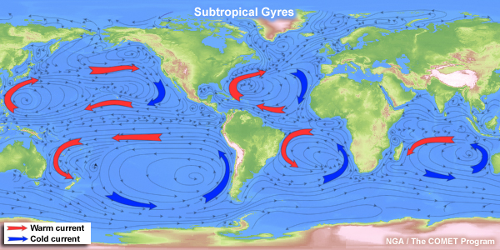
Southern Ocean… NZ vs Peru
NZ has an annual fish catch of around 400,000 tonnes. Peru has a much more variable catch but is still 3 to 6 times the size of the NZ catch.
Discuss how ocean currents are responsible for the big differences in the Peru and NZ catches.
Include an account of the cause of the relevant ocean currents as well as the impact.
(Some words to use: upwelling, nutrients, Coriolis effect, trade winds, plankton growth, food chain)

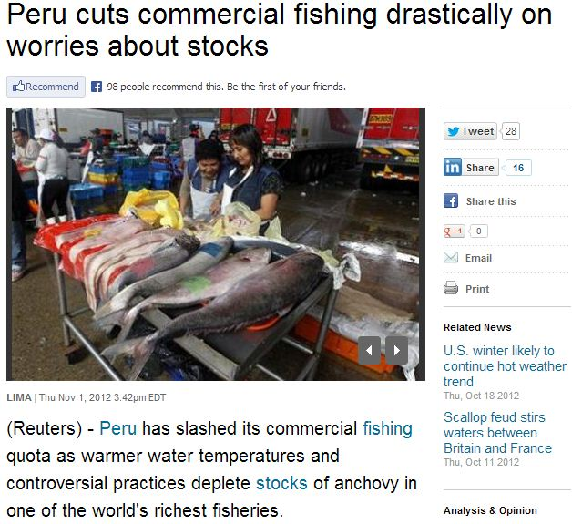
An article from Reuters news

Discuss what has led to Peru cutting its fish quota last year.
Include an explanation of the Southern Oscillation and an explanation of whether 2012 was a normal, El Nino or La Nina year, maybe some diagrams too

Part 1: things to cover…  - Cause of trade winds (H and L areas)  - Link between trade winds and ocean current  - Formation of Sth Pacific gyre  - Coriolis effect  - Ekman spiral cause and effect  - How upwelling is driven  - Nutrients and productivity and food chain  - Diagram showing this stuff | Part 2: things to cover…  - Southern oscillation ‘normal’  - Explanation of el nino (pressure)  - Effect on trade winds  - Effect on eq current  - Effect on upwelling and temp (thermocline)  - Effect on productivity  - diagrams

