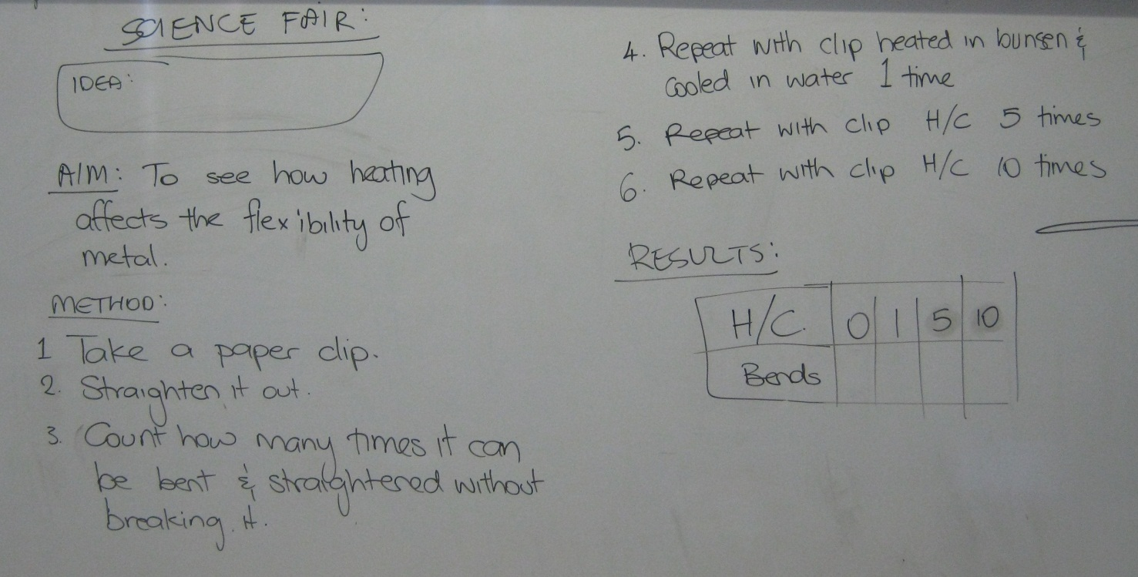

Changes to the method:
Paper clip has to be bent flat and straightened (180°)
Heat paperclip until red-hot

