Antarctic Voyage: The Magnetic South Pole

This is a short question

Read this for background information and do the short exercise at the end.

Written by Helen Bostock (marine geologist, NIWA)
Date: 15/02/2013
Location: 64.807561°S, 139.86694°E
Today we passed over the South Pole.
Well, not quite, but very, very close by. How is this possible when we are on board a ship and haven’t set foot on Antarctica itself?
We have been close to the Magnetic South Pole. The Magnetic South Pole is the wandering point in the Earth’s Southern Hemisphere where the geomagnetic field lines are directed vertically upwards – the ‘magnetic inclination’.
The Magnetic South Pole currently sits at 64°24’S, 137°00’E, so the RV Tangaroa passed just west of this, within 100 km of the Pole. It is constantly shifting, however, due to changes in the Earth’s magnetic field, moving northwest at a rate of 10-15 km per year. Unfortunately it being the middle of the night meant that there wasn’t much to see, except that the compass kept changing.
The magnetic poles are different from the geographic poles (which is where the lines of latitude meet at the Poles). This is critical to know if you are using a compass for navigation as the compass needle points to magnetic north, not true north (or grid north). The difference between magnetic north and true north is called the ‘magnetic declination’.
Most map coordinate systems are based on true north, and magnetic declination is usually shown on the map legend so that the direction of true north can be calculated. In some areas the declination is only 5°, so you wouldn’t get too lost if you are only going short distances. In New Zealand, though, we need to correct for this difference, as the declination is greater than 20°.
Closer to the magnetic poles, the declination gets very large and compasses are not very useful. As a result, the officers on the RV Tangaroa will have to rely on their Global Positioning System (GPS), which uses multiple satellites to work out our exact position, rather than relying on the compass and earth’s magnetism.

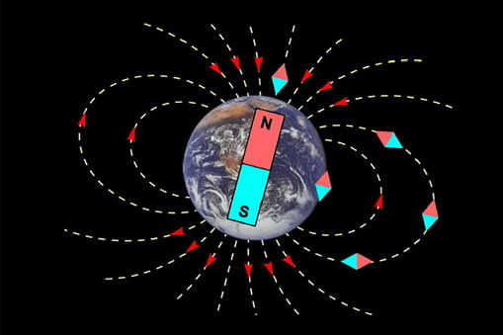

Write a short summary on the difference between the geographical South Pole and the Magnetic Pole. What are the implications for a traveller?

