Science Investigation: Rust
Name:
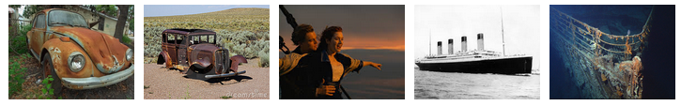
- The VW, sitting around for just a few years
- The old car in the desert, sitting around for decades (maybe 80 yrs)
- The Titanic sinking around since... (when was it) 19__
Observations:
____________________________________________________________________________________________________________________________________________________________________________________________________________________________________________________________________________

Some thoughts:
____________________________________________________________________________________________________________________________________________________________________________________________________________________________________________________________________________

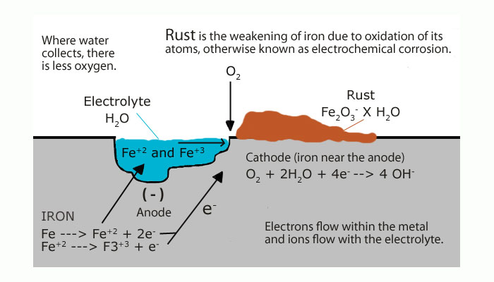

Questions....
What is needed for rusting to happen?
______________________________________________________________________________________________________________________________________

What is the overall equation?
___________________________________________________________________

How can we speed up rusting?
______________________________________________________________________________________________________________________________________

How can we stop iron rusting?
______________________________________________________________________________________________________________________________________

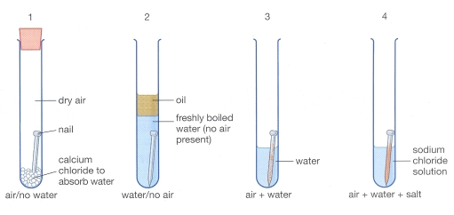
What would happen if we added more salt to the water?
______________________________________________________________________________________________________________________________________

Let’s find out…..
Results:

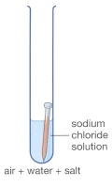
Salt=

Observations:

Conclusion:

