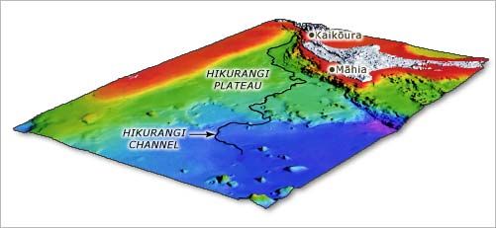
QUESTION ONE: THE HIKURANGI CHANNEL
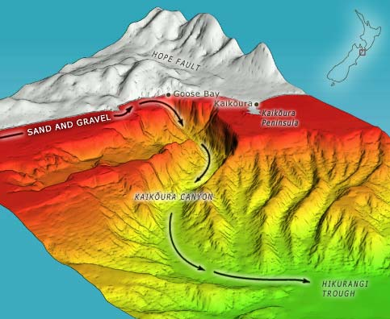
New Zealand has many marine canyons that are carved into the continental slope. A few canyons merge into meandering submarine channels, reminiscent of the Mississippi or the Amazon rivers. These channels, which are typically several hundred metres deep and 5–10 kilometres wide, meander across the deep ocean floor for up to 2,000 kilometres.
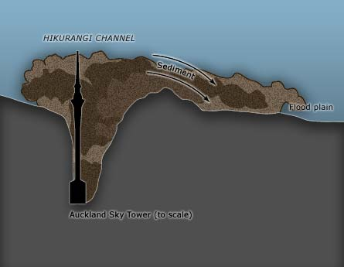
The longest, and one of the few presently active channel systems, is the Hikurangi Channel, which is fed by the Kaikōura and Cook Strait canyons. The 3km deep channel meanders along the Hikurangi Trough east of the North Island, cutting through the Hikurangi Plateau and continuing far out into the South Pacific Basin. The Hikurangi Channel starts at Kaikōura and meanders for 2,000 kilometres. It runs along the Hikurangi Trough as far as Māhia, then across the Hikurangi Plateau, and finally out across the South-west Pacific abyssal plain. New Zealand’s tallest building, the Auckland Sky Tower (328 metres), would disappear up to its observation platform in the Hikurangi Channel. Most of the time, there is no flow of water in the channel. Once every few centuries a flash flood of dense, turbid water that travel huge distances at very high speeds goes through the channel. Abyssal channels develop when these floods cause a build-up of the surrounding plains with more sediment to build up on one side of the channel than on the other.
Dead sea channels are the end member of a series of conduits that transport sediment from the top of the mountains to the ocean basins. They represent a major part in the planets major transport system with many characteristics of the world’s largest rivers.
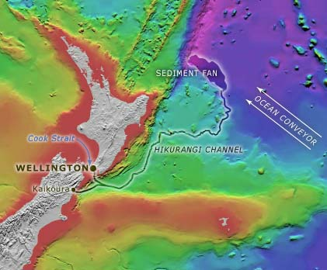
Discuss the relationship between geomorphology and the transportation of sediment (both terrestrial and marine). Link this to the Hikurangi Channel and include the following points:
- The path of sediment from the mountains to the Hikurangi Channel and the formation of different shapes of land as a result of transportation.
- Flash floods that occur down the Hikurangi Channel are caused by sediment-laden flows known as turbidity currents. Suggest a reason or these turbidity currents and their source.
- Why is there a more pronounced build-up of sediment to one side of the channel

QUESTION TWO: BIO-GEOCHEMICAL CYCLES
Water Vapor Feedback Loop Will Cause Accelerated Global Warming, Professor Warns
Andrew Dessler, a professor in the Department of Atmospheric Sciences who specializes in research on climate, says that warming due to increases in greenhouse gases will lead to higher humidity in the atmosphere. And because water vapor itself is a greenhouse gas, this will cause additional warming. This process is known as water vapor feedback and is responsible for a significant portion of the warming predicted to occur over the next century.
“It’s a vicious cycle – warmer temperatures mean higher humidity, which in turn leads to even more warming,” Dessler explains.
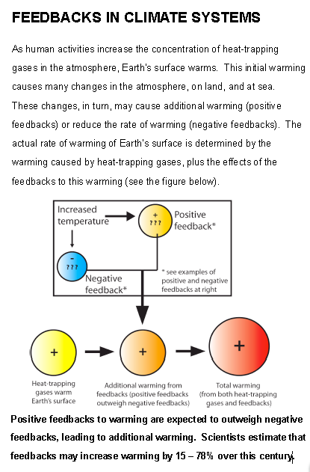
Predictions of significant global warming over the next 100 years by climate models require a strong water vapor feedback. Recent estimates suggest the earth will warm from 2 to 4 degrees Celsius (4 to 8 degrees Fahrenheit) over the next century – a scenario that could have devastating long-term consequences.
“The only possible way future warming won’t be significant is if there exists some sort of off-setting negative feedback, which has yet to be discovered,” Dessler notes.

Bio-geochemical cycles move the elements essential for life. These cycles also balance and regulate the Earth’s climate. Using your knowledge of two bio-geochemical cycles explain how they work together to create a positive water vapour feedback loop. Also suggest one possible way they could be manipulated to work together to create a negative feedback.

