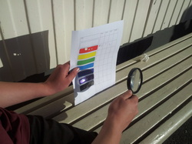

We found that the ……

A yr 9 class found that they could use the suns energy to set fire to paper!
Explain the effect of colour. Something like this...
"The black coloured paper caught fire very quickly and our black metal plate heated up the most because black absorbed a lot of solar energy which leads to heating as the particles vibrate faster, whereas...."

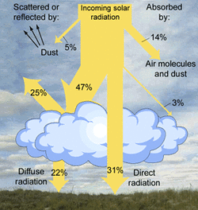
How much of the suns energy reaches the surface of the earth?
Explain what happens to the "missing" energy

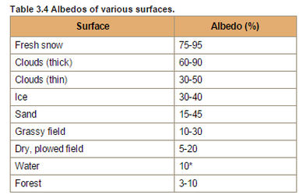
What is albedo?
Using the results of our expts explain the difference in albedo of snow and a grass field
Why do skiers often get quick sun burnt?

Extra for eggspirts:
- Global warming is likely to cause melting of the polar ice as well as mountain glaciers. This is likely to accelerate global warming. Use our expt and the stuff above to explain why.
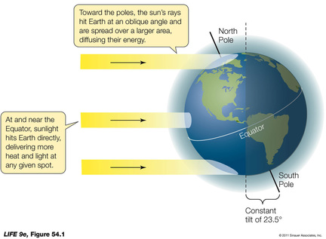
3. It is much warmer in Hawaii than the North Pole, explain why
4. Why is it really cold in Antarctica right now.

