TasBay Previous data…You might want to check out any patterns over the years…. Maybe also take a jolly close look at the uppy axis ranges over the years
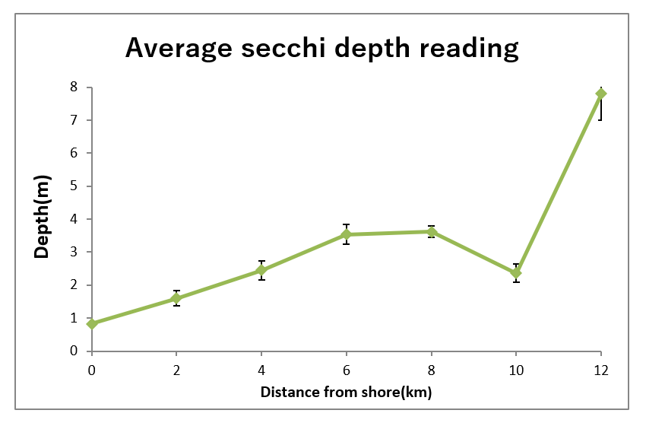  2013 Thanks Hannah | 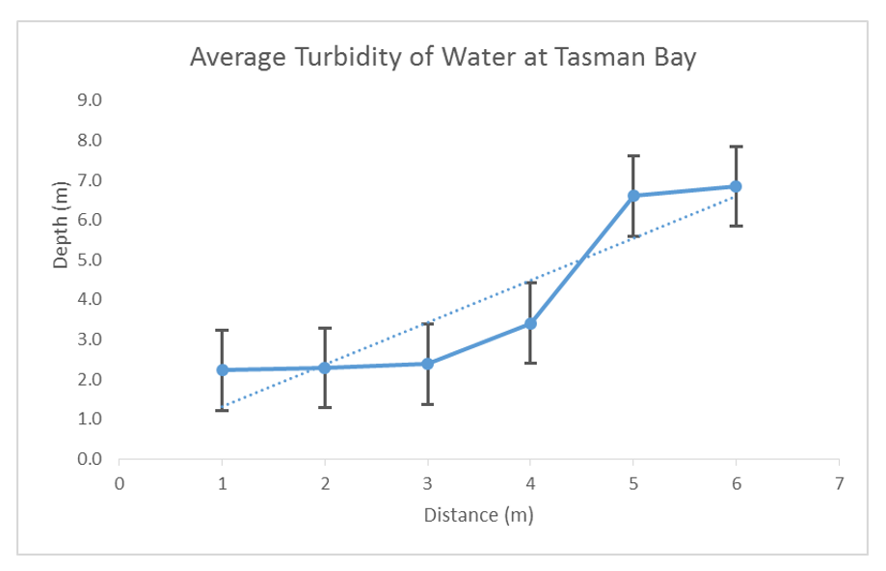  2015 Thanks Vanessa
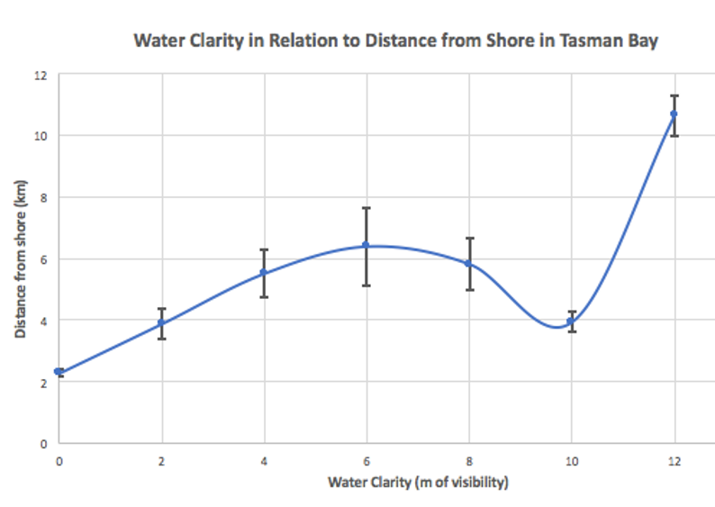  2017 Thanks Indi | 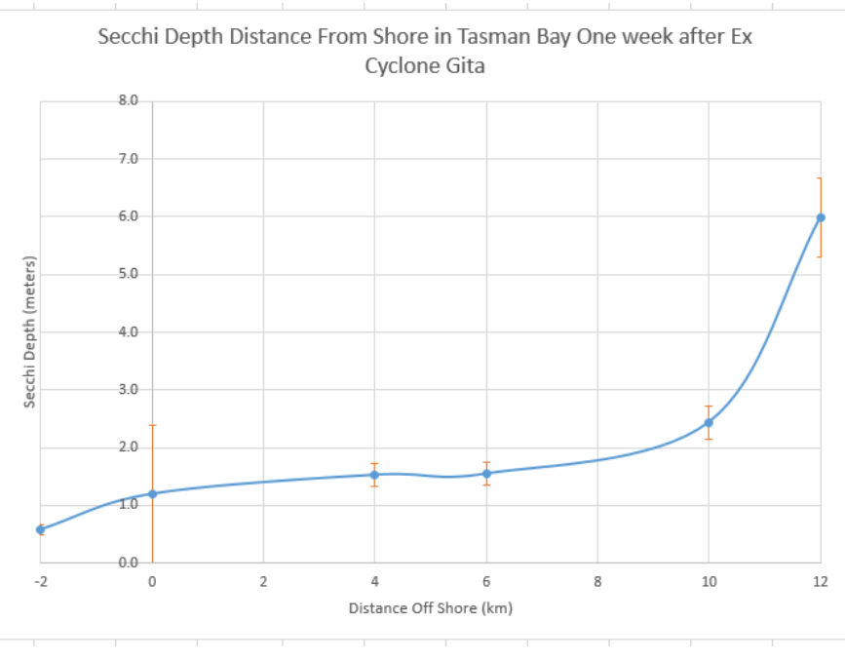  2018 Thanks Agni
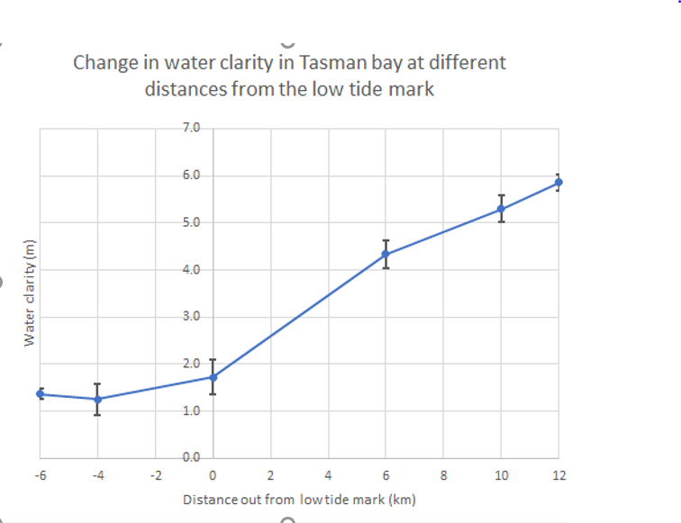  2019 Thanks Merlyn | 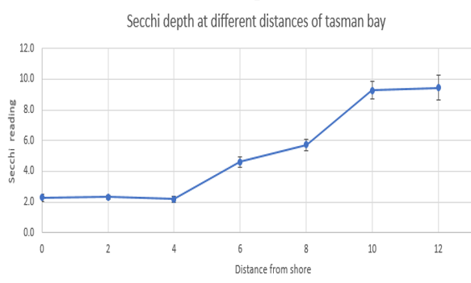  2020 Thanks Emma
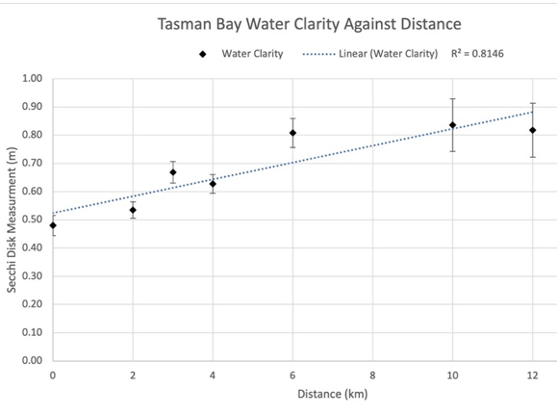  2021 Thanks Lennox | 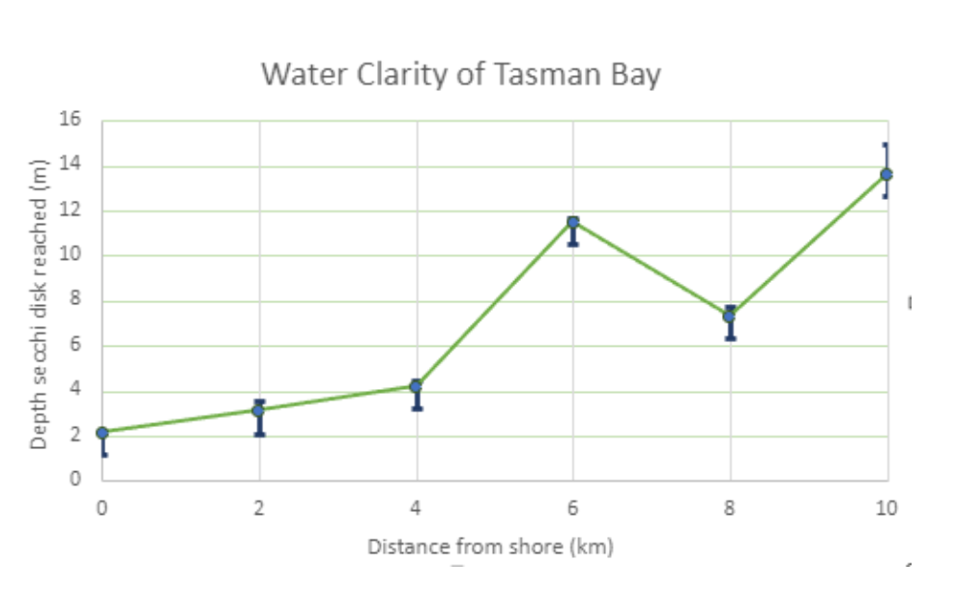  2022 Thanks Tegan
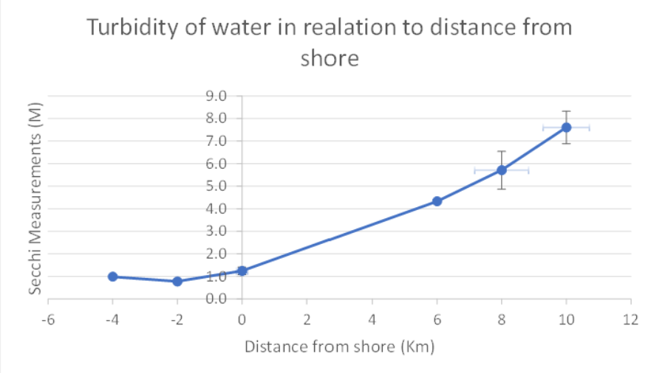  2023 Thanks Emily | What will we find?

