Terms and concepts to learn
Terms | Definitions
Weather is | The short-term atmospheric conditions that we see at any one moment.
Climate is | The average conditions found in the atmosphere over a long period of time
Climate is related to | the convection regions at various latitudes,  temperature differences between the equator and the poles, and  warm and cold surface ocean currents.
Why climate zones occur | 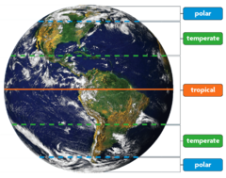  Because of the unequal heating of Earth by the Sun.
Temperatures in the temperate zone are affected most by | the changing seasons.
The driving energy source for heating of Earth and circulation in Earth's atmosphere comes from | the Sun and is known as solar energy.
Convection Currents | 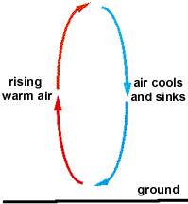  A cycle of warm air rising and cool air sinking causing a circular movement of air. Set in motion by the Sun heating Earth's surface unevenly.
Wind | Air moving from high pressure areas of cool dense air to low pressure areas of warm less dense air.
Global Winds are caused by | Uneven heating of Earth's surface by the Sun causes heat transfer by convection on a global scale in the atmosphere.
Coriolis Effect | Global winds appear to curve because convection cells are in place in the atmosphere and Earth is spinning on its axis.
Trade Winds | 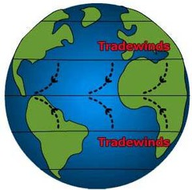  Blow from east to west in the tropical region - move warm tropical air in that climate zone.
Prevailing Westerlies | 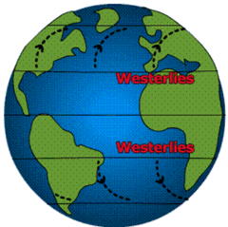  Blow from west to east in the temperate region.
Polar Easterlies | 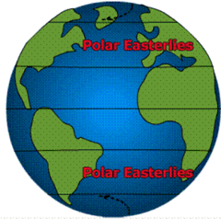  Blow northeast to west in the polar region moving cold polar air in that climate zone from the poles toward the west.
Jet Stream | 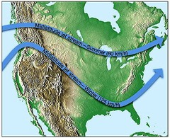  Near the top of the Troposphere, a fast-moving ribbon of air moves from west to east in the Northern Hemisphere around Earth. Air masses and weather systems in its path are moved along by the fast moving air.
Weather systems in New Zealand move from | west to east because of the Jet Stream and the Prevailing Westerlies wind belt.
Tropical Weather Systems, like hurricanes, move | in the direction of the trade winds, from east to west.  If they enter the prevailing westerly wind belt, they are often turned, and move from west to east.
Doldrums | Area near the equator with very little wind.
Local winds | On a smaller scale, convection currents near large bodies of water can cause land and sea breezes.
Sea breeze | 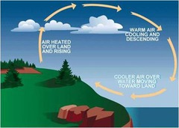  Land is warmer and air rises, sea is cooler and air sinks. Cool air blows onto land from the water.
Land breeze | 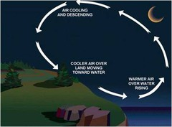  Land is cooler and air sinks, sea is warmer and air rises. Cool air blows from land toward water.
Surface currents of Earth's oceans | 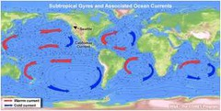  Circulate warm and cold ocean waters in  convection patterns. Influence the weather and climates  of the land masses nearby.
Surface ocean currents are caused by | Differences in temperature,  Differences in salinity,  and by wind.
Warm Gulf Stream current water | 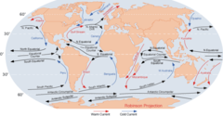  Influences the weather and climate of the eastern Atlantic shoreline of the United States and Britain.
Cold California current | Influences the weather and climate of the western Pacific shoreline of the United States.
Radiation | Transfer of energy by electromagnetic waves. Sunlight and heat energy are examples.
Some of the Sun's energy coming through Earth's atmosphere is | 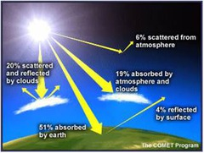  reflected or absorbed by gases and/or clouds in the atmosphere.
Absorption is | when energy is taken in by an object. Gases in the atmosphere can absorb solar energy.
Reflection is | when energy bounces off a surface. Clouds tend to reflect sunlight back out into space. Since clouds reflect the energy, they don't get warmed by it.
Land heats up and cools down | fairly quickly.
Water heats up and cools down | fairly slowly.
Process known as the Greenhouse Effect. | 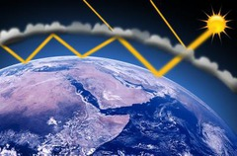  Solar energy that is absorbed by Earth's land and water surfaces is changed to heat that moves - radiates back into the Troposphere where the heat is absorbed or trapped by gases.
Gases in the Troposphere that absorbs heat energy radiating off Earth's surface. | 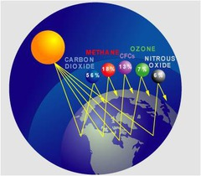  Carbon Dioxide and Methane
Gas is the Stratosphere that absorbs ultraviolet radiation. | Ozone
The water on Earth | helps to regulate the temperature range of Earth's atmosphere.

