Worksheet based on document from here:
http://globecarboncycle.unh.edu/CarbonCycleBackground.pdf
Click on the link above and use the document to complete the following pages.

The Global Carbon Cycle worksheet
Carbon reservoirs are sometimes referred to as pools or stocks. Explain what is meant by a carbon reservoir, and how it might act as a source or sink of carbon

Explain what is meant by a carbon flux (aka pump), and why the rate of flux is important

Pages 6-8 of the booklet outline many of the carbon fluxes or pumps that exist in the Earth system. There may be more than one carbon pump described under each heading. For each one, identify whether you think it is part of a biological process (ie, involves a biochemical process carried out in a living organism) or a physical process (everything else) and whether the process is carried out in the Geosphere, Biosphere, Atmosphere or Hydrosphere (or involves movement between 2 of these).
Complete the table below (continued on the back page of this booklet):
Biological Pumps
Process | Location & “Sphere” | Description of process

Carbon reservoirs or pools may store carbon for short or long periods of time (seconds to billenia). With reference to the resource, complete the following table in as much detail as you can. Carbon may be stored in more than one location in each carbon reservoir.

Carbon Pool | Short or Long Term storage | Form Carbon is stored in
Earth’s Crust
Oceans
Atmosphere
Terrestrial Ecosystems

Show where each of these carbon reservoirs is located on the Carbon Cycle diagram.
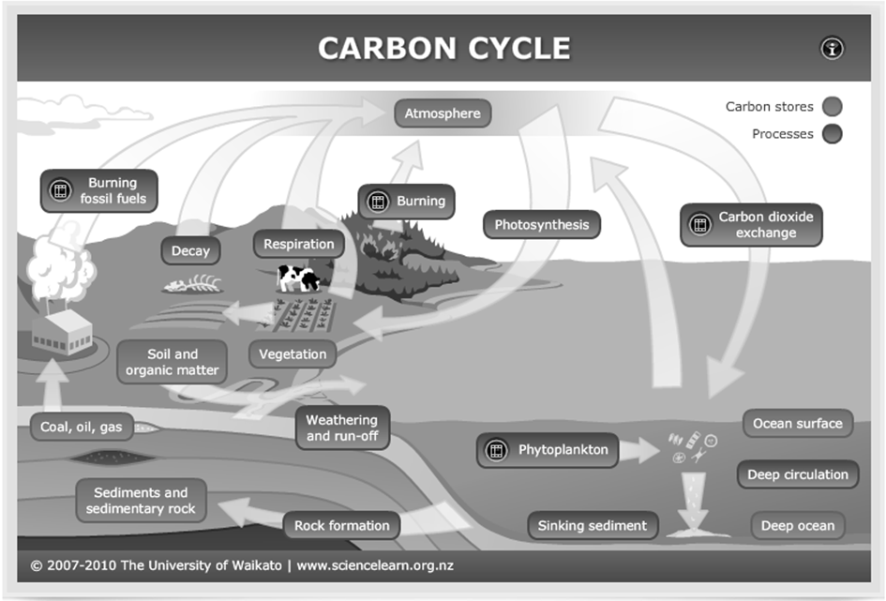
Physical Pumps
Process | Location & “Sphere” | Description of process

For each pump or flux you have identified and described above, label the carbon cycle diagram in the middle section to show where this transformation occurs in the global carbon cycle.

