Name:

Teacher : GBL

NAYLAND COLLEGE

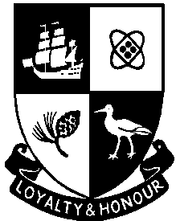

Achievement Standard 90948
(Science 1.9)

Demonstrate understanding of biological ideas relating to variation

Credits: 4

- You should answer ALL parts of ALL questions in this booklet.
- You must hand this examination paper to the supervisor at the end of the examination.
- Check that this paper has all 10 pages numbered and in the correct order.

For Assessor’s  use only | Achievement Criteria
Achievement | Achievement  with Merit | Achievement  with Excellence
Demonstrate understanding of biological ideas relating to genetic variation. | Demonstrate in-depth understanding of biological ideas relating to genetic variation. | Demonstrate comprehensive understanding of biological ideas relating to genetic variation.
Overall Level of Performance

QUESTION ONE: DNA

DNA is made up of repeating units called nucleotides. There are four different nucleotides, distinguished by their different bases. These are called adenine (A), thymine (T), cytosine (C) and guanine (G).

A small section of one strand of the gene that codes for the production of the colour in hair is:
A A T T C G A T C G A T A T G C C A T T T A C A G T A G T C A

Use this information to explain how DNA is important in determining an organism’s characteristics, for instance hair colour. In your answer you should:
- define the terms gene, allele and DNA
- explain how the information in the DNA determines the characteristics and the different forms (variations) of that characteristic
- use the example of hair colour.

Diagram space:

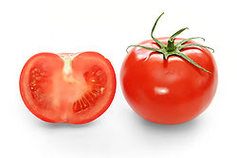
QUESTION TWO: TOMATOES
Gardeners can use seeds (sexual reproduction) or cuttings (asexual reproduction) to create more tomato plants.
http://en.wikipedia.org/wiki/Tomato

Discuss why genetic variation is important for survival of a species. In your answer you should:
- explain the advantages of using cuttings
- explain the benefits of using seeds
- justify the use of sexual reproduction by many species instead of asexual methods.

QUESTION THREE: ALBINISM

About one in every 17,000 people has albinism. These individuals fail to produce melanin, a pigment that gives humans skin colour, and are, therefore, white-skinned.

The following pedigree chart shows the inheritance of albinism in a family:

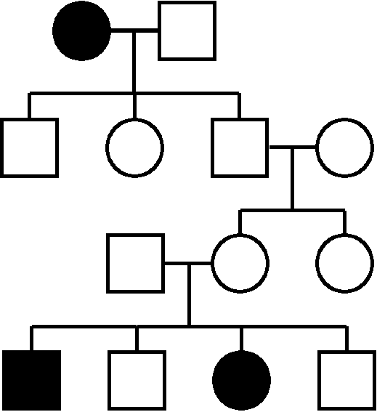
Key:

Male
Female
or Affected individual
or Unaffected/unknown

A B

C D E F

G H I

J K L M

- Using ‘N’ to represent the dominant allele, and ‘n’ to represent the recessive allele, give the probable genotype of individual G.

- In this pedigree, the trait for albinism has skipped (not been expressed in) two generations. Discuss how it is possible for recessive traits to skip some generations and show up a lot in others. In your answer you should:
- define dominant and recessive
- refer to specific individuals in the pedigree chart
- compare the expected outcome for generation 4 to the actual outcome
- use Punnett square(s) to support your answer.

Diagram space:

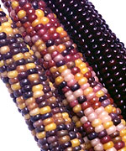
QUESTION FOUR: SWEETCORN
http://parkseed.com/images/l/5096.jpg

The sweet corn we eat has yellow (p) kernels. This is a recessive trait, while purple (P) is the dominant trait that is still found in areas where corn has been grown traditionally, like Latin America. Farmers there can expect to have corn cobs with a mix of purple and yellow kernels.

- Complete the punnet square to calculate the expected phenotype ratio of breeding two purple corn plants heterozygous for kernel colour together.

Male

Female

Phenotype ratio:

Yellow kernel colour is most likely to have turned up originally as a mutation.

- Discuss why mutations are considered to be the “original source of all variation” when compared to variation produced during meiosis. In your answer you should include:
- a definition of mutation
- how mutation results in variation
- the heritability of mutations
- the processes that increase variation in meiosis.

Extra space. Number all answers carefully.

