what we study in L2 EARTH &Marine Science
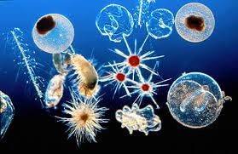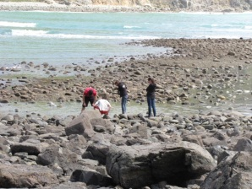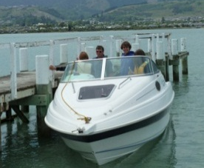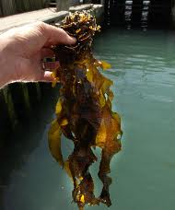
Plankton: theory, catching and microscope viewing
Ecosystems around Nelson: Waimea Estuary, Cable Bay, Oyster Is.
Geology: local geological processes, eg boulder bank, faults, dunes
Organisms living nearby: periwinkles, undaria, crabs, snails, etc
Mud: what is in it, who eats it, how important is it
Adaptations: reproduction of fish, sharks, shellfish, crayfish
Aquaculture: theory, visit to Cawthron research facility
Seawater Chemistry: theory, practical investigations
Extreme Environments: life in Antarctica- Emperor Penguins
Resource Management: NZ fishing industry, history, rules,
