what we study in L3 EARTH &Marine Science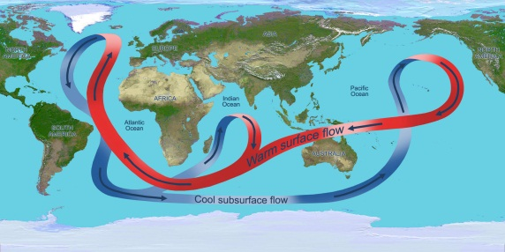 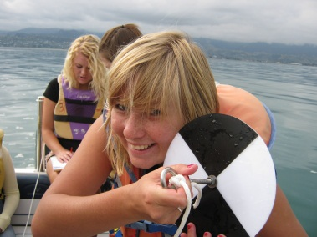 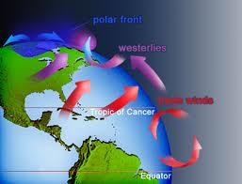

Tasman Bay: the impact of erosion on the water in Tasman Bay
Earth Science Issue: mining in the Cobb Valley / Waimea dairy farming
Oceanography: ocean currents, waves, tides - global & local
Atmosphere: the structure and behaviour of the atmosphere
Astronomy: the study of an aspect of astronomy
Abel Tasman Restoration: a study of people and the environment.
Topic of choice: lots of opportunities for work on something of interest

