what we study in L2 Biology
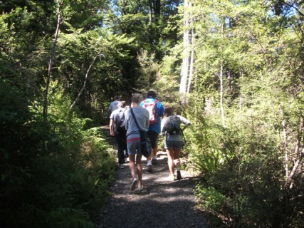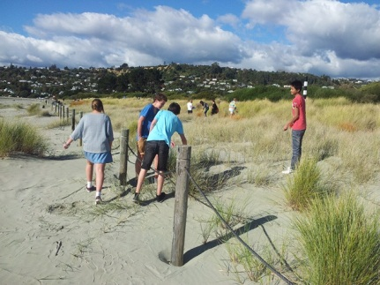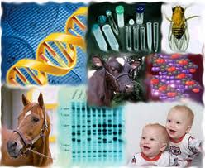
Ecosystems and Ecology: theory, Rotoiti Nature Recovery Project, Tahuna sand dunes
Genetic Variation: sources of variation, inheritance, evolution
Cells: microscope viewing, parts of a cell, processes inside cells
Research Project: an aspect of Biology – your choice
Gene Expression: DNA – what is it for, metabolic pathways
Animal Adaptations: theory & practical investigations on how organisms carry out gas exchange
