Question 2 Big Bad Wellington Storm
June 20, 2013
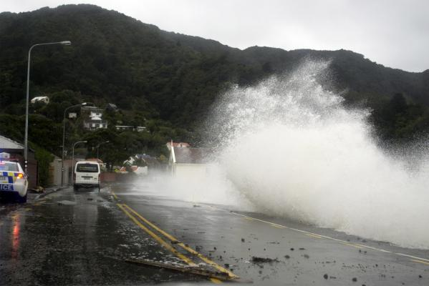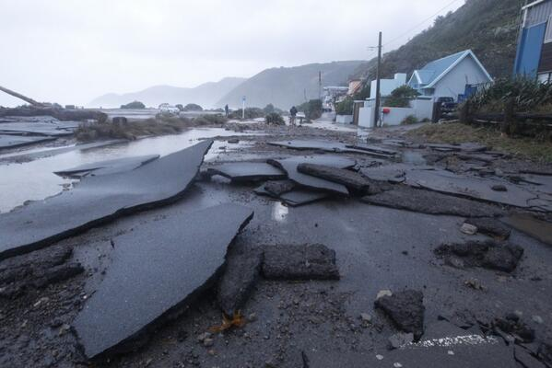

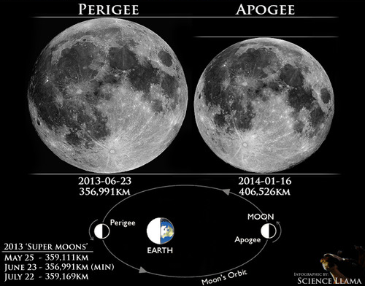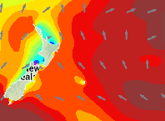
Swellmap.com showed a wave height of 8m from the south for this day.
(Swellmap image above was for 2 days after the storm when the weather pattern had moved off to the east)
The South coast of Wellington was hammered with waves up to 15 m and wind gusts up to 200Km/h. This pattern had been similar for the previous day or more.
The worst damage occurred around the time of high tide
The moon was very near its perigee.

Use your knowledge of tides and waves to discuss why Wellington’s south coast suffered such a lot of damage. Include an explanation of the factors that affect wave height and how these contributed to the damage. Also include an explanation of the contribution of the moon to the damage, including an explanation of spring and neap tides.

