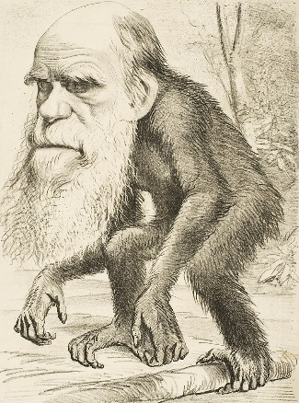
Darwin’s explanation of natural selection
- Within a population there is lots of v_____________

- There are more individuals produced by r______________ than there are those that get to s__________________.... there is a struggle for survival

- Individuals with the best a___________________ get to survive, esp. if conditions are harsh

- Those that survive then become the ones that get to b_____________

- The breeders therefore are the ones that get to pass on their genetically determined
f_______________ to the next generation

- Over time a population will c________ to include more with desirable features and L______ with undesirable features (like the finch beaks)

- Different populations may change so much that they no longer interbreed, we then have different s_____________

For the speciation exercise
The area the mammal ancestor will move into ___________________________
Likely conditions there:

Some useful adaptations to increase the chance of survival think about what is needed to :
- Tolerate any harsh environmental conditions
- Get food
- Avoid being food for something else
- Attract a mate

