Effect of Environment on phenotype
- Via genotype, ie mutation
http://www.globalanimal.org/2012/08/15/mutant-butterflies-product-of-fukushima-nuclear-disaster/79949/
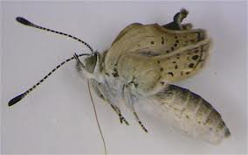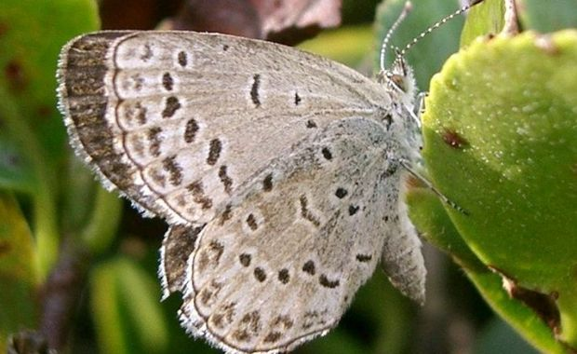

Mutagen
From Wikipedia, the free encyclopedia
Jump to: navigation, search
In genetics, a mutagen (Latin, literally origin of change) is a physical or chemical agent that changes the genetic material, usually DNA, of an organism and thus increases the frequency of mutations above the natural background level. As many mutations cause cancer, mutagens are therefore also likely to be carcinogens. Not all mutations are caused by mutagens: so-called "spontaneous mutations" occur due to spontaneous hydrolysis, errors in DNA replication, repair and recombination.

Also:
UV rays
Chemicals (esp. organic solvents, incl. Tobacco tar)
Some microbes (viruses)

Location of mutation- does it matter?
- With no change in genotype…
Wind and trees
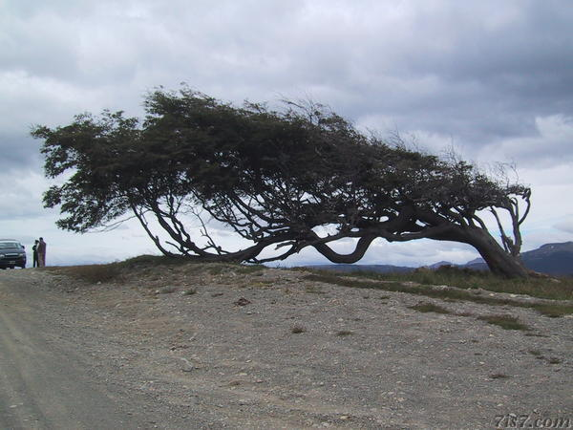
http://www.7is7.com/otto/travel/photos/20040209/ushuaia_treewind.html
wonky windswept tree… does it really want to look so silly- wouldn’t it prefer to be tall and proud

Hydrangeas and pH
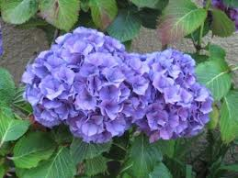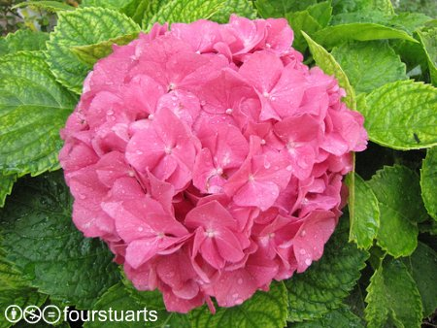

Daphnia
http://www.youtube.com/watch?NR=1&v=2g-04Uk0ut0&feature=fvwp
Daphnia helmet formation:
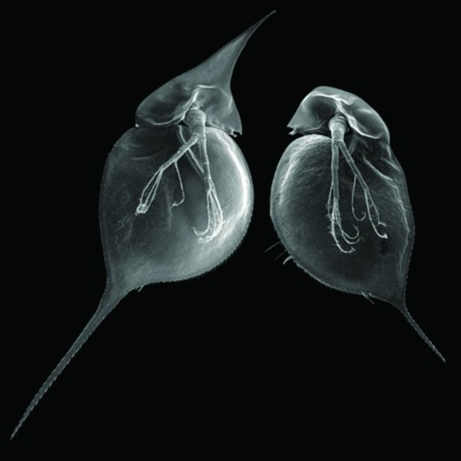
http://www.comprehensivephysiology.com/WileyCDA/CompPhysArticle/refId-c110008.html

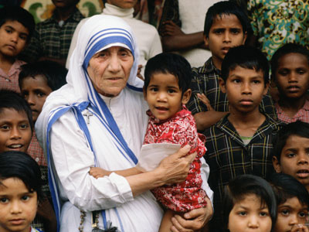

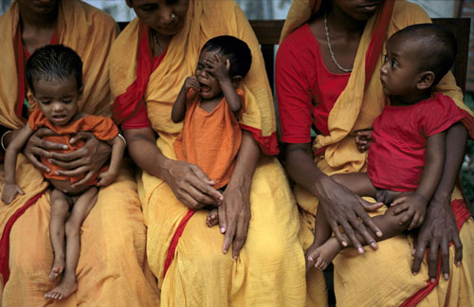
http://anooplal.com/children-starve/
What about human behaviour…..
http://en.wikipedia.org/wiki/Michael_Meaney 