Boulder Bank

What is the Boulder Bank?
The Boulder Bank is a 13 kilometer long stretch of rocky substrate that separates Nelson Haven from Tasman Bay and is a very unusual naturally formed landform in Nelson, New Zealand. It begins at the Mackay Bluff and ends at the cut of the Nelson Harbour Haulashore Island used to be a part of the Boulder Bank, but the cut made it an island. It is composed of pebbles and boulders up to 1.2 metres in diameter that have originated from Mackay Bluff at the nothern end. During nothernly storms the boulders are moved south-west along the bank. Radiocarbon dating shows that the bank has developed in the 6,000 years since the sea rose to its present level.
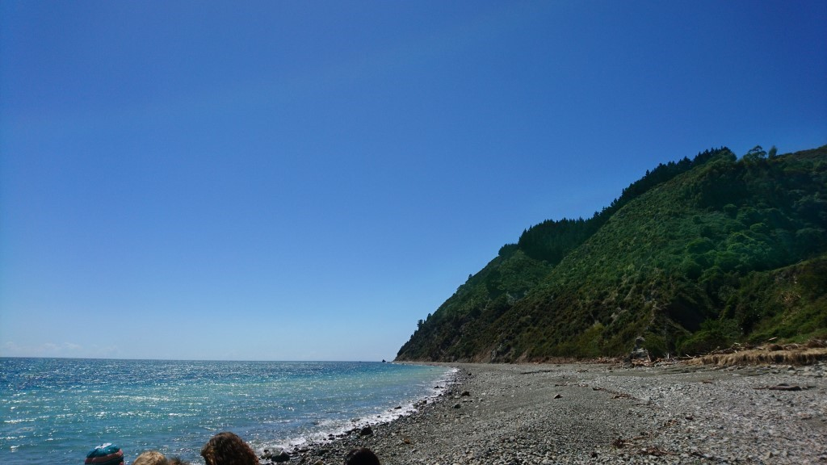

How was it formed?
The Boulder Bank is composed of Granodiorite, which is a mixture of Granit and Diorite. You can see large crystals in it. That shows that this rock is made underground and cooled down very slowly. Although it is made deep under the ground we can find it on the surface. Why?
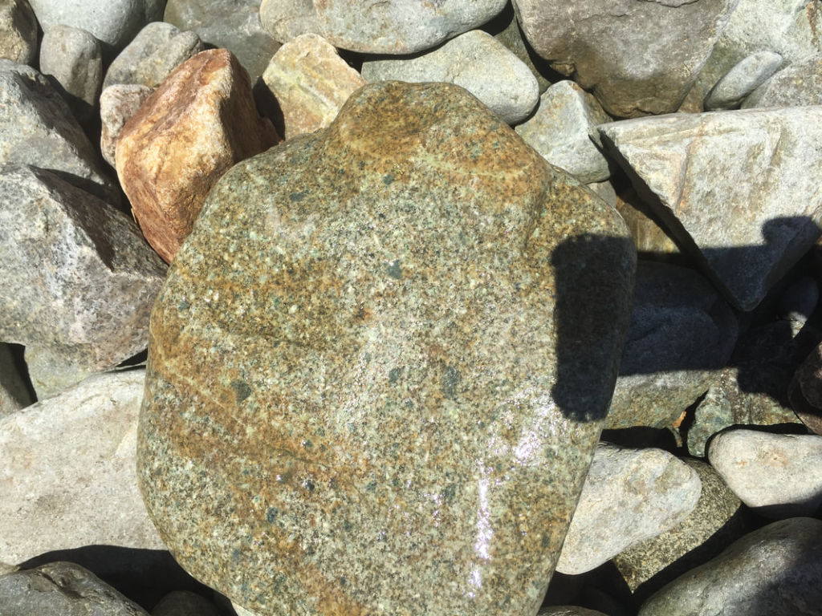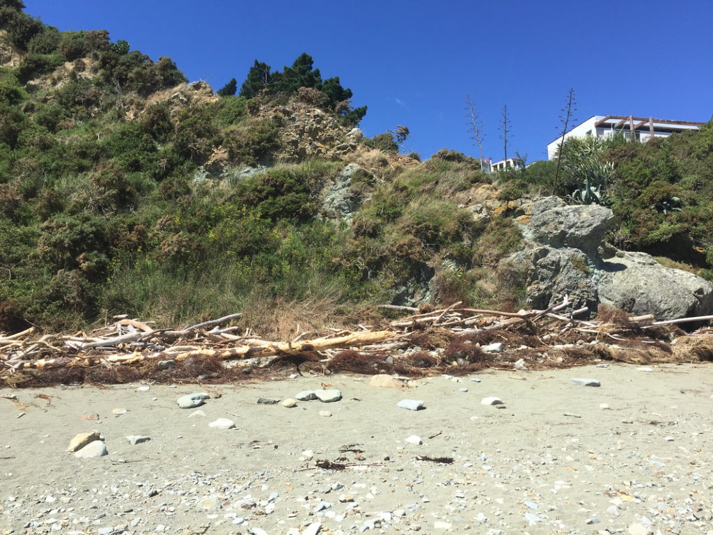
The Boulder Bank is located directly next to the Flaxmore fault line. Every time when there is in Earthquake, one side of the Faultline is lifted up and brings rocks like Granodiorite to the surface.
Via Erosion the Rocks fall down the hill and land on the beach.

There are lots of waves coming to the beach. But they are not coming straight, but in an angle. And so the waves take some rocks with them in an angle along the beach. When the waves go back, the rocks move straight backwards and so they moved along the beach and formed the Boulder Bank. This movement of the rocks is called Longshore Drift. On average the rocks move approximately 7.5 meters a year.

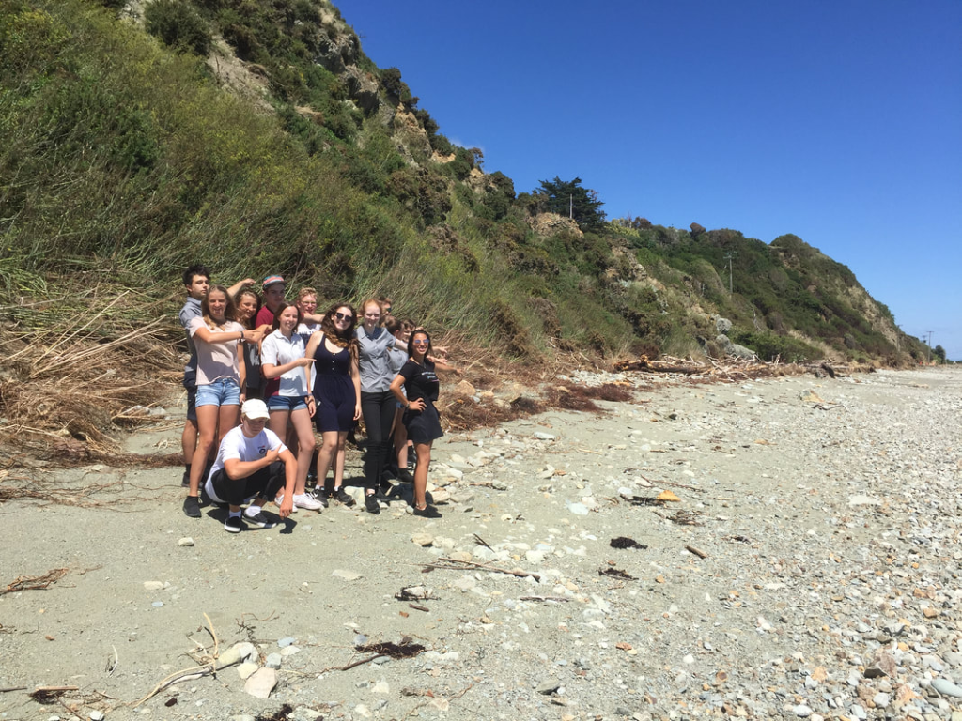

History

The Cut
An important thing in the History of the Boulder Bank is the Cut which is a hole through the Boulder Bank to enable the Nelson Port to allow the increasing demands of sea transport for the Tasman Area. The Construction of the cut started in 1903. In 1905 a 61 meters wide entrance was operational. Today the cut is 150 meters wide and it is dredged every six month to maintain a depth of 10 meters.
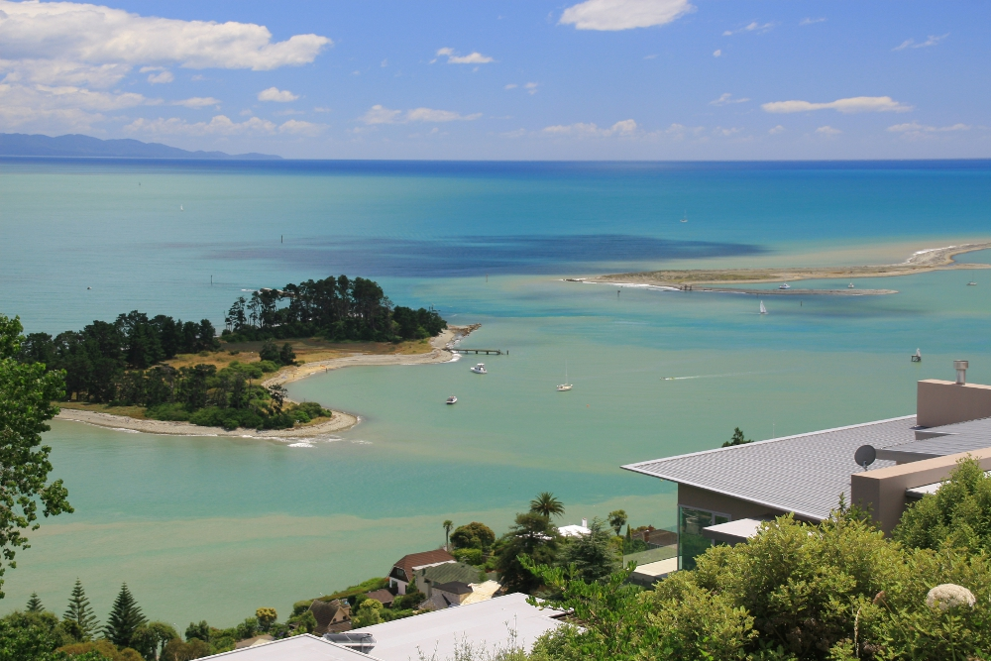

The lighthouse
The Boulder Bank Lighthouse was erected in 1862. It is located near the port end of the Boulder Bank and was New Zealand's second permanent lighthouse.
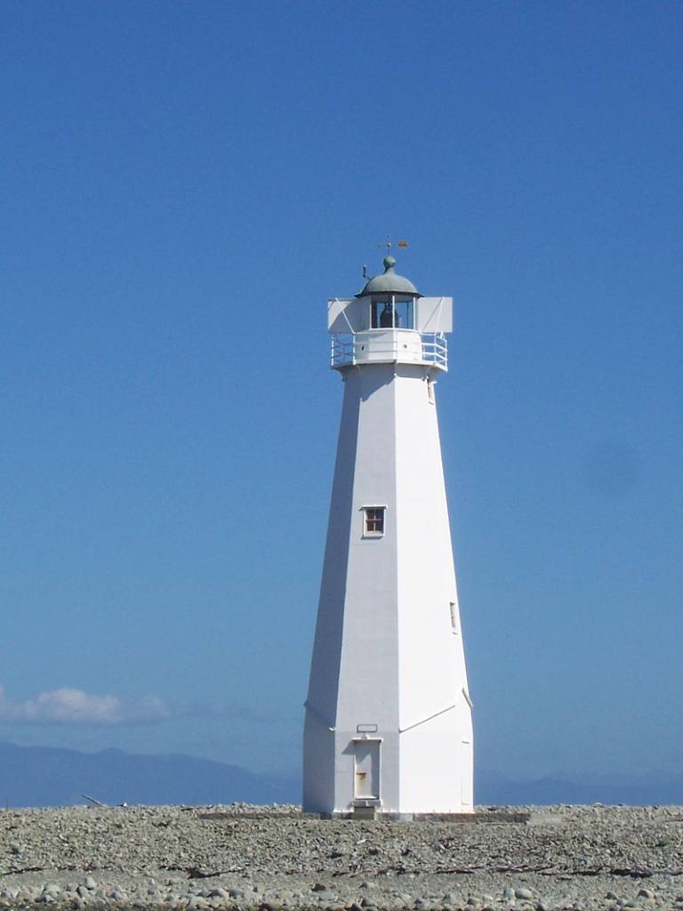

Biological importance
The Boulder Bank is especially important for birds because they nest in the rocks of the Boulder Bank.

The marine reserve
The Horoirangi Marine Reserve, sometimes referred to as the Glenduan Marine Reserve, is situated to the north east of Nelson in New Zealand. It stretches along the coast from the northern end of Boulder Bank to just south of Cable Bay.
It was established in 2005 and has an area of 9.58 km².

Plankton
Here is how we catch the we things
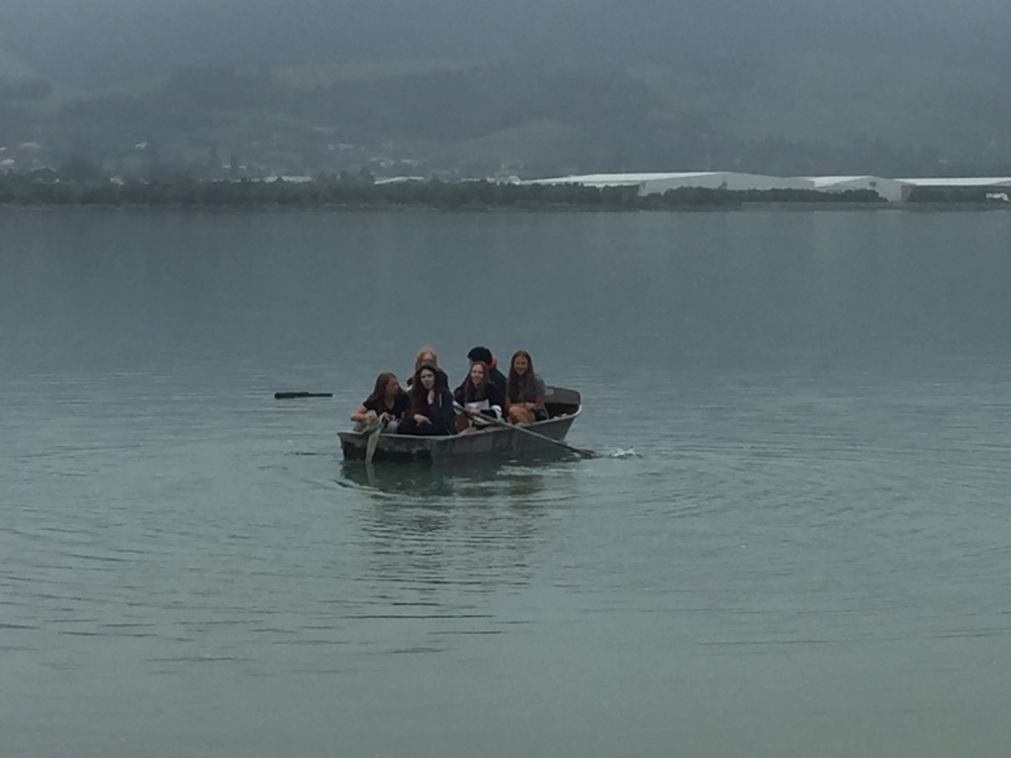

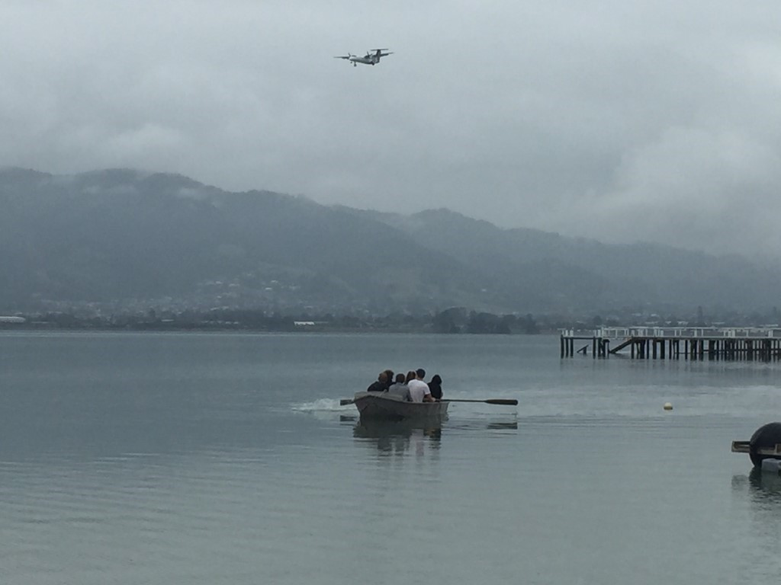

1
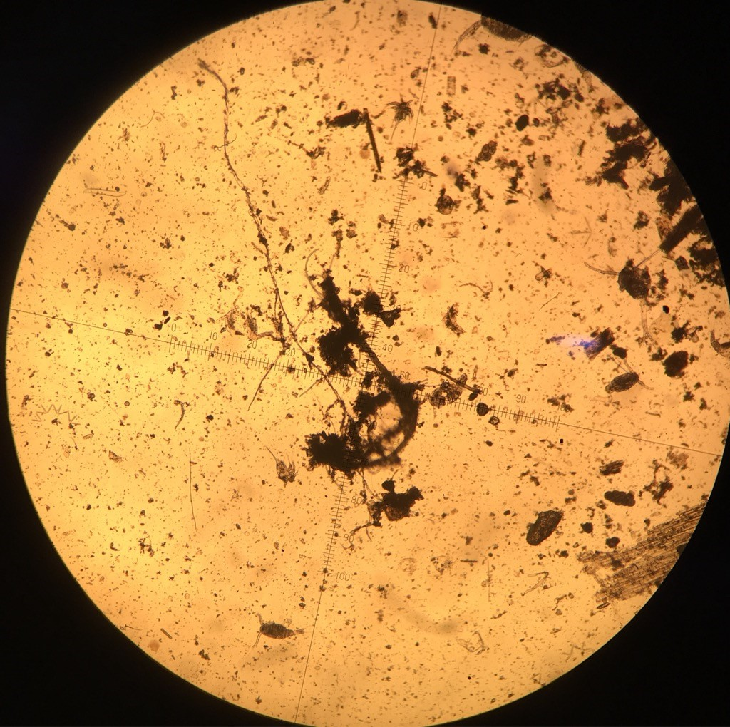

2
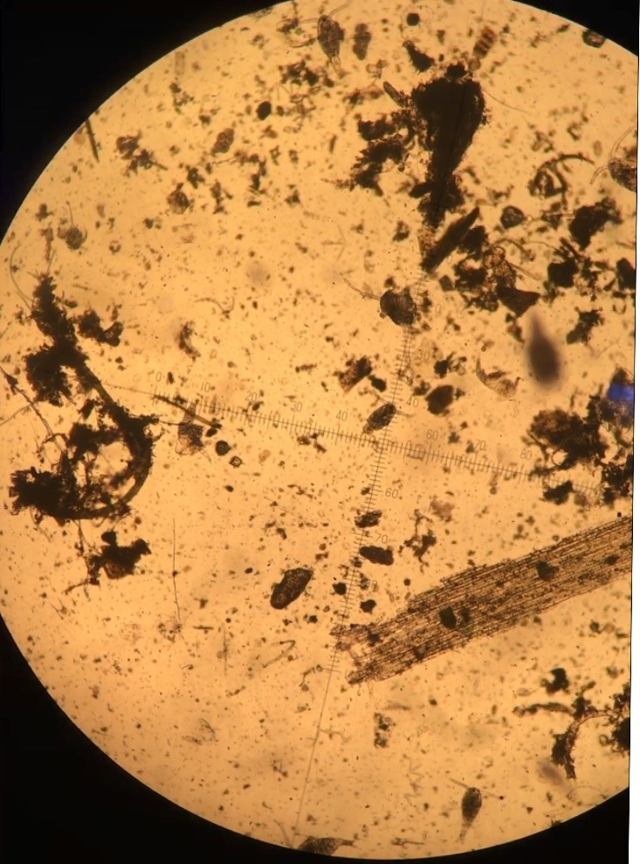
3
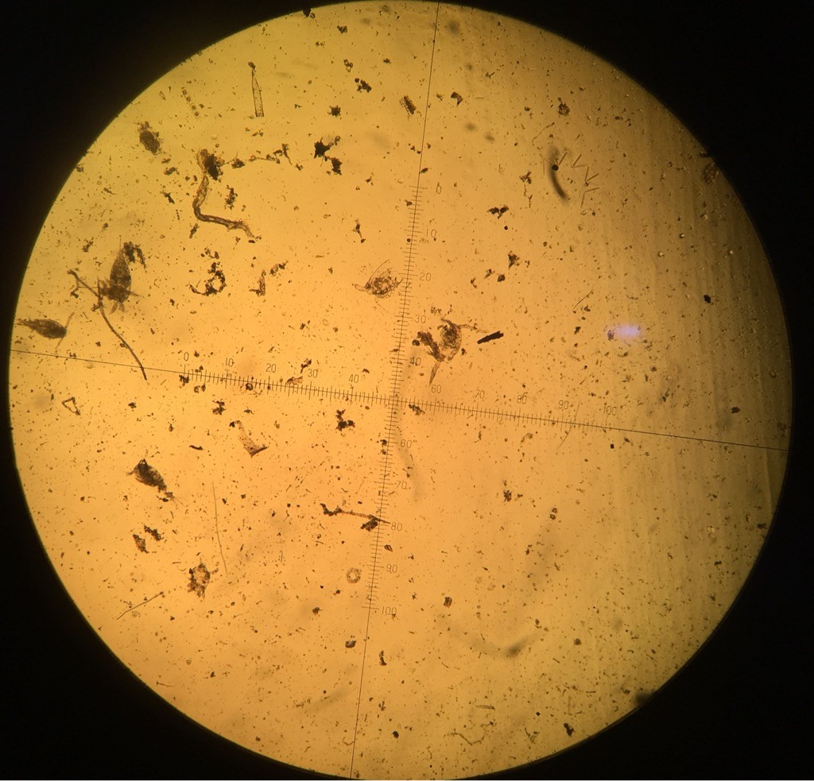

Oyster Island

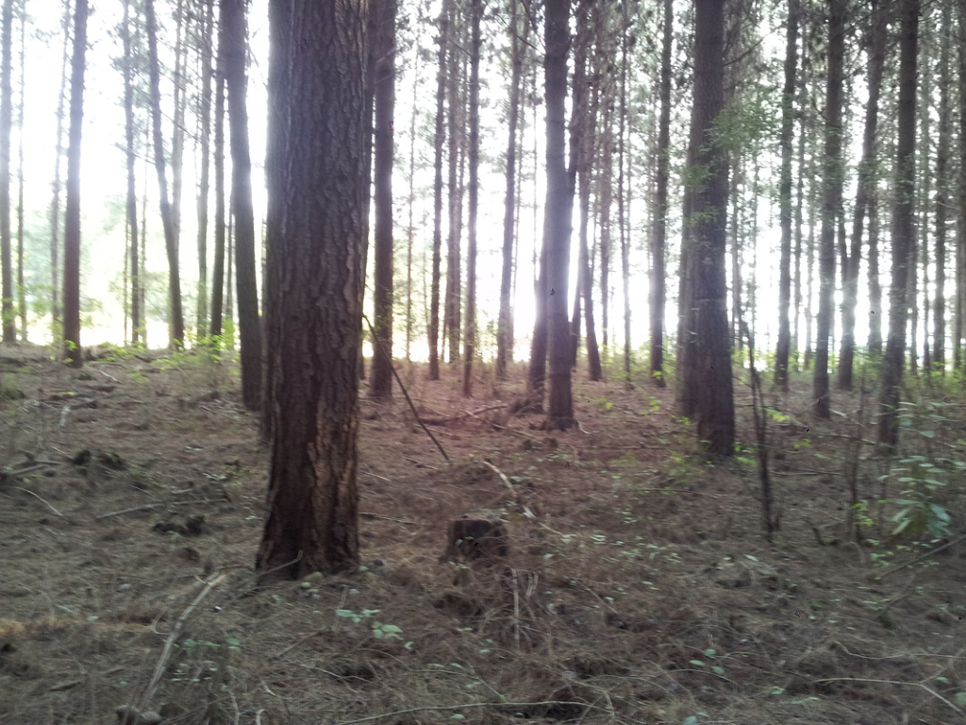
In 2007 the whole Island was covered with huge Pine Trees. They created a lot of shade on the ground and there was not enough sunlight reaching the ground to make other plants grow there. Furthermore the whole ground was covered by needles of the Pine Trees and the soil was without nutrients because the Pine Trees sucked everything out. The Problem was that the Pine Trees were not New Zealand natives and are not wanted on that Island, because they stole the space for the native plants to grow.

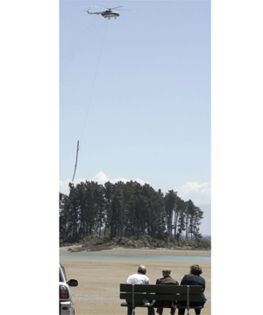
Therefor they started to cut them down and remove them with helicopters, because they did not want to destroy the island.

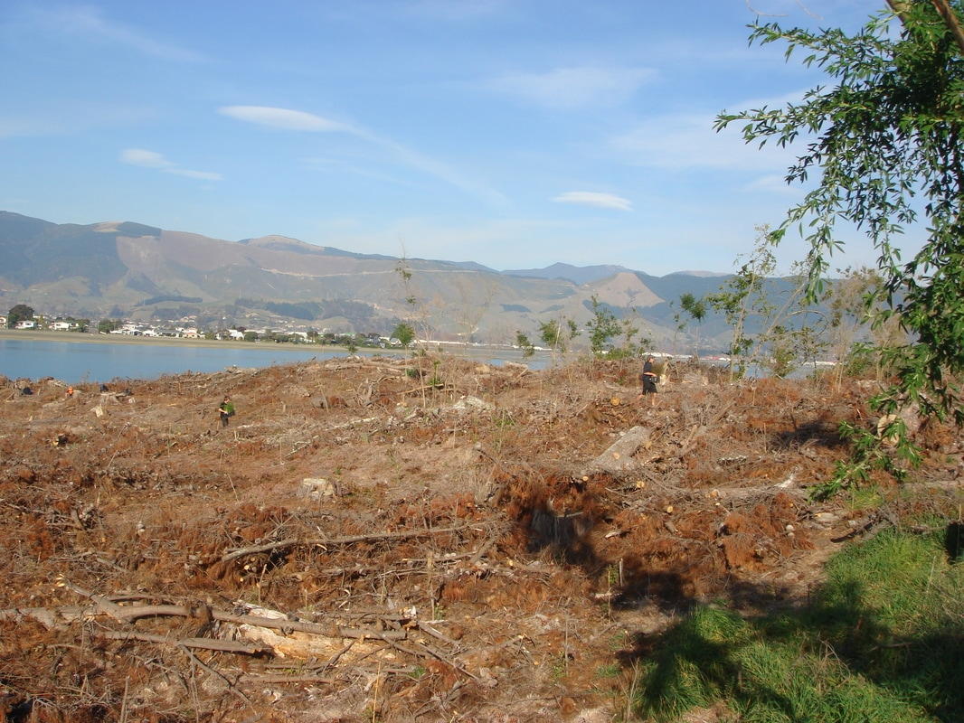
After the Trees had been removed there was a lot of rubbish and soil without nutrients left. There was too much sun and wind to get natives plants grow on that Island.

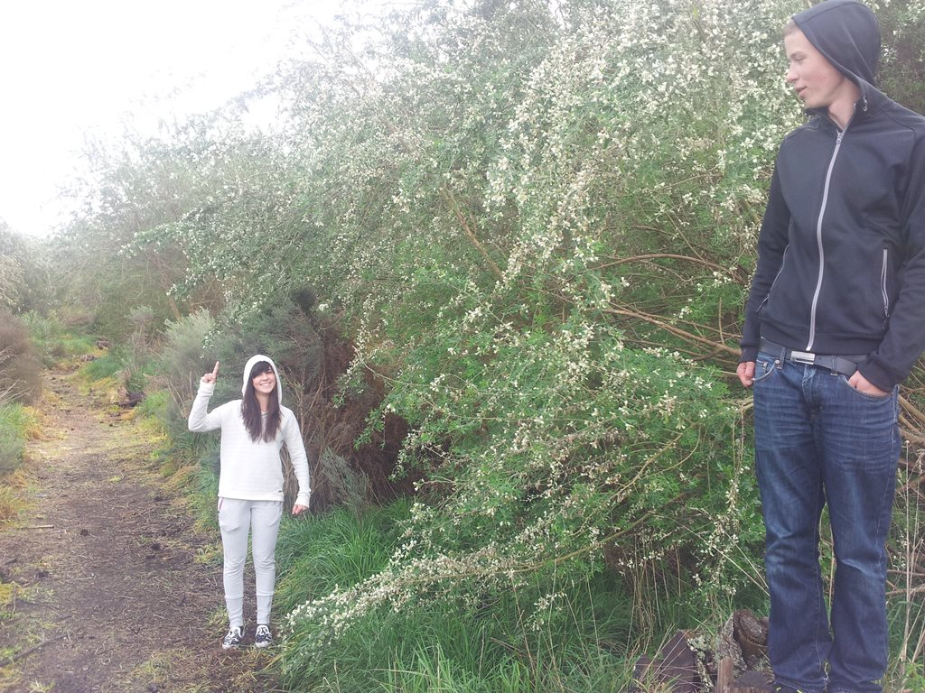
That is why they planted a lot of European Trees (Tree Lucerne). These trees grow very quick and are friendly. They create a bit of shade and give the soil some nutrients back so that native plants can start growing under them. For a few years the whole island was covered by Tree Lucernes to create nice conditions for the tiny native trees to grow.

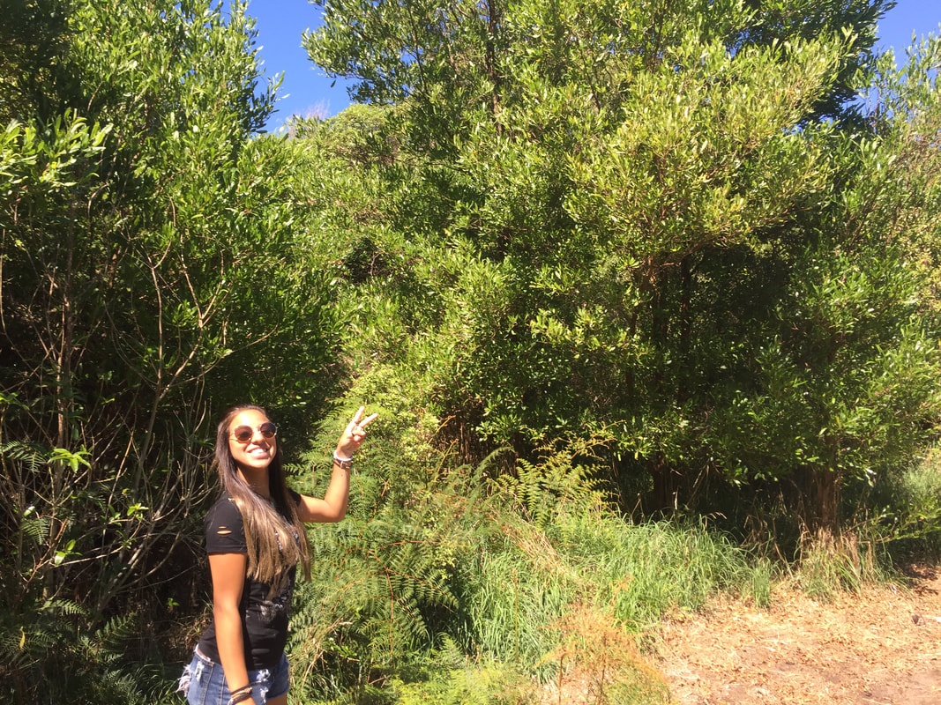
Then a lot of new native plants have been grown and cover the island.
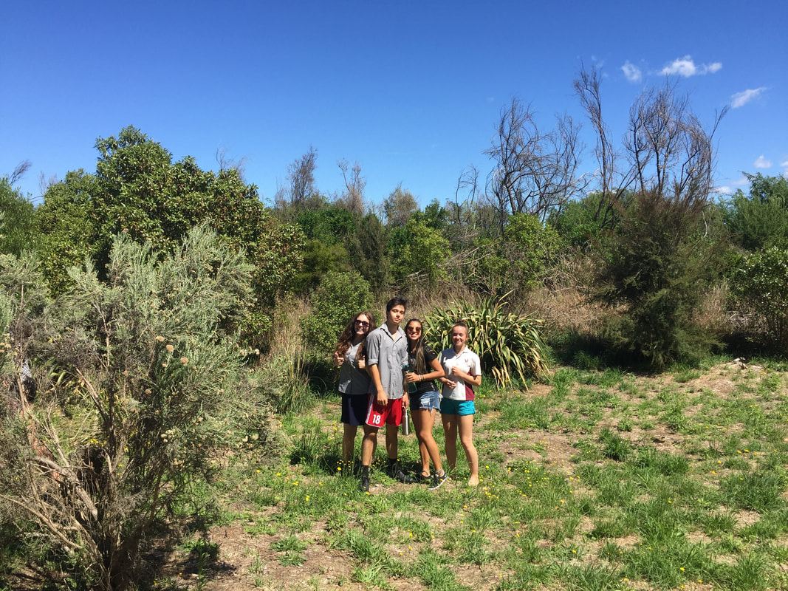
Now the friendly European Trees are not needed any longer and they started to cut them down so just native plants are left on Oyster Island.
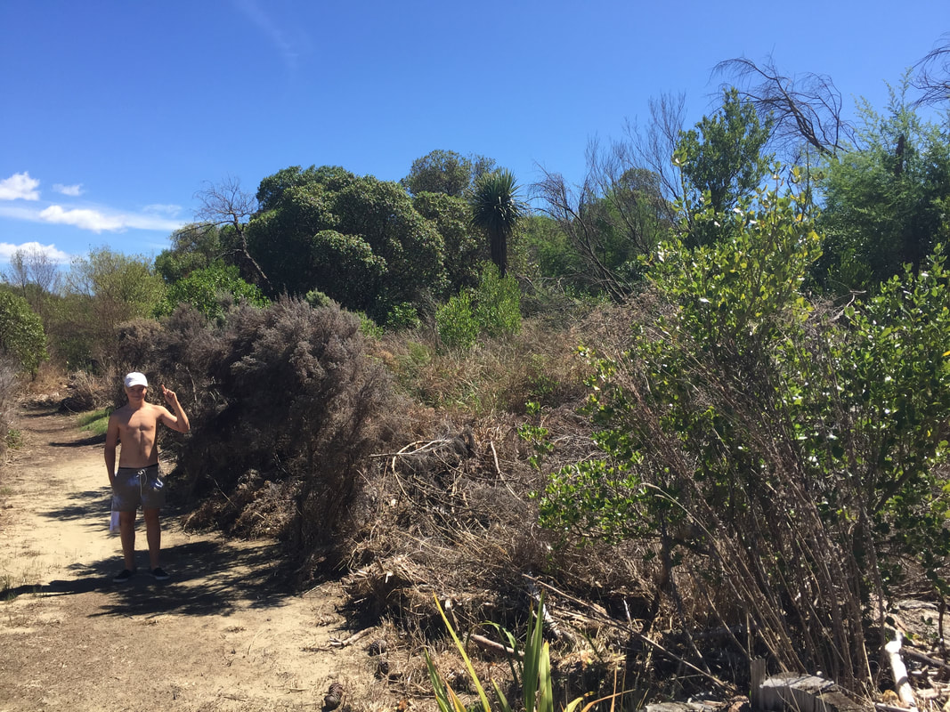
Because of the recent storms a lot of salty sea water came on the island and killed many of the native plants again. That is really bad because it took so many years to make them growing there and now you have to start all over again.

Tree Lucerne
There aren’t many trees as useful as the Tree Lucerne.
It’s an easily-propagated, fast-growing, frost-tolerant tree that can reach its full potential in just three to four years, it provides shelter, shade, and is a high protein evergreen fodder tree.
Furthermore it can also fix nitrogen.
Hailing from a subfamily of legumes, it generally forms multiple stems and spreads out, providing ample leaves.

Argillite
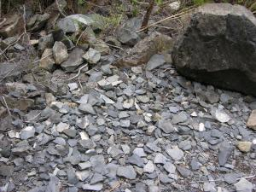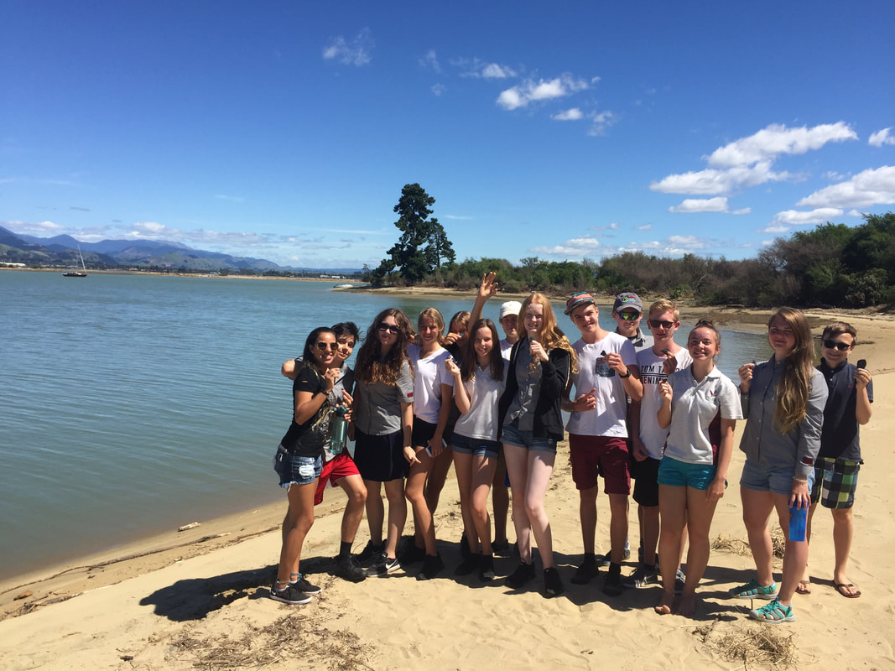
Known to Maori as pakohe, and to geologists as metamorphosed indurated mudstone, argillite is especially associated with the Nelson-Marlborough region in New Zealand.
Earliest Maori communities noticed its qualities of hardness, strength, and ability to hold a sharpened edge, ideal for making tools and weapons. It also provided a source of razor-sharp flakes for filleting fish, preparing roots and vegetables, woodcarving, flax work and net-making.

Our tiny beach adventure
The Marram grass is growing near to the see, because it can handle the salt-water better than other plants.
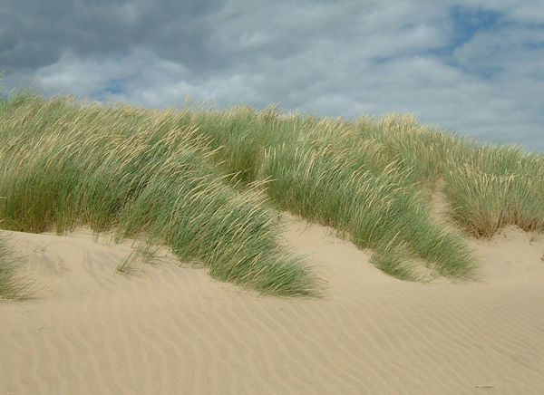

The whole beach was full of European plants and that's not good because we want native plants so all European plants were killed and the Pingao were planted. And we care about them because they were important for the Maori.
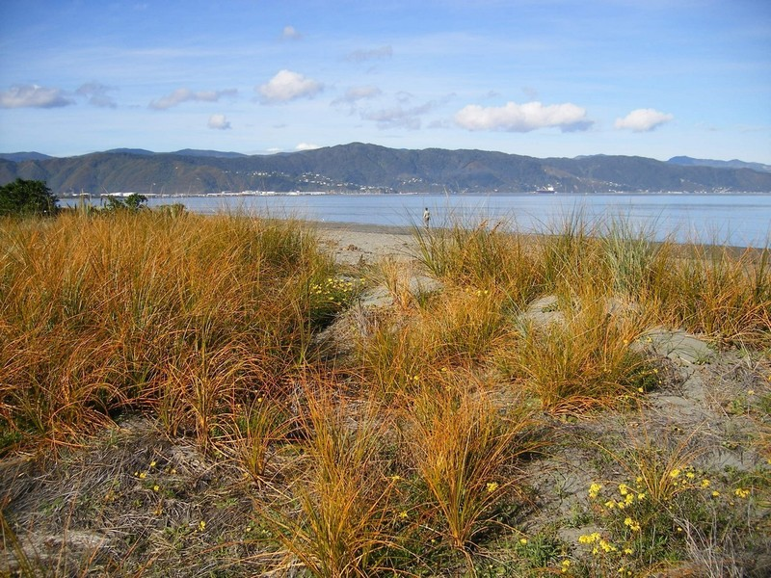

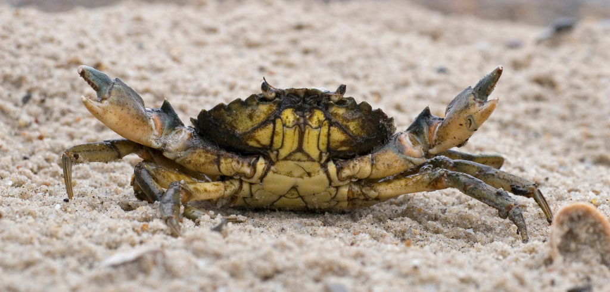

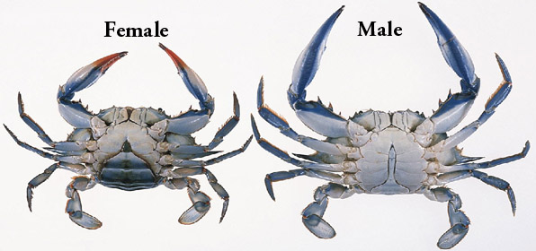
The male crab sits on the female. The female crab has eggs under her kind of round shell and the male crab puts sperm on the eggs.
The oyster came here with cutterships from japan. When the ship arrived, they spread over the whole cost of NZ.
We can make good money with them, because the Japanese people are buying the oysters back from NZ, because the environment is cleaner here.
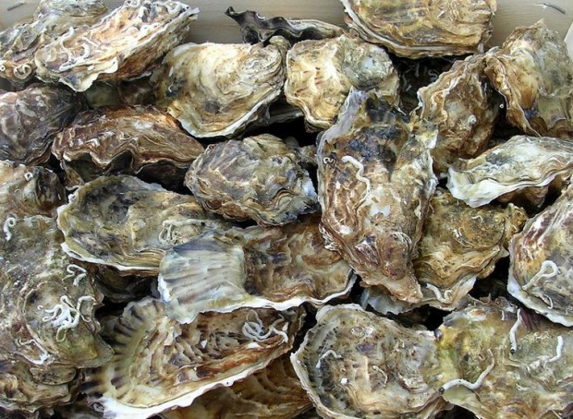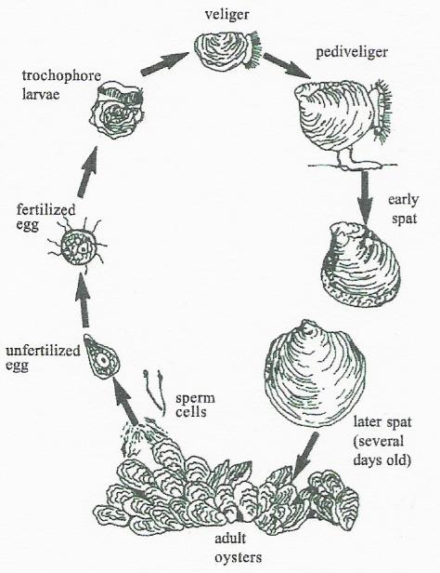

Scallop growth
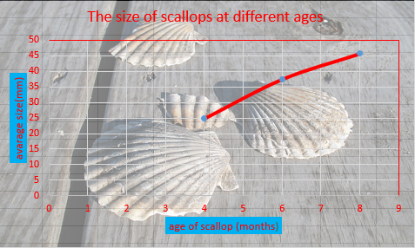

Cable bay
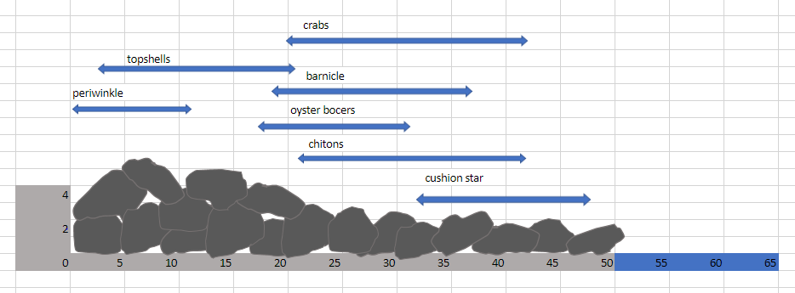

Creek salinity
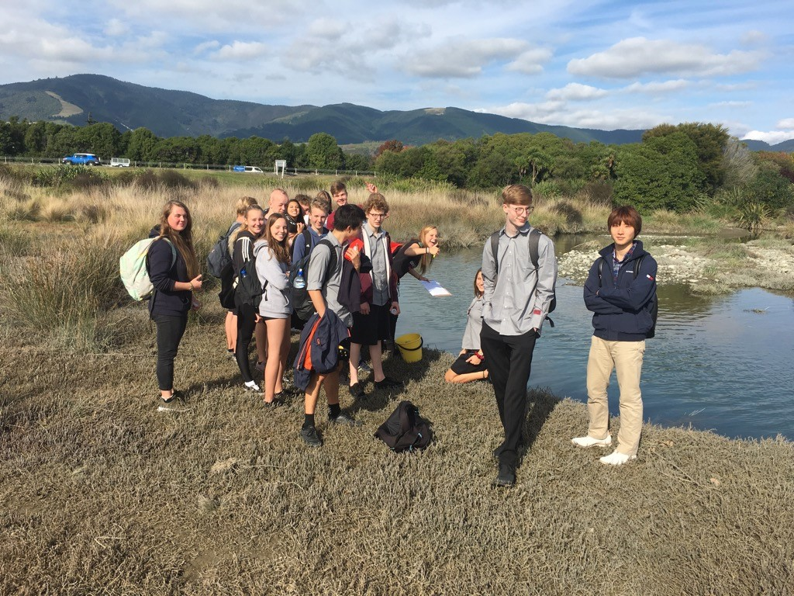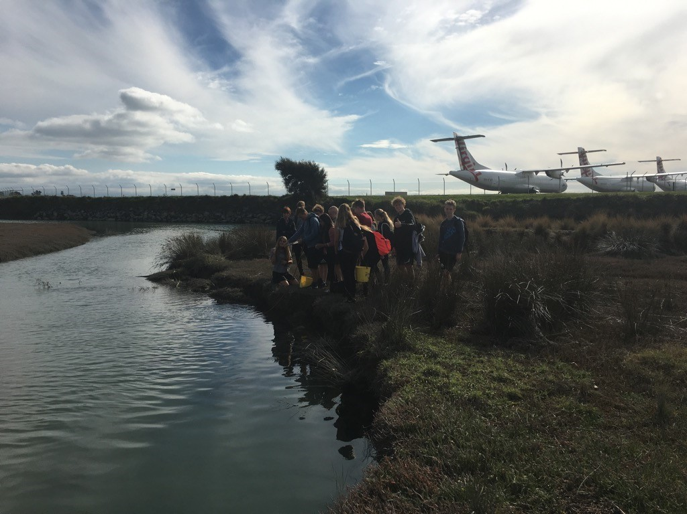
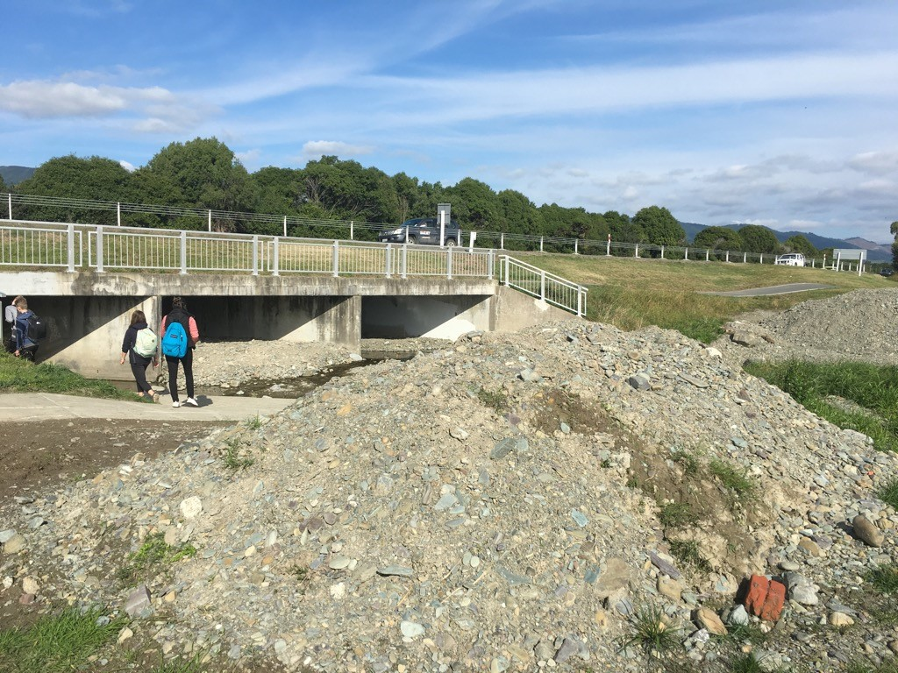

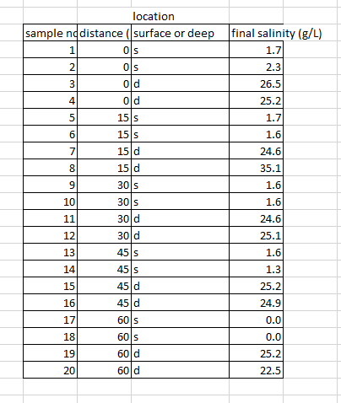

Undarin & alginate

We collected the brown seaweed from the Nelson port on Thursday.
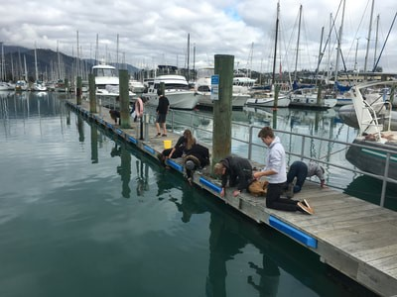
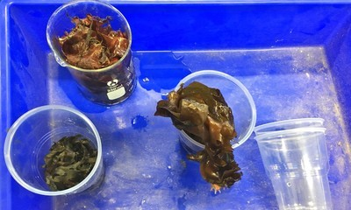

We washed the seaweed and left it in acid for 24h.
24h after the brown seaweed turned green.

Before adding sodium carbonate (to extract things out of the seaweed) we had to wash the it with fresh water.
After that we stirred it around for 30 mins.

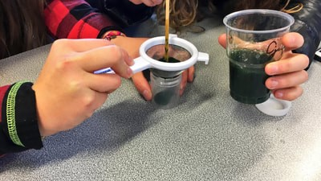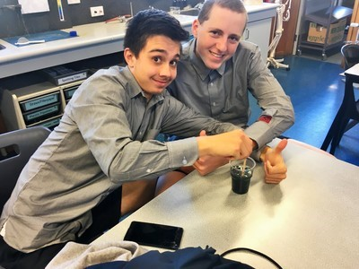

Afterwards we poured the water-jelly mix into separate containers to but it into the centrifuge.
After 6 mins of spinning around we got it out and could see how clear the mix was.
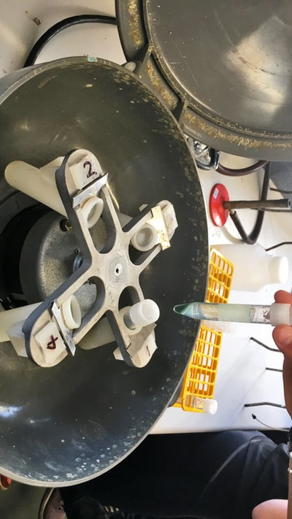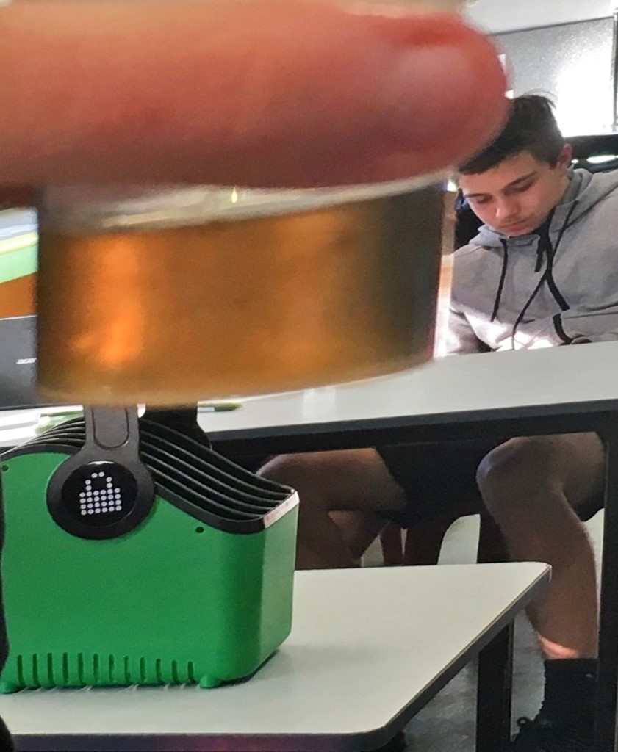
We colored the "clear" liquid with red food coloring so it looks like salmon eggs. Afterwards we put the red colored liquid in a syringe and dropped it in Calcium Carbonate.
As soon it was in Calcium Carbonate it stayed in the bubble form and you could get it out and it stayed how it was.

