Formative assessment

Task 3 – Write a report
Name:

Secondary information (research) (No need to refer to your data)
As you did for the car example in your research, refer to TWO heat transfer methods to explain why one of this girls feet feels hot but the other not so much
some ideas of things you may refer to: heat source, black, light colour, absorb, reflect, kinetic (movement) energy, radiation, conduction, solid, liquid, gas, vibrate,

In the summer the dark coloured land around Stoke and the base of the hills absorbs lots of solar radiation. This means the land gets quite hot. Paragliders use this to go flying from Barnicote. 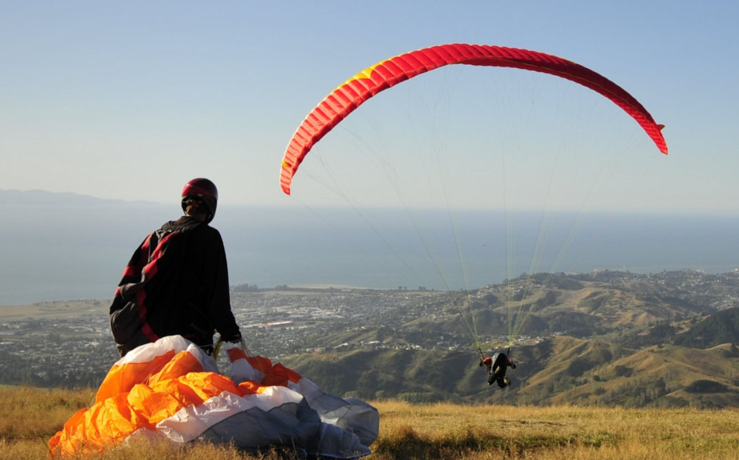
Use your knowledge of convection to explain why Barnicote is a good place for paragliding

