**Genetics Revision**

**QUESTION ONE: DOGS**

1. Define the term **homozygous**.

1. Using the letter H, give the genotype for a **homozygous recessive** individual.

1. German shepherd dogs have 78 chromosomes. How many would they have in an egg cell?

**Short hair is dominant over long hair in German shepherds**.

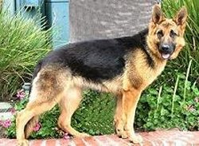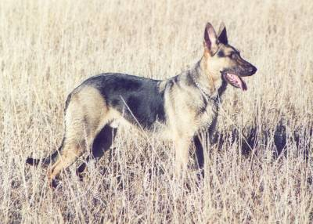

Long haired female

Short haired male

A **homozygous** **short haired male** German shepherd was mated with a **long haired female** German shepherd and all the pups were short haired.

1. Complete the Punnett square for the cross showing the genotype of the pups.

**Use the letter H**.



1. Give the percentage of offspring expected to have short hair.

**QUESTION TWO: BRACHYDACTYLY**

Brachydactyly is a rare condition of humans in which the fingers are very short.

It is due to a gene that is **dominant (B)**.

A man who has **normal fingers** married a **heterozygous short-fingered woman**. They are considering having children.

1. Complete the Punnet square below to show the possible outcome of this couple having children.

Normal male

punnet square

Heterozygous short fingered female

1. Give the genotype of their offspring who will have brachydactyly.

1. What is the probability of the man and woman having a child with brachydactyly?

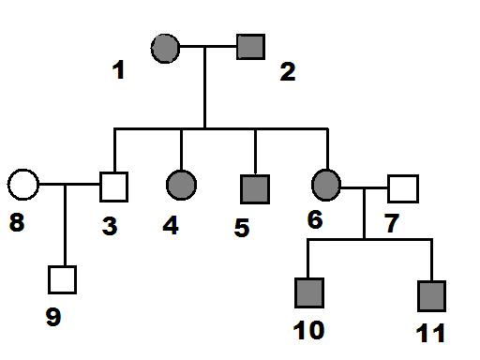The following is a pedigree chart showing the inheritance of this trait.

**The grey shaded shapes represent individuals with short fingers.**

1. Give the genotype of individual **8.**

1. **Explain** which **individuals** show you that the characteristic of short fingers are dominant.

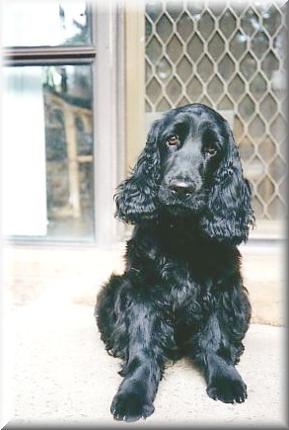**QUESTION THREE: COCKER SPANIELS**

In cocker spaniels, the allele for black coat colour (**B**) is dominant to the allele for brown coat colour (**b**), which is recessive.

1. Describe what is meant by the term **recessive**.

1. Describe the **difference** between the terms gene and allele.

1. A heterozygous, black coated male cocker spaniel is mated with a female cocker spaniel with a brown coat. Complete the Punnett square below to show the **genotypes** of the offspring. Use the coat colour alleles given at the beginning of this question.



1. Give the phenotype ratio of the puppies produced.

QUESTION Four: Sex Inheritance

* 1. The sperm cells in a male cocker spaniel contain 39 chromosomes. How many chromosomes are there in a skin cell of a cocker spaniel?

A cocker spaniel had a litter of five puppies. The puppies produced were all males.

* 1. Complete the Punnett square below to show the expected inheritance of sex in the puppies.



* 1. If the cocker spaniel had another litter of eight puppies, what percentage of the puppies would you expect to be **female**? Explain your answer.

**QUESTION FIVE: HUMANS**

A young boy is convinced that he is adopted. He finds evidence for this in the fact that although his parents and his older brother have brown eyes his eyes are very blue. He discusses this with his older brother**.**

The older brother explains that the **gene** for eye colour has a number of different ‘**forms**’. A form can be carried by a parent but it doesn’t show up in them. It might show up in some but not all of the children.

1. What is the correct genetic term for ‘**a** **form of the gene’**?

1. What is the genetic term for ‘**the form that only shows up if it is the only form there**’?

1. punnet%20sqTheolder brother used a diagram to show the boy that he could be the natural offspring of brown eyed parents. **Complete the following diagram as he would have**. (Use **B** to stand for the brown form and **b** to stand for the blue form, of the gene for eye colour).

1. Give the **phenotypic ratio** of brown eyed to blue eyed offspring from the cross above.

1. Explain why a blue eyed couple cannot be the natural parents of a brown eyed child.

QUESTION SIX: CELL DIVISION

**Mitosis** and **Meiosis** are types of cell division.

* 1. Complete the sequence below by putting **mitosis** or **meiosis** in the correct box: (You may not need to fill every box.)

cell%20division

* 1. **Discuss** meiosis and mitosis in terms of: the **type** and **number** of cells each produces, the **genetic complement** of these cells and the **number of divisions** required to produce them.

QUESTION SEVEN: Aliens

A group of scientists was studying aliens called *namuhs* that live on a planet in another galaxy. It was observed that some of the *namuhs* had eyelids that closed from side to side; a trait not observed in humans on earth. Other *namuhs* had normal eyelids that closed up and down, as humans' do.

Scientists studied one *namuh* family whose pedigree chart is shown below.

numahs

1. What is the genotype of individual 13
2. Is the allele for side-to-side eyelids dominant or recessive? Justify your answer.