Geology: the story of the Earth and its history
Name:
Japan 2011……
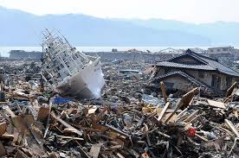
What caused this? ___________________
What caused that? ______________________
What made that happen? ______________________
https://www.youtube.com/watch?v=w3AdFjklR50
Christchurch 2011
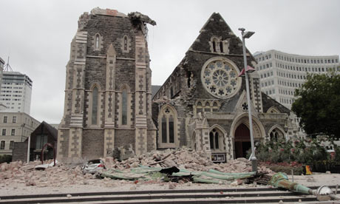
What caused this? ___________________
What made that happen? ______________________
https://www.youtube.com/watch?time_continue=6&v=bIms6vXnL30
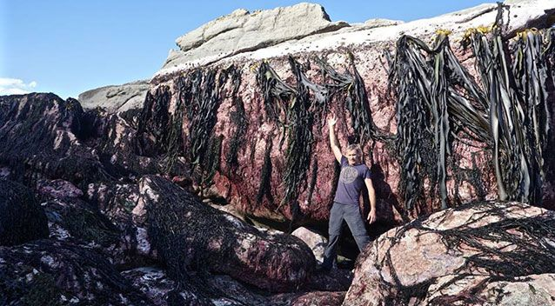
Kaikoura 2016
What caused this? ___________________
What made that happen? ____________________
https://www.youtube.com/watch?v=P7t2u61daPg

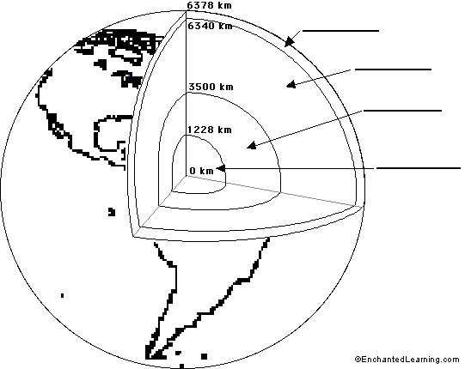
- https://www.sciencelearn.org.nz/resources/337-inside-the-earth
- https://www.youtube.com/watch?v=DL3Ez9bxMTo lava lamp
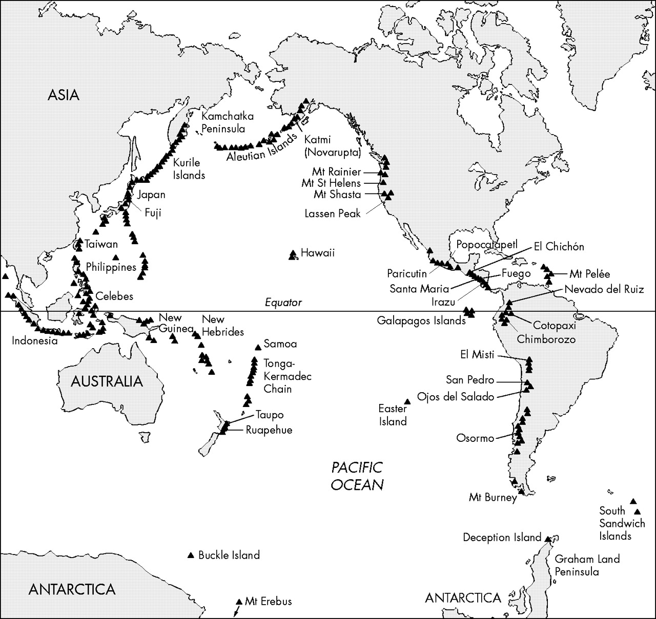
https://www.youtube.com/watch?time_continue=4&v=uw7Uq137YJQ
This pattern of volcanoes is called the _________ ___ _________
How can it be explained?

