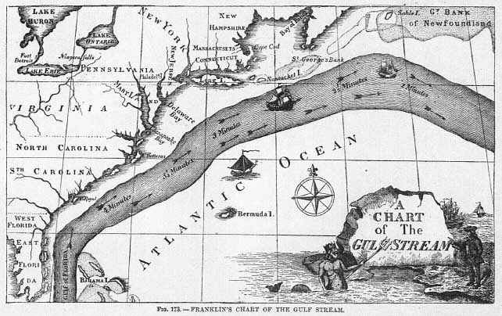
Gulf Stream
This is Benjamin Franklin’s 1769 chart of the Gulf Stream. It was based on sea temp measurements, water colour and whale movements.
What would Ben have noticed about the temperature of the Gulf Stream compared to the water adjacent to it?

Whales were seen to move along the edge of it but not in it, why did they avoid it?

Explain the temperature pattern seen (then and now)

The Gulf Stream helps sailors get to from the USA to England quicker than they would if they were not in the current. Explain why the current goes in that direction.

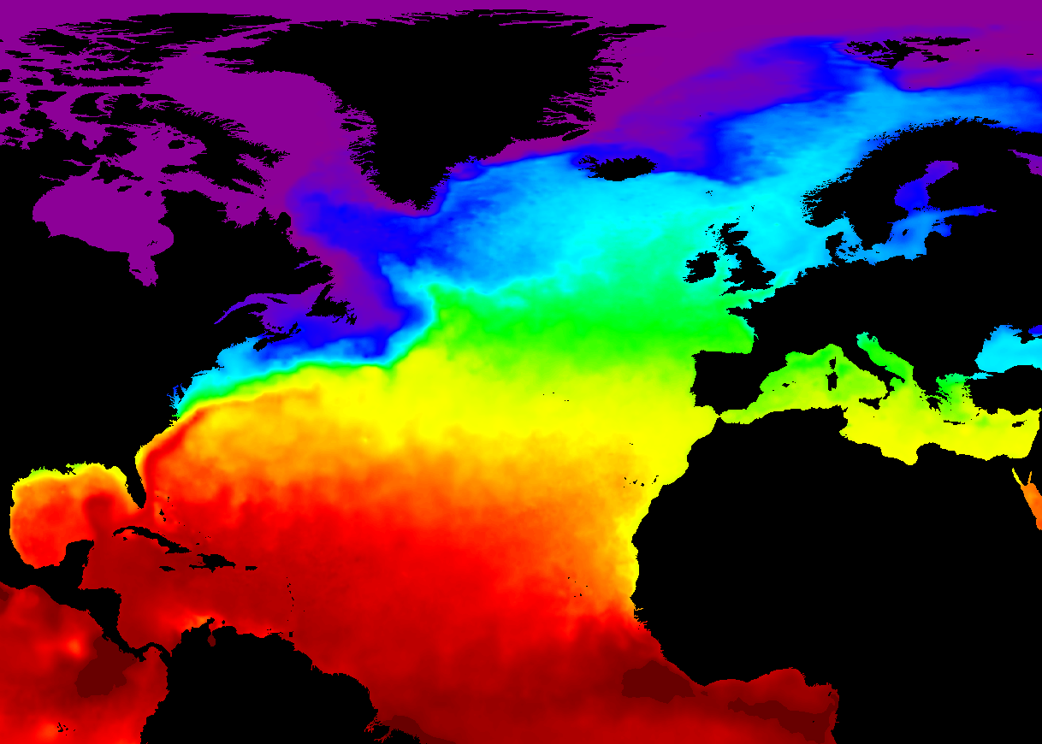
B
A
This map shows sea surface temperature
Give an approx. key for the colours
Red= yellow= green= blue= purple=

Explain the impact of the Gulf Stream on the climate of northern Europe (A) and Canada (B) – both at the same latitude

Discuss the possible cause and consequence of the breakdown of the Gulf Stream due to global warming. Include an account of the connection between the Gulf Stream and the thermohaline deep water current.

