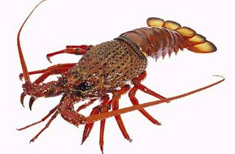
Key words for rock lobster / crayfish adaptations

