L i f e i s a B e a c h
Beach life - webQuest

Purpose of this exercise: To appreciate the hardships of being a beach plant and becoming familiar with the adaptations that our 4 focus plants have evolved that enable them to survive and compete.

Welcome Biology students! Please make a copy of this Doc and then away you go (Click on ‘File’ and select ‘make a copy’).

What is an adaptation? Insert your definition here

Name these 4 plants
Photo | Common Name | Botanical Name  (Scientific name)
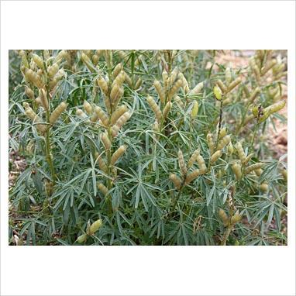
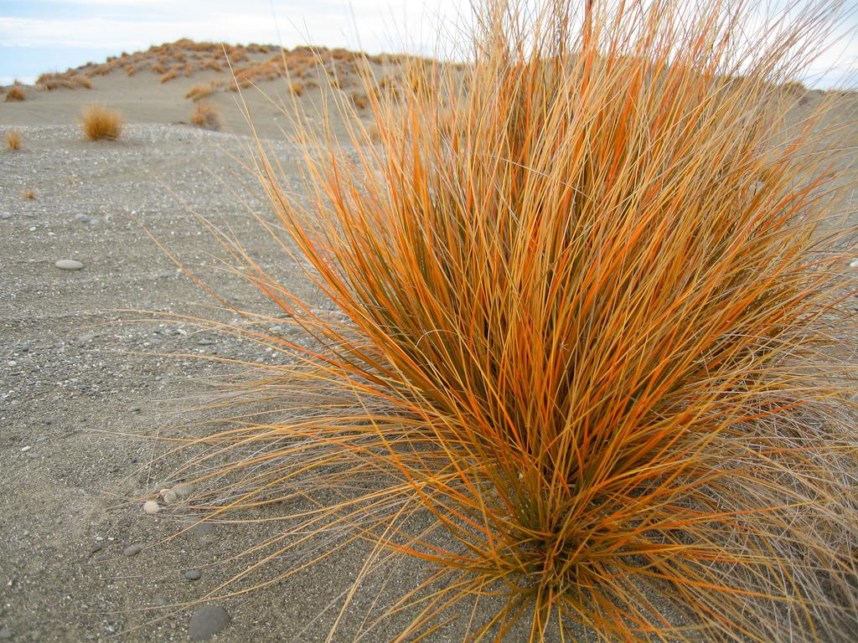
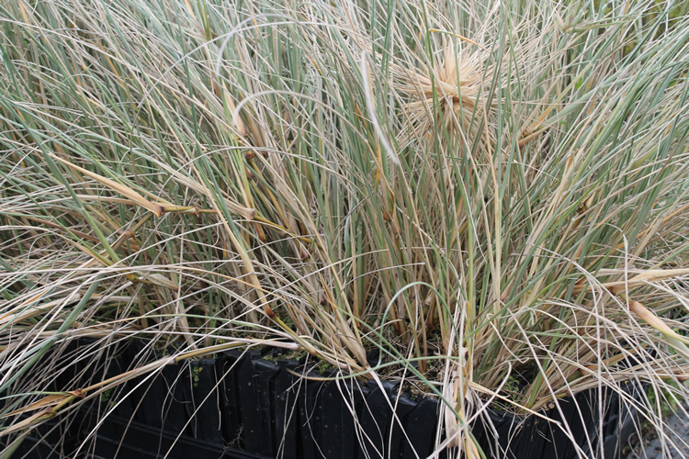
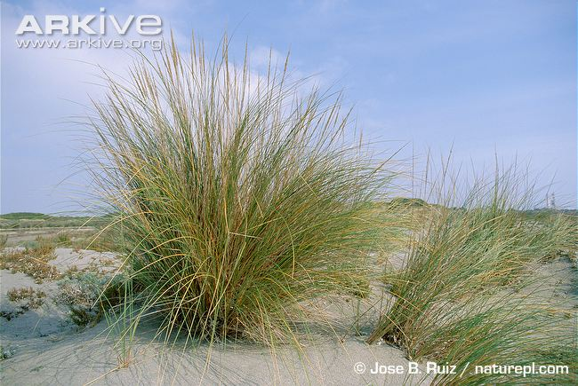

All living organisms need to adapt to get the best of the following five things:
- Food
- Water
- Appropriate temperature
- Shelter
- Gas exchange

In a sand dune environment, which of the above might be difficult to get (limiting factor)?
My Answer…

I think this because…

The following image is a cross section of a Marram grass leaf
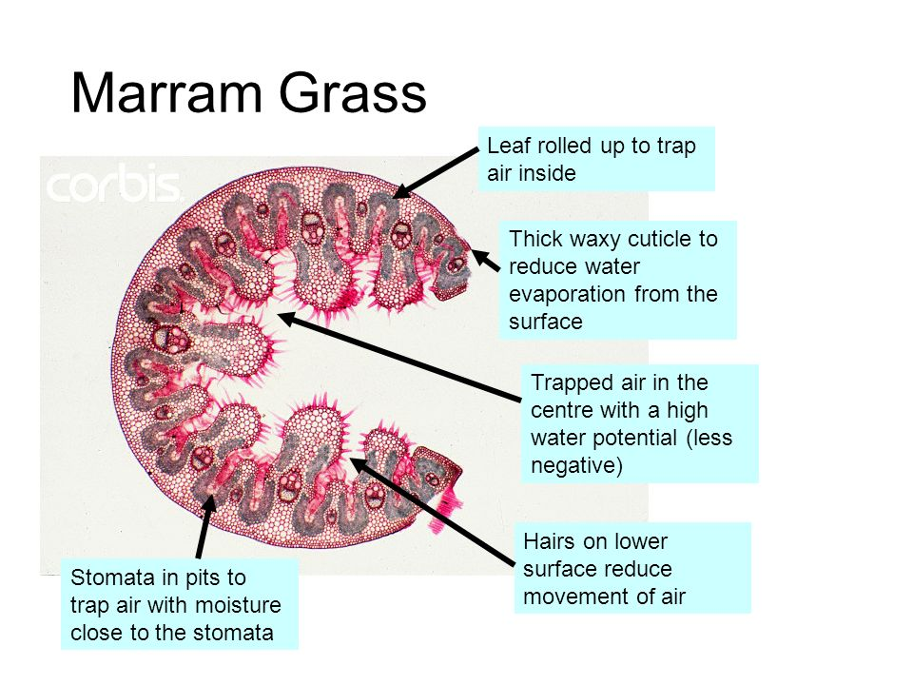
The above image shows some of the adaptations that a marram leaf has. Which of the following are these adaptations designed for
- Food
- Water
- Appropriate temperature
- Shelter
- Gas exchange

My answer…

Follow this link: http://en.wikipedia.org/wiki/Ammophila_(Poaceae)

Or maybe try:www.microscopy-uk.org.uk/mag/articles/anne1.html

Using the info make a list of the adaptations that marram grass has that allows it to survive better

Marram Grass adaptations | What the adaptation does...

Compete the same exercise for the remaining plants

Pingao

http://www.landcareresearch.co.nz/research/biosystematics/plants/weaving/pingao.asp

http://tvnz.co.nz/meet-the-locals/nz-geography-our-own-gold-coast-3342514

Pingao Grass adaptations | What the adaptation does...

Lupin

http://en.wikipedia.org/wiki/Lupin

Lupin adaptations | What the adaptation does...

Spinifex

http://www.teara.govt.nz/en/coastal-shoreline/5/2/2

Spinifex Grass adaptations | What the adaptation does...

Well done my fab Biology Student. You are now a semi- expert on sand dune species and their adaptation.

