MICROBES
and their interactions with humans

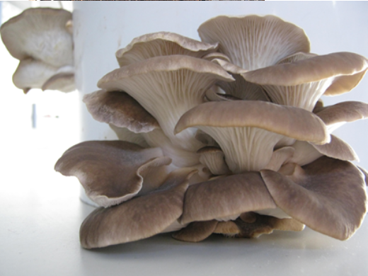
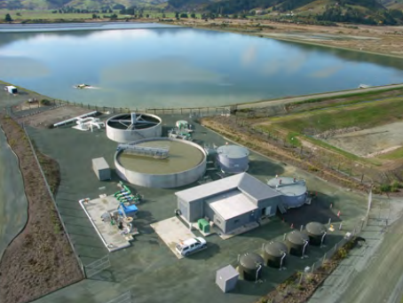

AS 90950
(Science 1.11)

Achieved | Merit | Excellence
Investigate biological ideas relating to interactions between humans and micro-organisms. | Investigate, in depth, biological ideas relating to interactions between humans and microorganisms. | Investigate, comprehensively,  biological ideas relating to interactions between humans and microorganisms.

What you need to know for...
AS 90950 - MICROBES
- 4 credit, internal
TYPES OF MICROBE
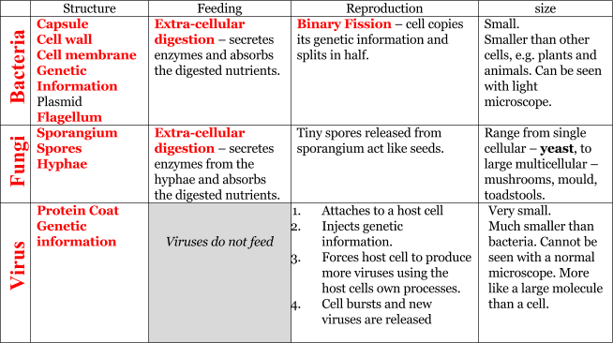

GROWTH AND CULTURE
Bacteria and fungi can be grown on a nutrient agar plate. The plate is inoculated (microbes are added) then incubated (kept warm).
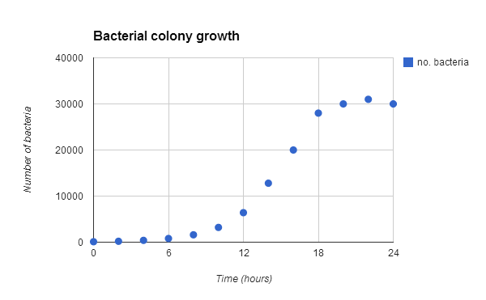
Viruses need a living host cell, so must be grown in a living organism, such as a fertilized chickens egg.
To thrive Fungi and Bacteria need Food, Warmth and Moisture.
In ideal conditions some bacteria can reproduce in 20 minutes. A colony will show the following growth curve:
- It starts slowly as there are only a few bacteria reproducing (lag phase)
- speeds up as there are more and more (log phase)
- then slows as food and space start to become scarce (stationary phase)
- and the numbers may drop, as bacteria as well as the reproduction rate dropping. They may also start to be killed by their own toxins (excreted waste) (death phase)
pH and O₂ availability will also affect growth rates.
MICROBE EXAMPLES
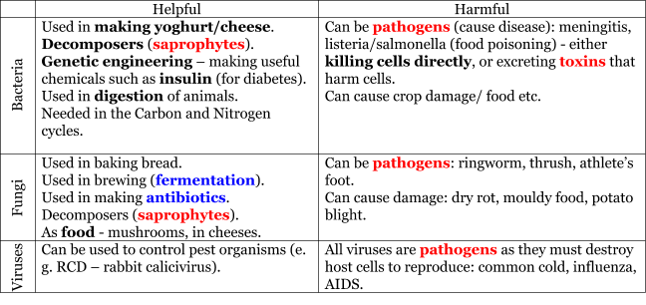
DISEASE CONTROL
Chemicals can be used to control Fungi and Bacteria.
Antibiotic is a chemical used to kill bacteria internally (in the body). Some bacteria have developed a resistance to some antibiotics, and can pass this information on.
Disinfectant Kills bacteria and fungi on surfaces.
Antiseptic Used to kill bacteria and fungi on the skin (weaker).
An immunisation (vaccination) is the process of putting a dead or weakened pathogen into the body. This means that the body can prepare the antibodies that will kill the pathogen if it is ever present. This is called getting immunity. For the same reason people usually can’t get a disease twice.

RESPIRATION
Like all living things Bacteria and Fungi undergo respiration. This means that they obtain energy from food (glucose).
This may be:
- aerobic - with O₂ (not “air”): glucose + O₂ → H₂O + CO₂
- anaerobic - no O₂ (not “air”): glucose → Ethanol + CO₂
Anaerobic respiration is used in brewing and in baking (the yeast produces CO₂ and makes bread “rise”).
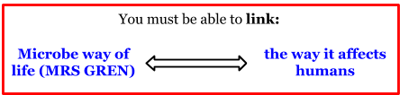

Microbes from our two poo ponds:
- Where were there the most microbes found (use other peoples results, too)?

- Why do you think they were there?

- Where were there not many microbes present?

- Why do you think they were not there?

- What does a bacterial colony look like?

- Why does it look this way (what features of its structure cause its appearance)

- What does a fungal colony look like?

- Why, do you think it looks like that?

BACTERIA QUESTIONS
- Bacteria can reproduce every 30 mins in ideal conditions. What are “ideal conditions”?

- If you start with one bacterium, how many will you have after:

1 hour ___ 2 hours _____ 8 hours _______ 24 hours (for eggsperts) _____________

- Why can bacterial growth not continue for long like that?

- A more realistic colony growth might look like this:

Time (hrs) | 0 | 2 | 4 | 6 | 8 | 10 | 12 | 14 | 16 | 18 | 20 | 22 | 24
no. bacteria | 100 | 200 | 400 | 800 | 1,600 | 3,200 | 6,400 | 12,800 | 20,000 | 28,000 | 30,000 | 31,000 | 30,000

  - Plot this on the graph on the next page (just ruff as guts)
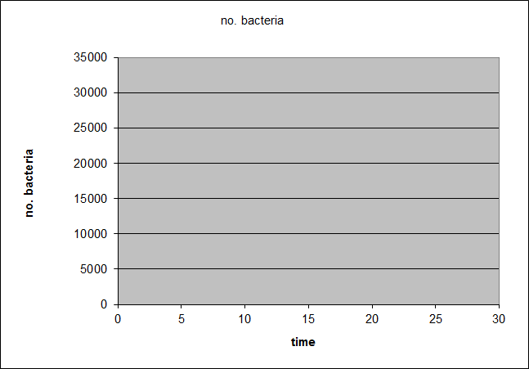

- Explain what is happening at the end of the graph (and why).

- Sketch the shape of the bacterial growth (on your graph) if it was grown at a lower temperature.

- Why do we incubate our bacteria at in the hot water cupboard (about 20°C)?

- Use the graph to help explain why people don’t get sick until a while (maybe a day or 2) after being exposed to a disease.

- Draw and label a generalized bacterial cell.

- Explain how bacteria feed (you could use a diagram instead).

- Explain how bacteria reproduce (or with a diagram).

FUNGUS QUESTIONS
- Fungi are needed for the breakdown and recycling of nutrients. Explain how their feeding helps to recycle nutrients.

- What is the name for a microbe that breaks down dead things and waste.

- Draw and label a fungus to show the parts that are involved in digestion of its food source.

- Fungi have some things in common with bacteria. Compare the feeding and reproduction of fungi and bacteria.

- Why must the sporangium be high above the substrate (food source)?

FLUSHABLE WIPES
The microbes used in the zing boost were lactic acid bacteria, yeasts, photosynthetic bacteria, actinomycetes and fungi.

- Draw and label a fungus (multicellular).

- Describe what type of cell processes is happening in the compost to deal with the paper and wipes.

- Draw and label a diagram that illustrates extra cellular digestion

- What did we do to assist the microbes in doing their function … (to break down waste) ?

OYSTER MUSHROOMS
- Explain how each of the processes in the preparation and growing of the oyster mushrooms aid in their successful production:
  - Choice of substrate

  - Microwave the substrate

  - Letting it cool but not drying it

  - Adding the spawn

  - Holes in the container

  - Leaving it in the dark

  - Exposing it to light after 10 days

- Explain how the growing oyster mushrooms “affect personal actions or society”.

ANSWERS
MICROBE INCUBATION RESULTS
- Pretty much everywhere
- Because they are everywhere. Everywhere.
- Recently washed places, maybe too hot, too dry, too salty, or somewhere with chemicals that kill microbes (like some places in your body)
- As above
- A greasy/oily spot
- Slimy capsule
- Wispy/fluffy/dusty
- Sporangia/spores

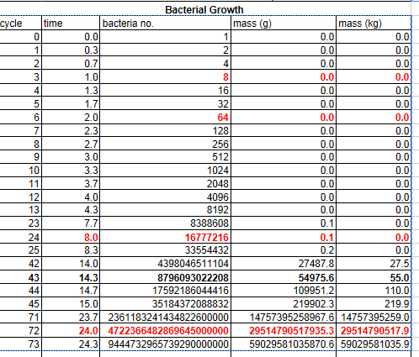
BACTERIA QUESTIONS
- Warm (not hot), moist, plenty of food and space (and oxygen if needed)
- See table
- Run out of the stuff in no. 1… there is too much competition
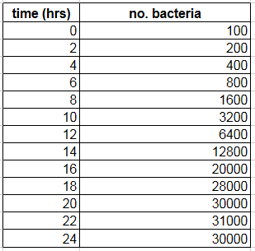

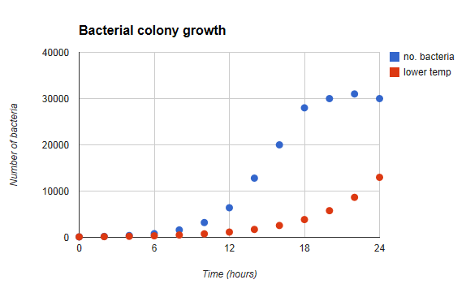

- The bacteria are dying as they run out of food and space, etc.
- See red line
- Warm enough so bacteria reproduce well, but below human body temp - so we don't incubate diseases.

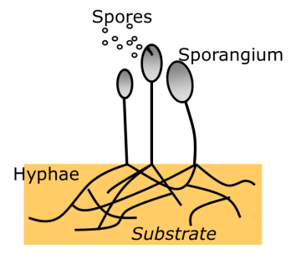
FUNGUS QUESTIONS
- ECD – secrete, dig, abs… their food is broken down… recycled
- Saprophyte

- Feeding is the same: Extracellular digestion
Reproduction either: Fungi – spores
Or Bacteria – binary fission
- Spread the spores around as far as possible. If it was underground this wouldn’t happen.

OYSTER MUSHROOMS
- a. Mushrooms will feed on some things better than others
- To kill off any competing microbes
- To avoid killing off the oyster mushrooms, but allowing them the moisture they need to grow
- Inoculating the substrate to start the colony growing
- Let oxygen in
- Mushrooms often grow better in dark places, and reduces them drying out
- Encourages them to produce fruiting bodies (sporangia)
- Humans can use the mushrooms to break down otherwise unhelpful materials, like sawdust. In doing so we can make food for ourselves (something from nothing). There is a high nutritional value in mushrooms, containing many important minerals and compounds.

Science 1.11(v3) (AS 90950): Investigate biological ideas relating to interactions between humans and micro-organisms

Credits: 4
Achievement | Achievement with Merit | Achievement with Excellence
Investigate biological ideas relating to interactions between humans and micro-organisms. | Investigate, in depth, biological ideas relating to interactions between humans and micro-organisms. | Investigate, comprehensively, biological ideas relating to interactions between humans and micro-organisms.

Student information

On the following pages are the questions that will be in the test. You are to use the next 3 lessons to prepare for the test by answering the questions.

You may use knowledge learned in class, experiments you have carried out, research information from the internet/books/etc.

You may work individually, or in small groups as directed by your teacher.

You may not take any of the information with you into the test, so you need to know it well.

RESOURCE LIST:
How humans may use/be affected by microbes:
- disposal of organic wastes
- composting
- food production
- food poisoning
- microbial action on everyday materials (helpful and harmful micro-organisms)
- disease in humans and animals they are in contact with
- antibiotics
- resistance to antibiotics
- origins and control of pandemics
- use of viruses to control pests
- others?
- NOT SEWAGE TREATMENT – given in worked example

Choose an idea from the RESOURCE LIST.
Using this idea, describe how a NAMED BACTERIA affects humans.
In your answer you should LINK information on:
- the bacteria feeding, structure, reproducing
- how humans are affected or control the bacteria in terms of life processes
- how understanding the bacteria affects personal actions or society

Choose a DIFFERENT idea from the RESOURCE LIST.
Using this idea, describe how a NAMED FUNGUS affects humans.
In your answer you should LINK information on:
- the fungus feeding, structure, reproducing
- how humans are affected or control the fungus in terms of life processes
- how understanding the fungus affects personal actions or society

Worked example:
Sewage treatment
Names the bacteria. Any of these 4 attempts would be sufficient (for achieved) as these is no single species. “Many types” would probably be insufficient for merit.
Many types of bacteria are present in sewage treatment. These include faecal coliforms – bacteria associated with human excrement. This includes Escherichia coli, present in the human gut. Saprophytic bacteria such as these are what break the sewage down.
Some of the bacteria have flagella, allowing them to move around to gather food. However, most are simply a cell wall surrounding a membrane, with genetic material within.
Structure given. Could have been from diagram.
The bacteria reproduce quickly in ideal conditions by binary fission, where the bacteria split in 2. This causes exponential growth of a population.
Reproduction by binary fission, fast
One of the goals in sewage treatment is to continue to supply the bacteria with the ideal conditions necessary to allow them to grow, reproduce and feed as fast as possible¹. It is also important to provide them with plenty of oxygen. Oxygen allows the bacteria to respire aerobically, rather than anaerobically². Anaerobic respiration can cause unwanted or harmful product formation³.
How bacterial potential is maximised – control of environment.
The pH, temperature and other conditions like salt concentration are carefully controlled to maximise helpful bacterial health.
Feeding by extracellular digestion (described)
Given the appropriate conditions the bacteria feed on waste matter, such as faeces, by secreting digestive enzymes through their membrane⁴. These enzymes break down the waste matter into nutrients⁵, which can be absorbed by the bacteria. In doing so the sewage, potentially harmful to humans, is turned into harmless chemicals. This also means that the nutrients contained can be released. The more bacteria present, the faster this breakdown and recycling is achieved⁶.
How humans are affected – nutrients recycled, waste removed (link to personal actions/society)

