NAME TEACHER
NQA
Nayland Qualification Authority

Level Two Biology, 2014

Demonstrate understanding of gene expression
Credits: 4

Suggested Time: 40 minutes

Instructions
- Answer all questions in the spaces provided.
- You must hand this examination paper to the supervisor at the end of the examination.
- Check that this paper has all 5 pages numbered and in the correct order.

Achievement Criteria. (for assessors only)
Achievement |  | Achievement  with Merit |  | Achievement  with Excellence
Demonstrate understanding of gene expression |  | Demonstrate in-depth understanding of gene expression |  | Demonstrate comprehensive understanding of gene expression
Overall Level of performance:

No © Nayland Qualifications Authority, 2014
No rights reserved. Any part of this publication may be reproduced by any means without the prior permission of Graeme or Jeff or Duncan or our little boss Hamish or our big boss Rex, ….after all… it’s all about learning!

Assessor’s use only

You are advised to spend 40 minutes answering the questions in this booklet.

QUESTION ONE: BASE PAIRING
Maintaining the nature of the genetic code through replication and gene expression relies on successful complementary base pairing.
Discuss your understanding of the significance of complementary base pairing to gene expression. In your answer:
- Describe the structure of both DNA and RNA nucleotides and provide an account of all complementary base pair combinations observed during transcription.
- Explain how the coding and template strands of DNA relate to the product of transcription.
- Relate the role of triplets, codons and anti-codons to the process of translating one strand of mRNA.

Assessor’s use only

QUESTION TWO: TAY SACHS MUTATION
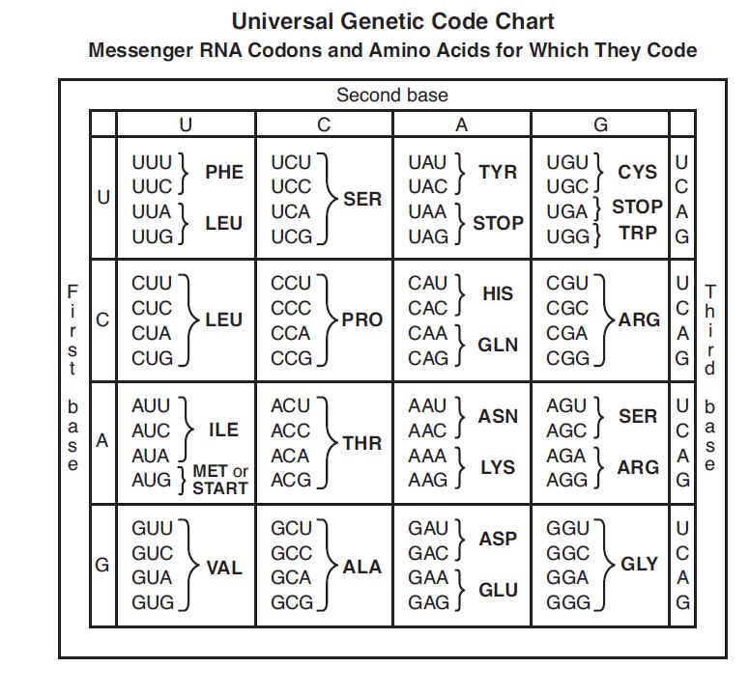
Tay Sachs Disease is caused by the build up of proteins called gangliosides inside nerve cells causing cell death.
Assessor’s use only

The HEXA gene on chromosome 15 codes for a gene product that normally helps to catalyse the breakdown of these harmful ganglioside proteins.

People born with Tay Sachs have a mutation in the HEXA gene which involves the insertion of four base pairs into the HEXA gene.

(a) Complete the codon sequence resulting from transcription of the section of the normal HEXA allele shown below.

DNA CGT ATA TCC TAT GCC CCT GAC …
GCA TAT AGG ATA CGG GGA CTG...

mRNA CGU AUA UCC _____ GCC _____ GAC ...
polypeptide Arg – Ile – Ser – Tyr – Gly – Pro – Asp ...

(b) Complete the sequence of amino acids resulting from the translation of the section of mutated Tay Sachs HEXA allele shown below.

DNA CGT ATA TCT ATC CTA TGC CCC TGA C...
GCA TAT AGA TAG GAT ACG GGG ACT G...

mRNA CGU AUA UCU AUC CUA UGC CCC UGA C...
polypeptide Arg – Ile – Ser – Ile – _____– Cys – _____ - Stop
(c) Explain how the insertion of four base pairs into the HEXA gene affects the process of translation and the structure of the gene product for children born with the Tay Sachs allele (you may refer specifically to alleles in parts (a) and (b))
Assessor’s use only

(d) Discuss the significance of the Tay Sachs mutation. In your discussion:
- Explain how a mutation in DNA can negatively affect the catalytic role of an enzyme
- Analyse the effect of the Tay Sachs mutation on the third amino acid to provide evidence of redundancy due to degeneracy in the genetic code

Assessor’s use only

